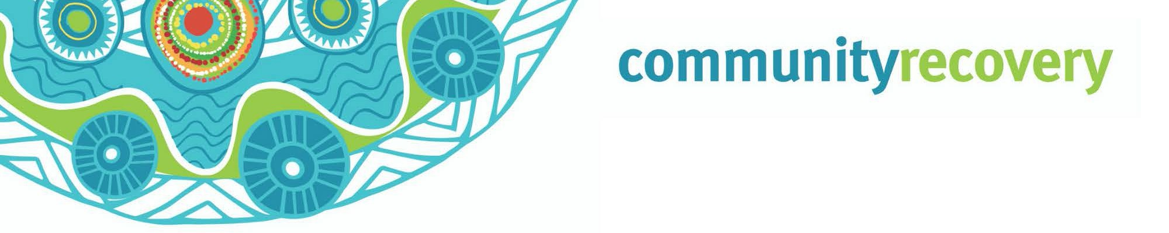
Wunt tha’iy an a kaap an thee uwalan ang
ngamp an erkam ma yalmathnak yuk waymin anangan.
Kaap Pianam
Inan Kankanam Lat

Aak kaap way ngeen eh?
Aak kaap way ngan ul piikiw, an ngamp ke ngaantam ngeeyimp aak thanth an wantiw. An puth pam wanch yoot waymiy than a yuk waymin nanthathiw.

Aak kaap pian an theen wunt kuchirra, wunt pian patham a, a ngak pian mayan, ngaay a ngak pian an ukuw a yuk waymin wayathuw. A ngak anhyan a ngan ngul mulathiw a yuk waymin wayathiw.

Wunt a ngak anhyan ang palpuuy an yuk waymin thee’iw, a awuch an ngul yeelal ang maayiw.

Yuk radio thak an ngeeyn an ang yipmam wik an waa’ow.

Wik ilngan puth yipmam ma aathow nintang yalmath an yuk waymin awuch nungkerang an.

Ke meem ulpan, ngantam ngeeyan kaap an.

A RACQ Get Ready Queensland, www.qld.gov.au

Wantak an nintang wantiw?

- An nint kemp wee weeyam a kemp waay ngank wee weeyam wunin. An nint ke weep wunin, weep wayathin, man kul a ngak ul mungkin.
Kampan nungkeram an minam pian thanang a nungkerak man thamp. May minh min mungkan, weep min wunan, a tv thathan a radio ngeeyan.
- Nint puk thamp ay? Ma pathathan thanang ang, ke than waawaa ayn yootant kaap an, ngank min wunan. Waa’an wanakan wanch pam yoot ngan ma aathan than wee weeyan kampan aak min koyam yumpayn. A puk many niindam an yipmam ngank min wunayn
- Ku a ku waak a minh bullock, minh ninthan (pig) thak an ney ay? Ma yalmathan thanang a yipmam minam wunayn aak kaap ngan. Nint aak min uwan thant yipmam angan wunayn, a may ngeen an munkayn, aak petch we’irr uwan a. Engkan ku a ku waak an ang man wantin thangang weey alathanang.
- Awuch a yuk waymin nungkeram an thuthnam ulan wunin. Nint kan minam aak aniy yumpan ay? Nint insurance thamp awuch yumpayn a yuk waymin an koyam thee’ayn ay?
- Nintang ma yalmathan ayn ang a anan nungk ma aathayn an nintang, yipmam anman min yuk waymi thak an pian. Nint ngul awuch ak an.

Ma Yalmathnak Kankanang Wunt/Kaap Pianam:

  - Ma yalmathan awuchngan: Aak min an ma yalmathnak an ang nath kaap an thinth ul wompiw. Wik yumpan a chill ma yalmathan awuch nunk ngul puth ngak pian ang uunth.

  - Ma yalmathan yuk waymin opirr ak an: Ma yalmathan yuk waymin opirr ak an aak kap thonam akam, kankanang kaap’am.

  - Ma yalmathan aak pech wantan Wik yumpan ngeen awuch ngan yuk waymin thak an umpan.

Inan thatan https://getready.qld.gov.au/be- prepared/ Ma yalmathnak kankanang wunt

- Pam wanch nungkerang thinth an a wunthan, thanang ma aathan a waa’an ngan an umpayn.

- Ku a Ku’waak an keengk keengk kon ngam pekan yipmam karrpam kalan.

- Ngeeyan yuk radio a tv ngan thathan yipmam nungk waa’ow wantin an ngak a wuntan iy.

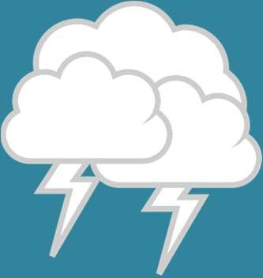

Download the
Self Recovery app
Visit our website www.qld.gov.au/ communityrecovery

