Bush fire

This factsheet is about what to do in a bush fire.

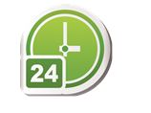
A bush fire is a big fire that can:
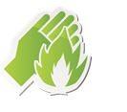
- move fast

- happen at any time

- be dangerous.

Dangerous means you can get hurt. For example, you can get burnt.

If there is a bush fire warning you have to decide to stay or go.
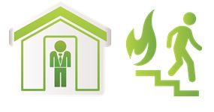

What can a bush fire do?

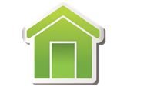
A bush fire can hurt you and your family. A bush fire can damage your:
- house

- things in your house, for example furniture.
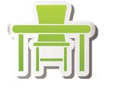

Damage means to break something.

How can I get ready for a bush fire?

To get ready for a bush fire you should:

- have an emergency kit
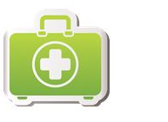

- plan what you and your family will do if there is a bush fire warning
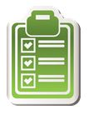

- get insurance for your house and things in your house. Insurance is money you might get from an insurance company when something goes wrong.

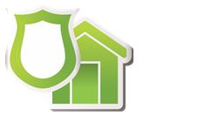

You should also:

- listen to ABC radio or TV for bush fire warnings

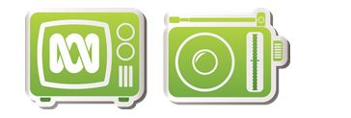

- clean up long grass and small trees near your house

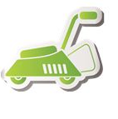

Bush fire

- visit our website
https://getready.qld.gov.au/be-prepared/

More information

https://www.qld.gov.au/communityrecovery

