.

Promotional Toolkit

Acknowledgment of Country
We pay our respects to the Aboriginal and Torres Strait Islander ancestors of this land, their spirits and their legacy. The foundations laid by these ancestors gives strength, inspiration and courage to current and future generations, towards creating a better Queensland.

About Queensland Women’s Week

This year, Queensland Women's Week (QWW) will run from Sunday 8 to Saturday 14 March 2026.

The 2026 theme, ‘Shaping tomorrow together’, recognises that we all have a part to play in working towards a better tomorrow for women’s economic security. To support this, the Queensland Government is developing Queensland’s first Women’s Economic Security Strategy which aims to improve outcomes for women and girls across the state in key areas including health, housing, safety, education and employment.

QWW recognises and celebrates the successes and achievements of women and girls across Queensland, as we work towards equality and advancing women’s economic security. It Is a time to acknowledge that everyone has a role in creating a Queensland community that respects women, embraces equality, and promotes and protects the rights, interests and wellbeing of women and girls.

To support Queensland Women’s Week, organisations, schools, businesses, workplaces, clubs and community groups are encouraged to reflect on how they are shaping tomorrow for women and girls by getting involved and hosting or attending events and activities.

By doing this, we enrich and strengthen our communities and help create a more equal Queensland where everyone is valued.

Get involved

You can support QWW 2026 by:

• Hosting a QWW event and promoting it on the QWW event calendar
• Attend a QWW event. See the QWW event calendar to find an event near you
• Share this toolkit with your network
• Promote QWW using the resources available at www.qld.gov.au/womensweek.
• Find out more at www.qld.gov.au/womensweek.

Resources available
Visit www.qld.gov.au/womensweek to access resources to promote Queensland Women’s Week 2026.
You can also promote participation and awareness of the week by sharing this toolkit with your stakeholders.

Resources include:
- Key messages
- Social media accounts and hashtags
- Social media posts
- Newsletter and/or email content
- Social media tiles
- eDM assets – header and footer
- Poster
- MS teams background.

Host and promote your event
Organisations, schools, businesses, workplaces, clubs and community groups are encouraged to get involved and host an event during or around Queensland Women’s Week.

Tell us about your event
Complete this form to submit your event for inclusion in our Queensland Women’s Week calendar.

Use and share the event resources
Templates and resources are available to help you promote and run your Queensland Women’s Week event.

These include:
- Event invitation template
- Social frame
- Certificate of participation.

Key messages

- Queensland Women’s Week: 8 – 14 March 2026
- Queensland Women’s Week: shaping tomorrow together
- Recognise and celebrate the successes and achievements of women and girls across Queensland and advance women’s economic security
- Organisations, schools, businesses, workplaces, clubs and community groups are encouraged to reflect on how they are shaping tomorrow for women and girls by getting involved and listing their events at www.qld.gov.au/womensweek.
- Get involved: host a Queensland Women’s Week event, attend one, or share your story.
- Spread the word: resources are available at www.qld.gov.au/womensweek
- Everyone has a role to play: Queensland Women’s Week is for all Queenslanders. Be part of a future that promotes economic security for women and girls.

Social media accounts and hashtags

Let us know you’ve shared – tag us on social!
Facebook
@qldwomen / Women on Boards – Queensland
LinkedIn
Department of Women, Aboriginal and Torres Strait Islander Partnerships and Multiculturalism
Hashtags:
#QWW26 #WomeninQLD

Social media posts

Announcement

Save the date - Queensland Women’s Week is coming soon!

From 8-14 March 2026, Queenslanders are invited to celebrate the incredible women and girls across our state.

Get involved and contribute to shaping tomorrow together to advance women’s economic security.
To find out more visit www.qld.gov.au/womensweek 👩🏻

#QWW26 #WomeninQLD

Get involved

Post 1

Get Involved in Queensland Women’s Week!

From 8 – 14 March, Queenslanders are invited to celebrate the incredible achievements of Queensland women and girls whilst striving for a brighter, more inclusive future.

Host or attend an event, share your story and contribute to shaping tomorrow together and advancing economic security.

Find event details and resources at www.qld.gov.au/womensweek #QWW26 #WomeninQLD

Post 2

There are so many ways to get involved in Queensland Women’s Week!

From 8-14 March, host or attend an event and share your story. It’s the perfect way to contribute to shaping tomorrow together to advance economic security for women and girls across the state.

To submit your event, find out what’s on or download resources to help spread the word visit www.qld.gov.au/womensweek

#QWW26 #WomeninQLD

Celebrate

It’s Queensland Women’s Week!

Celebrate the incredible achievements of women and girls in Queensland.

To find all the events and activities happening across the state visit www.qld.gov.au/womensweek
#QWW26 #WomeninQLD

Email and/or newsletter content

Announcement

Save the date - Queensland Women’s Week is coming soon!

From 8-14 March 2026, Queenslanders are invited to celebrate the incredible achievements and successes of women and girls across our state.

Get involved and contribute to shaping tomorrow together to advance women’s economic security, building a safer, fairer and more secure future for women and girls across Queensland.

Host an event, attend an event or share your story – there is something for everyone.

To find out more visit www.qld.gov.au/womensweek

Get involved

Inspire your team, workplace, school, club or community organisation to celebrate Queensland Women’s Week this year:

📅 Host an event for your community

📣 Download the resources

💜 Attend a Queensland Women’s Week event in your area

Queensland Women’s Week (QWW) is for all Queenslanders. Everyone has a role to play in creating a community that respects women, embraces equality, and promotes and protects the rights, interests, and wellbeing of women and girls.

This year’s theme, shaping tomorrow together reminds us that together we shape a Queensland that protects women’s economic security creating a strong economic future for Queensland.

QWW will run from 8 to 14 March, kicking off with International Women’s Day on 8 March. On that day, Queensland women join millions of others around the world to celebrate the achievements of women in the past, present and future.

To share your event, find out what’s on or download the resources, visit www.qld.gov.au/womensweek

Celebrate

Celebrate Queensland Women’s Week!

March 8-14 marks Queensland Women’s Week, a time to unite, celebrate for progress in women’s equality and economic security.

There are events and activities on across the state, to celebrate the theme shaping tomorrow together. It’s a time for us all to stand together and create a community that respects women, embraces equality, and promotes and protects the rights, interests, and wellbeing of women and girls in Queensland.

Find event details and resources at www.qld.gov.au/womensweek.

Further information

Office for Women
Department of Women, Aboriginal and Torres Strait Islander Partnerships and Multiculturalism.
Email: women@qld.gov.au

Assets to promote Queensland Women’s Week

Social Tiles
1080 x 1080 1200 x 627

1080 x 1350 (version 1) 1080 x 1350 (version 2)

1200 x 627 627 x 1200

eDM assets
Header
Footer
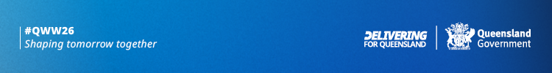

Poster – A2, A3 and A4

Assets to host and promote your event
Event invitation

Social frame
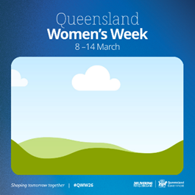

Certificate of participation

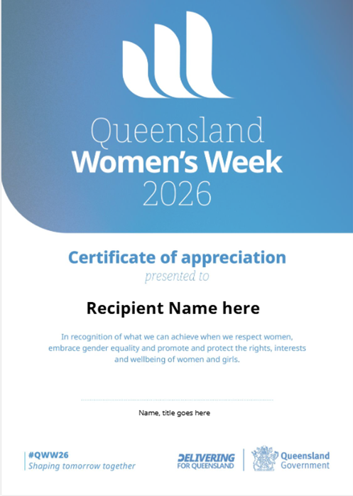

Additional creative assets

If you require additional creative assets to promote Queensland Women’s Week or would like existing creative assets to be tweaked, please reach out to discuss. We will endeavour to accommodate requests where we can.

Contact -

Strategy Insights and Communications
Email: communications@dwatsipm.qld.gov.au

