
Young Queenslanders Strategy
Annual Highlights Report 2024

Empowering young Queenslanders
for a bright future
Contents
Minister’s Foreword 4
The Young Queenslanders Strategy 5
Participate 6
Key 2024 highlights 6
Case Study 8
Queensland Youth Parliament 8
Cultivate their futures 9
Key 2024 highlights 9
Case Studies 10
2024 Young Researchers Program 10
Meet Olivia Leighton – a graduate with CS Energy 12
Balnggarrawarra Melsonby Rangers Youth Engagement Program 14
Building Futures with the Workforce Connect Fund and HIA’s Advanced Apprentice & Employer Mentoring Program 16
Live their best lives 17
Key 2024 highlights 17
Case studies 19
Buy Smart Program Expansion 19
Top Blokes Foundation – Youth and Community Connection Project 20
Thrive in our communities 21
Key 2024 highlights 21
Case Studies 22
Queensland Indigenous Youth Leadership Program 22

License
This document, including text, pages, graphics, and photographs are protected by copyright law. Copyright in Department of Housing and Public Works materials is owned by the State of Queensland. The State of Queensland asserts the right to be recognised as author of this material and the right to have its material remain unaltered.
The text within this document is licensed under a Creative Commons Attribution licence and is able to be used in accordance with the licence terms, which are found on the Creative Commons website. In all other circumstances, written permission must be granted by the Department of Housing and Public Works before the material may be used or reproduced. You must keep the copyright notice on the copyright material and attribute the State of Queensland as the source of the copyright material.
The images, artwork and design elements within this document are not included in this license and may not be used for any purpose without appropriate permissions from the rights holders.
Attribution
Text from this work should be attributed to: The State of Queensland, Department of Housing and Public Works, 2024.
Interpreter
The Queensland Government is committed to providing accessible services to Queenslanders from all culturally and linguistically diverse backgrounds. If you have difficulty in understanding this document, you can contact us on 13 QGOV (13 74 68) and we will arrange an interpreter to communicate the report to you. www.qld.gov.au/languages


Minister’s Foreword
As Queensland’s new Minister for Youth, it is my privilege to present
the 2024 Annual Highlights Report, celebrating the achievements
and impacts of the Young Queenslanders Strategy since its release.
The Strategy is a vision shaped by young people, for young people.
Through consultation with thousands of young Queenslanders, we ensured their voices, ideas, and aspirations were at the heart of its development. Being co-designed with young people from across our state, the Strategy reflects their priorities, so it truly belongs to them.
In the last few months, we have seen this vision come to life. From innovative programs and initiatives to inspiring case studies, this Strategy is a testament to the power of youth leadership and collaboration.
Every success highlighted in this report has been driven by young Queenslanders and their passion to advocate for meaningful change.
The Crisafulli Government is listening to young Queenslanders through our youth-led initiatives to make sure their voices are heard across government and within their communities.
The 72 actions in the inaugural Action Plan represent the delivery of the change young Queenslanders want to see, addressing the issues that matter most—whether it’s creating opportunities for employment, improving access to services, or fostering life skills.
Thank you to every young person who contributed to the Strategy and to everyone working to bring it to life under the guidance of the Queensland Government’s outstanding Office for Youth.
Your insights and energy are the foundation of this journey, where together we are building a Queensland in which young people are empowered to actively participate, cultivate their futures, live their best lives, and thrive in our communities.
Sincerely,
The Honourable Sam O’Connor MP
Minister for Housing and Public Works
Minister for Youth

The Young Queenslanders Strategy
The Young Queenslanders Strategy provides a framework to achieve the vision that Queensland’s young people are empowered to actively participate, cultivate their futures, live their best lives, and thrive in our communities.
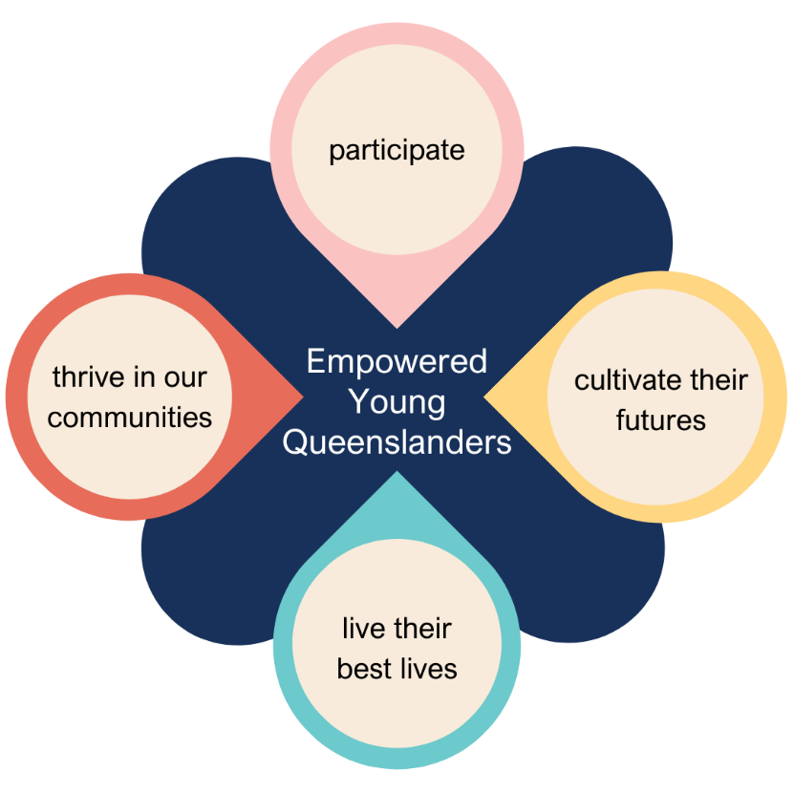
Informed by the diverse voices and experiences of young Queenslanders, the Young Queenslanders Strategy’s 2024-2026 Action Plan includes 72 targeted government actions aimed at delivering meaningful change in the areas that young people told us matter most.
This 2024 Annual Highlights Report captures progress made against the first Action Plan's commitments and showcases the real-life impact of these initiatives on young people. The Queensland Government remains dedicated to empowering young Queenslanders, with the next report set to detail further achievements in 2025.


Participate
Young people participate in the world around them through exploration and positive influence.
This pathway provides mechanisms for young people to connect with government, contribute to civic life, and learn about the formal systems that support them. Initiatives within this pathway are about creating meaningful opportunities for young people to participate in government decision-making and shape their future.

Key 2024 highlights
- Health and Wellbeing Queensland and the Office for Youth jointly supervised three Master of Nutrition and Dietetic Practice placement students to lead two focus groups to workshop food system solutions for improved food security in remote Aboriginal and Torres Strait Islander communities in Queensland. These workshops informed the development of nutrition content for social media to support young Queenslanders to make healthier choices.
- Thriving Lives, Connected Communities was released by Health and Wellbeing Queensland and the Queensland Mental Health Commission. Its development included dedicated engagement with young Queenslanders including sessions at Logan Youth Foyer, two workshops with young Queenslanders from the Youth Strategy Engagement Group and the First Nations Youth Strategy Engagement Group, and a Townsville Engagement Roadshow, all facilitated by the Office for Youth, to ensure that the strategy was shaped by young people’s experiences with mental health.
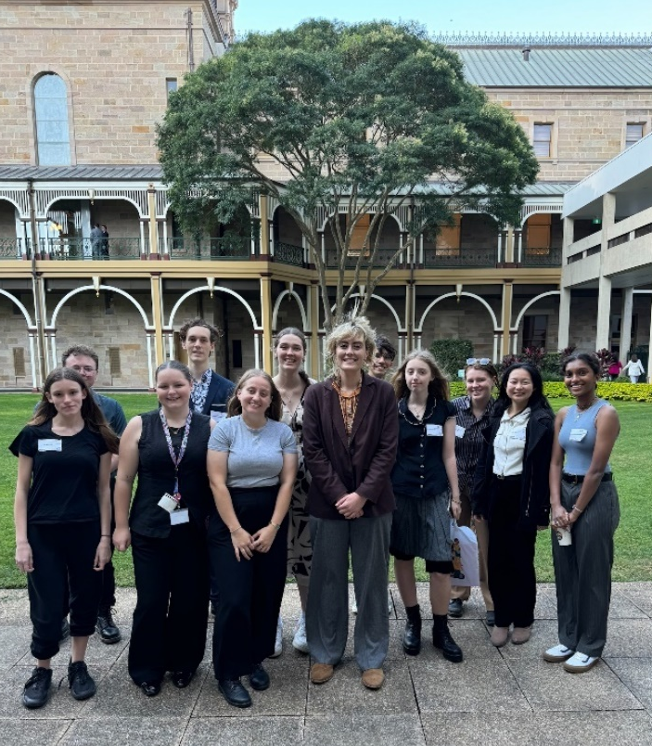
- The Office for Youth launched the dynamic online version of the Young Queenslanders Strategy, including videos and interactive content designed by young Queenslanders for young Queenslanders, during Queensland Youth Parliament. The launch brought together members of the Youth Strategy Engagement Group, the First Nations Youth Strategy Engagement Group, and all members of Queensland Youth Parliament.
Members of the Youth Strategy Engagement Group and the First Nations Youth Strategy Engagement Group at the launch of the online version of the Young Queenslanders Strategy at Parliament House
- The Department of Natural Resources and Mines, Manufacturing and Regional and Rural Development was involved in organising and funding the North Burnett Community and Careers Expo in October 2024. It brought together 24 exhibitors to showcase local job vacancies, future career opportunities and pathways, and apprentice and traineeship opportunities. More than 120 school students from Monto, Mundubbera and Eidsvold State High Schools attended.
- The Department of Families, Seniors, Disability Services and Child Safety engaged the Centre for Innovative Justice (CIJ) to develop risk assessment tools and approaches for young people impacted by violence. Supported by the Office for Youth, CIJ engaged with 6 youth advocates to test the risk assessment tools and receive feedback on the use of language and best practice for engaging with young people. Feedback from a post-workshop survey indicated that young people felt heard and validated during the session.

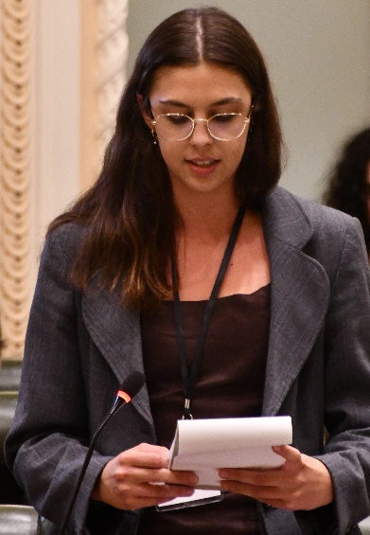
Case Study

Queensland Youth Parliament
My name is Una Murphy, and I am in my first year of university at The University of Queensland studying Politics, Philosophy, and Economics, with a strong interest in policymaking and governance. To learn more about my passion for politics I joined the YMCA Queensland Youth Parliament this year as the Member for Chatsworth, which allowed me to engage directly with the legislative process and collaborate with peers on important issues. Though my long-term goal is not to be a politician I found this program incredibly insightful, as one day I would like to work for the United Nations and create meaningful policies that address global challenges.
Una giving her speech in Queensland Parliament House
During the program, I was assigned to the Environmental and Clean Energy Committee. Together we designed a Bill to give Queenslanders a human right to water. I had the chance to draft and debate this legislation as well as practise public speaking, research, and teamwork.
This experience also opened the door for me to work in the Office of Youth, where the team adapted my role to allow me to learn from them and develop my passion for policy and governance. This experience has given me invaluable knowledge of the workings of systems that I one day hope to be a part of.
Queensland Youth Parliament is an annual program run by YMCA Queensland and funded by the Queensland Government. The program empowers young people aged 15–25 to engage in the democratic process, represent their local electorates, and influence change through debate and legislative simulation. Youth Members collaborate in teams to draft Youth Bills on issues they are passionate about, culminating in the rare opportunity to debate these Bills at Parliament House.
Beyond fostering civic engagement, the non-partisan program is a launchpad for personal and professional growth. Youth Members develop leadership, public speaking, and advocacy skills while building lifelong connections. By amplifying the voices of young people, Queensland Youth Parliament continues to shape the next generation of leaders and changemakers.

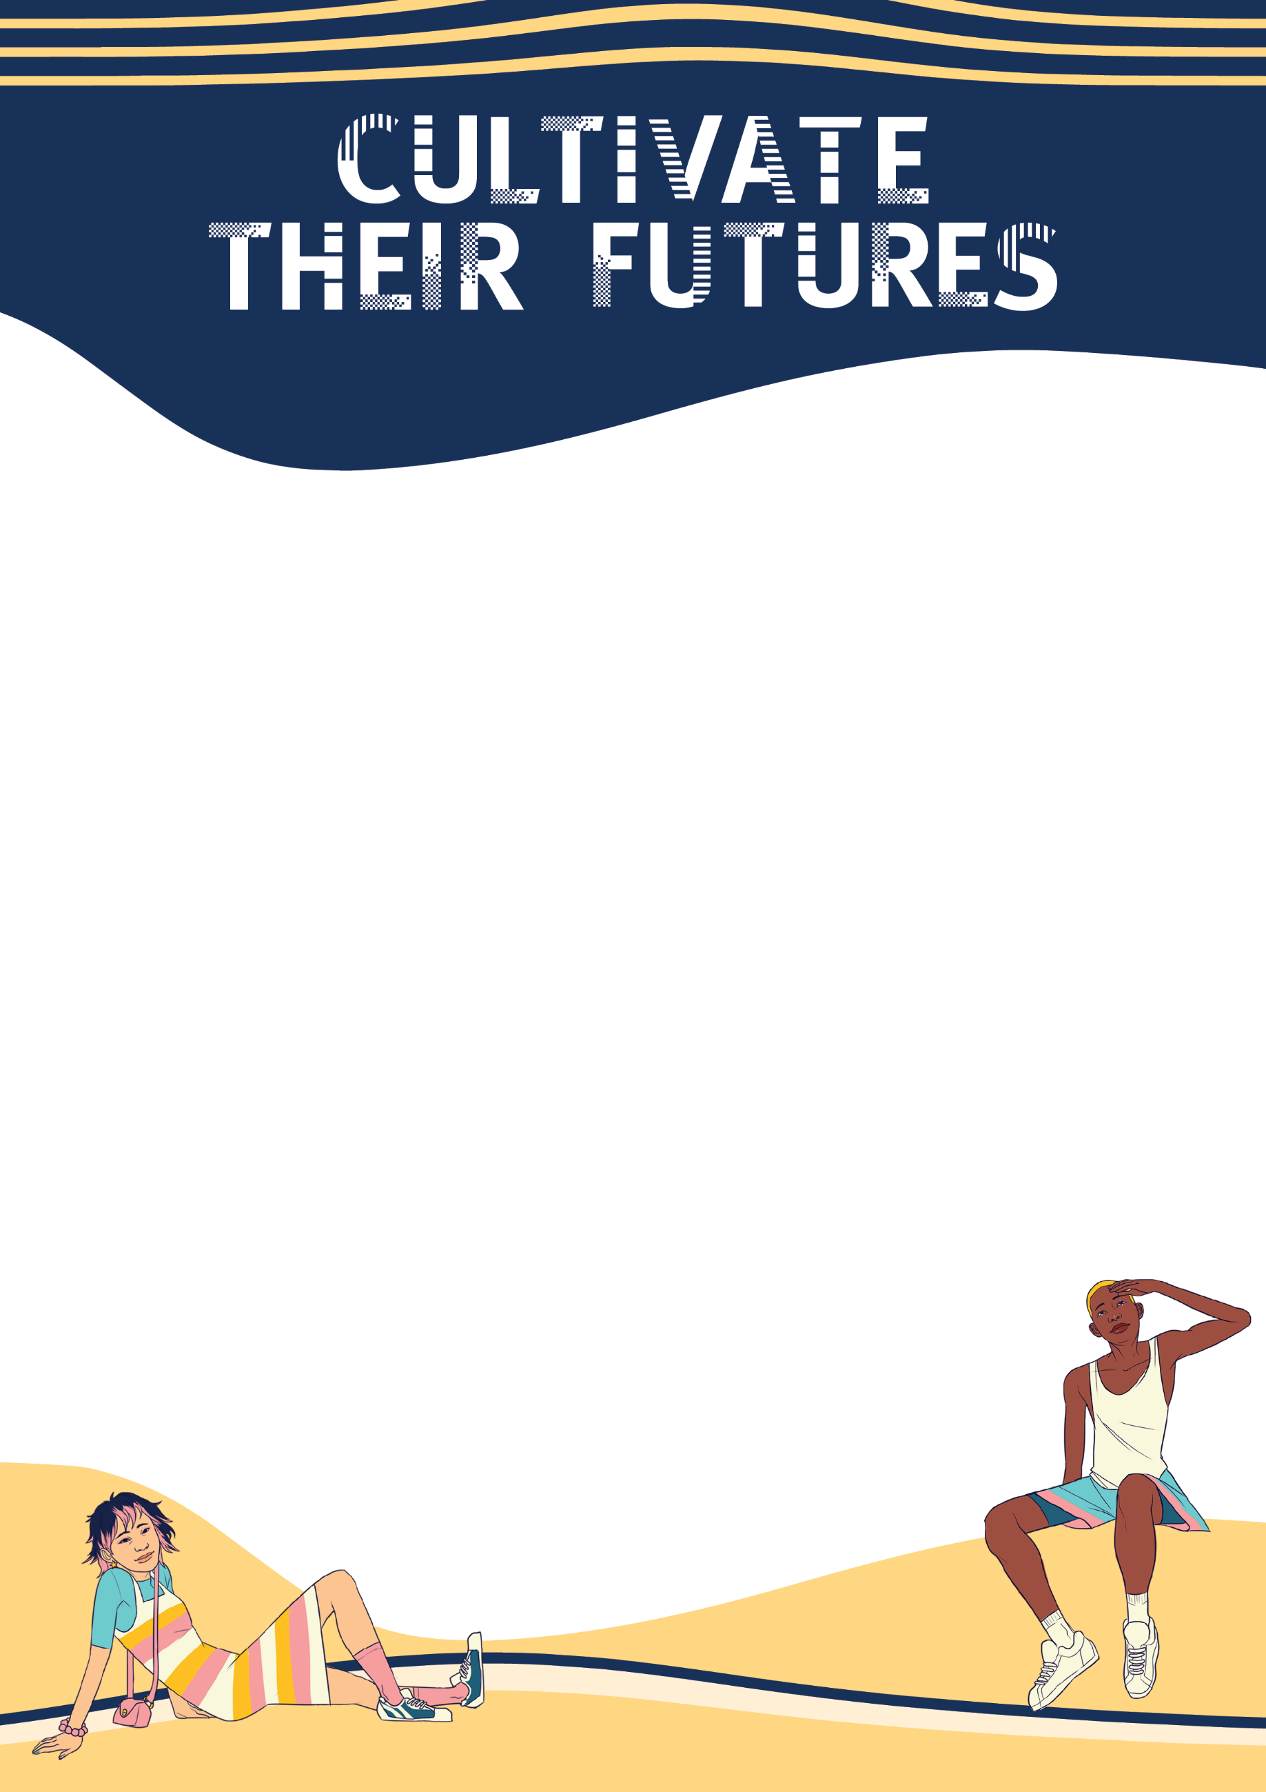

Cultivate their futures
Young people cultivate their futures supported by access to tailored opportunities that nurture their unique needs and interests.
This pathway emphasises the importance of creativity and connection in fostering positive social and economic outcomes. It supports young people to develop their skills and explore opportunities in both traditional and emerging industries, helping them to pursue careers they are passionate about. Additionally, it provides guidance for young Queenslanders through school-to-work transitions and encourages their active participation in the workforce.

Key 2024 highlights
- The State Library of Queensland facilitated 11,451 students to engage with its information collections, artefacts and resources.
- Queensland Treasury, in partnership with Queensland’s publicly owned energy businesses, established the Energy Jobs Portal as the one-stop-shop for energy jobs in Queensland. The portal lists available roles, highlights skills in high demand and energy technologies which are powering Queensland’s energy transformation. A Renewable Energy Gateway to Industry Schools Program targeting over 30 schools and 2,000 students across Queensland was also established. Check out the case study from Olivia below for more information.
- Arts Queensland facilitated 73 industry placements in arts and cultural organisations
to build capacity and grow Queensland’s creative and cultural workforce. Of those placements, 60% were provided to young people in the 18–29 age group.
- The Rural and Remote Schools Touring Service funded by Arts Queensland
delivered 25 weeks of touring activity in regional, rural and remote communities to
107 schools, engaging almost 14,000 students. Almost half of this activity (45%) was
in remote communities across the State.
- 60 girls across Queensland participated in the STEM Girl Power Program delivered by the Department of Education, including university and industry visits and developing and delivering National Science Week events across all eight regions.
- The Department of Education developed resources to support teachers to implement Version 9 of the Australian Curriculum which delivers STEM to students in Queensland state schools.
- The Department of the Environment, Tourism, Science and Innovation delivered the Engaging Science Grants program, funding 28 projects totalling almost $500,000 to support the delivery of STEM-based events, educational activities and science projects that inspire students to study STEM subjects, promote STEM careers and increase awareness of the Queensland scientific ecosystem.
- The Office for Youth hosted multiple co-design workshops with young people to inform the development of targeted pieces of work, including to co-design resources that will help them to understand and apply for government grants and funding opportunities.

Case Studies

2024 Young Researchers Program
The Young Researchers Program (the Program) invites selected regional and remote schools to participate in an online learning initiative and an onsite weeklong workshop. The 2024 Program included students and teachers from Cloncurry State School and Cairns School of Distance Education. The regional Young Researchers Program incorporates delivery of State Library of Queensland’s Live at the Library virtual research sessions, to introduce regional students to State Library’s resources, including images, digital stories, databases, and eBooks.
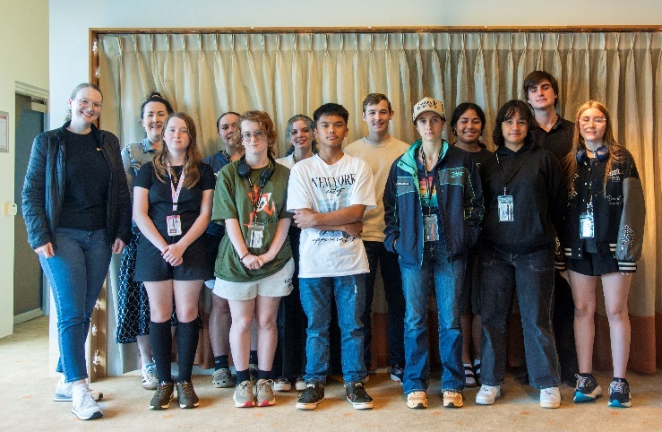
The weeklong paid practicum is held during the September school holidays at State Library and is open to students in years 9, 10 and 11 as well as teachers interested in chaperoning the experience. This project is made possible through funding from the Queensland Library Foundation.
In September 2024, the Program workshop offered participants the chance to develop critical research skills while engaging with State Library collections and specialist staff, as well as interactions with other cultural and educational institutions in Brisbane. Eleven students and two teacher chaperones from Cloncurry State School and Cairns School of Distance Education were afforded the exceptional opportunity to attend the workshop.
2024 Young Researchers Practicum cohort
The Program workshop included:
- dedicated research and learning experiences with State Library research professionals
- immersive experience with State Library of Queensland’s historical and contemporary Queensland collection items, including white gloves experiences with rare and precious content
- exploration of Anzac Square Memorial Galleries, Queensland Museum and Holocaust Museum
- a visit to Queensland University of Technology city campus to learn about university life
- cultural experiences including attendance at Brisbane Festival events, and
- travel, accommodation and meal costs.
The online learning component, delivered in the first semester, engaged 77 students and staff from the schools in tailored ‘Live at the Library’ workshops to build research and information literacy skills. This provided a participatory learning opportunity for all students in the relevant classes.
Highlights for the Young Researchers Program participants included:
- Research, information and literacy skills, delivered by professionals whilst having fun
- How to find, use and handle primary and secondary sources in State Library’s collections
- Building teamwork skills
- Learning collection handling and preservation skills
- Presentation and public speaking skills
- Life skills, such as how to navigate an urban/city environment (public transport, lifestyles) and managing their own travel allowance.
Participants shared enthusiastic feedback about their experiences. Many expressed excitement about exploring items from the collection and were fascinated by the chance to go behind the scenes to learn about the diverse roles of staff and their responsibilities at State Library. A particular highlight for participants was handling items from the collections and accessing the repository, which provided an in-depth view of State Library’s extensive collections.

Meet Olivia Leighton – a graduate with CS Energy
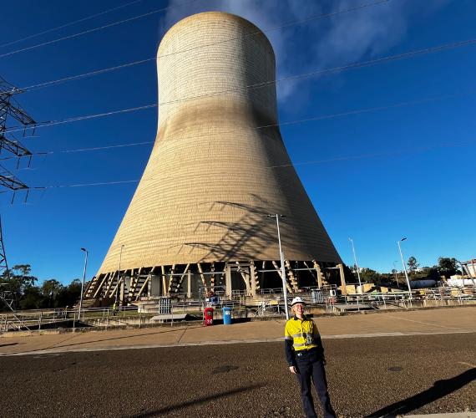
When Olivia Leighton joined CS Energy’s intake of university graduates in 2024, it was far from her first encounter with the government-owned energy corporation. “My stepdad is a Shift Operator Technician at Callide Power Station and has been for quite some time,” she said. “Growing up in Biloela, I’ve been to a few family Christmas events at the power station where several of our family friends also work.”
Like many students, Olivia wasn't sure what she wanted to do after high school. Some time spent at Callide Power Station helped set her on her path. “I really enjoyed chemistry and was leaning towards a career in agronomy, or something related to science," Olivia said.
Olivia standing outside Callide Power Station
“Then I did work experience in the chemistry lab at Callide Power Station when I was in Grade 11, and they had recently received new machines in the lab and were testing them out the week I was there. That was when I realised, I wasn’t interested in a science-based field, but the technology and innovation being used. I would write reports in school about drones or the innovation and automation in dairy farming, which is where I’d really say it all came together.”
Soon after graduating, Olivia moved from Biloela to Brisbane to complete a dual degree in Business and Information Technology at The University of Queensland. “It felt like I was going out a limb pursuing a career in technology, but I haven’t looked back since,” she said.

Natural progression
When the graduate intake for 2024 was advertised, Olivia's stepdad sent her a link about the program to see if she'd be interested in applying. “I had an initial interview with the head of the team I work with, and just hearing his enthusiasm about what he and his team were working on really left an impact. It was clear they were excited, and I knew this was an opportunity I wanted to get involved in.”
From university to the real world
When asked what her best experience has been to date in CS Energy’s graduate program, Olivia said there's no comparison to gaining real-world experience.

“In university, we work hard on projects for six months to a year and talk about how they could be applied in a real-life setting – but nothing compares to actually seeing it come to fruition," she said. “For the first time I’ve been able to not only come up with ideas and build on them but see how they’re going to work and how people will use them. It’s rewarding seeing a project come to life in a company setting where there are people depending on the platform to work intuitively 100 per cent of the time to help do their job."
Olivia with another graduate, Metabha Wanninayaka, in the Brisbane Office

Exploring new areas of the business
As part of CS Energy’s graduate program, Olivia and her fellow graduates can rotate through different areas of the business every six months. “The graduate program is a really great opportunity to get involved and to experience diverse teams and departments,” said Olivia. “I’m enjoying the work I’m currently doing in Retail Operations and might also look to spend time with Retail Projects or Digital & Technology in the future. All graduates are also given in-person and online soft skill training over the two-year period including psychological safety, effective communication, and tips for presenting. If you’re looking to join a company where you can build on your professional skills, gain experience, and get involved in daily operations from the start, I’d absolutely recommend applying for CS Energy’s graduate program,” said Olivia. “Some graduate programs are only six months and can be finished before it feels like they’ve started, while this one spans for two years and is a great amount of time to really learn about the company.”
If you want to find your dream job in energy like Olivia, click here.

Balnggarrawarra Melsonby Rangers Youth Engagement Program
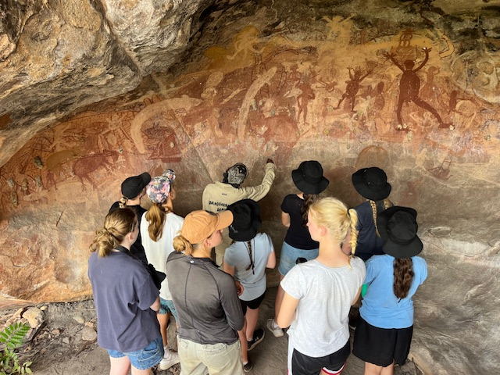
The Melsonby Rangers Youth Engagement Program aims to educate young people about Indigenous culture and land management practices. This initiative involves both local students and those from various parts of Australia, with over 300 student visits recorded in the past year.
Cooktown State School students learning about cultural heritage with a Melsonby Ranger
Youth engagement activities educate youth about Indigenous culture and traditional land management, build confidence and new skills within the Ranger team, offer work opportunities for Traditional Owners, enhance cultural awareness and understanding among young people from diverse backgrounds, and break down barriers and contribute to closing the gap between Indigenous and non-Indigenous Australians.
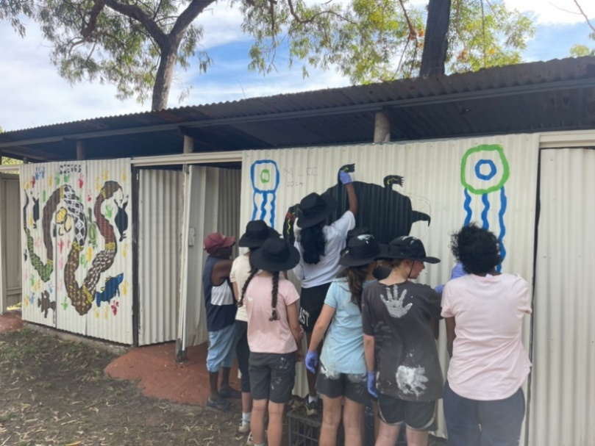
The Melsonby Rangers established partnerships with local schools and 'Red Earth' over the past few years and began hosting visits. They have developed a range of curriculum-aligned activities and immersion camp programs that allow students to learn about the work the Rangers undertake. Activities include cultural site management, fire management, weed control, erosion management, and ecosystem monitoring. This year, the Melsonby Rangers hosted over 300 student visits, with even more visits scheduled for 2024-25.
Red Earth students helping to paint a new shower block at Melsonby Ranger base after flood damage
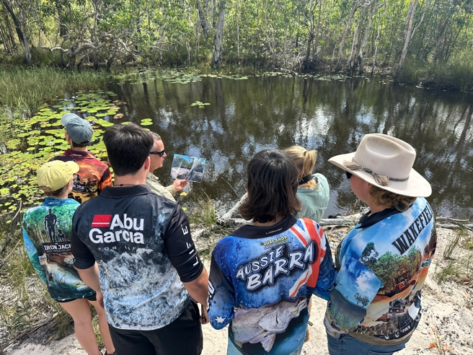
The Melsonby Rangers youth engagement has led to increased knowledge and appreciation of Indigenous culture among participating students. It has also enhanced skills and confidence among Rangers and Traditional Owners. Additionally, the program has strengthened community bonds as Traditional Owners participated in educational activities, generated greater interest from schools and organisations wanting to participate in future programs, and received positive feedback from students and educators, indicating potential for expansion. The benefits of the program are broad: environmentally, it has raised awareness and understanding of sustainable land management practices; culturally, it has contributed to the preservation and promotion of Indigenous culture and traditions; and socially, it has improved confidence, skills, and employment opportunities for Rangers and Traditional Owners.
Melsonby Rangers teaching Young Cape York Leaders team about water quality and wetland health
Lessons learnt from the program include a new understanding of the importance of flexibility in delivery to accommodate different learning styles and needs. The Rangers also now appreciate the value of building strong partnerships with schools and organisations to ensure success. Additionally, the Rangers have found a need for ongoing training and support to effectively mentor and educate youth.
The Melsonby Rangers are now supported by South Cape York Catchment’s Youth Engagement Officer, who will be able to support the team to strategically direct the Youth Engagement Program. The Team will continue to work with schools and the Red Earth program and look at ways to expand their program – perhaps with traineeships or placements.

Building Futures with the Workforce Connect Fund and HIA’s Advanced Apprentice & Employer Mentoring Program
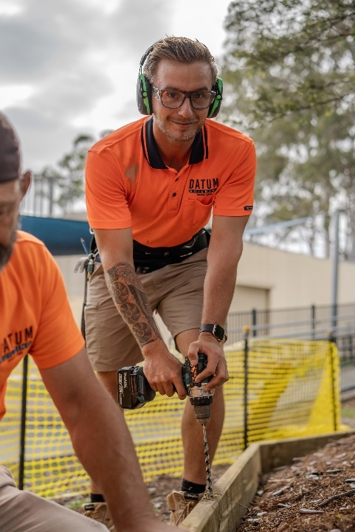
Housing Industry Association (HIA)’s Advanced Apprentice & Employer Mentoring Program is providing a holistic mentoring service to apprentices and their employers at risk of ending their apprenticeship agreements.
The program, which began in April 2023, is addressing the gap in support for apprentices and contributing to a more skilled, resilient and sustainable workforce.
Apprentices are benefitting from the program by being provided a unique support system outside of the traditional employer-teacher relationship, by accessing guidance, advice and a broader perspective on their careers and studies.
The program is also helping employers and educators by allowing teachers to focus on teaching and enhancing employers’ abilities to attract and retain talented apprentices.
Debbie Gridley, Chief Operations Officer, Datum Designs said “The HIA mentoring program came to us and it just seemed like such a good fit. Having people that I could trust that were professionals in their field has added another dimension to what we can offer our apprentices”.
Dylan, first-year carpentry apprentice
Dylan White, first year carpentry apprentice, Datum Designs said “It’s nice to talk to someone who isn’t a tradesman who we’re working with every day. To kind of get their opinion ‘cause they’ve been through it all as well”.
HIA will provide 500 apprentice mentoring places and 35 employer places. Both apprentices and employers will have up to 8 hours face-to-face, video link or telephone time per week with mentors to provide support and assistance in addressing any struggles or barriers being faced.

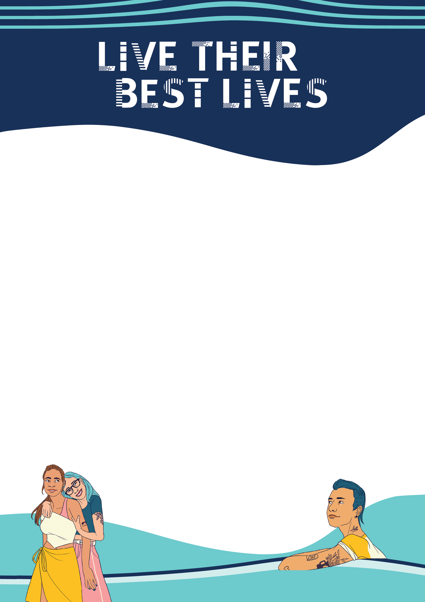

Live their best lives
Young people are enabled to live their best lives empowered and equipped with the information, resources and support they need to get there.
This pathway focuses on tailoring support to help young people build strong foundations for their lives, including secure housing, safety, access to quality physical and mental health care, trustworthy information, and opportunities to develop essential life skills for their future.

Key 2024 highlights
- The Department of Sport, Racing and Olympic and Paralympic Games delivered the Emerging Athlete Program, supporting 3,615 emerging athletes aged 10-19 on their pathway. Further, over 285,000 young people aged 5-17 have received a Fair Play Voucher of up to $200 to assist in removing the financial barrier to participate in sport across Queensland.
- Queensland Health delivered the Pathway to Cessation Program pilot, which aims to increase the uptake of smoking and vaping cessation support by students aged 12 -18, to 32 secondary schools across Queensland. A research agency was also appointed to determine attitudes and behaviours (including influences, barriers and enablers) that support quitting nicotine, with a focus on vaping.
- The Department of Housing and Public Works, including the Office for Youth, facilitated a targeted workshop with young people to better understand their housing needs and how information can be best tailored to improve their housing outcomes.

- The Department of Justice partnered with Queensland Cricket and the Brisbane Heat as part of a targeted community sports betting campaign “Forget the Bet. Enjoy the Game” to raise awareness about the potential risk and harm from sports betting and to address the normalisation of betting in sport, particularly among young Queenslanders.
- Health and Wellbeing Queensland delivered the first session of the ConnectingQ ECHO® Learning Series, "Effective Communication for Consumer Engagement," on 18 April 2024, focusing on strategies to engage diverse audiences, including young people, in health promotion. The session, attended by 42 professionals, contributed to the ConnectingQ platform, which now has 300 registered members.
- From 30 September 2024, rental law reforms commenced which include capping bonds to 4 weeks' rent, requiring fee-free rent payment options, ensuring claims against bonds are substantiated, and limiting re-letting costs based on the remaining lease term. These changes will help young people by reducing rental costs and providing fairer terms, making it easier to secure and maintain housing.
- Queensland Health implemented a broad range of new initiatives to improve health outcomes for young women and girls including:
  - the Women’s Wellbeing Line, a statewide service delivered through telephone, virtual and face-to-face appointments providing targeted support for women and girls with low acuity mental health issues across a range of conditions
  - two grants were awarded for research focusing on women and girls’ health
  - the PPEP-Talk Program focusing on periods, pain and endometriosis was delivered in high schools across the state
  - a total of 140 13HEALTH staff were upskilled in women and girls’ health topics
  - the 13HEALTH Way to Wellness expansion pilot was conducted, with 1,290 women on the gynaecology waiting list contacted and 164 of these completing the Way to Wellness Program.

Case studies

Buy Smart Program Expansion
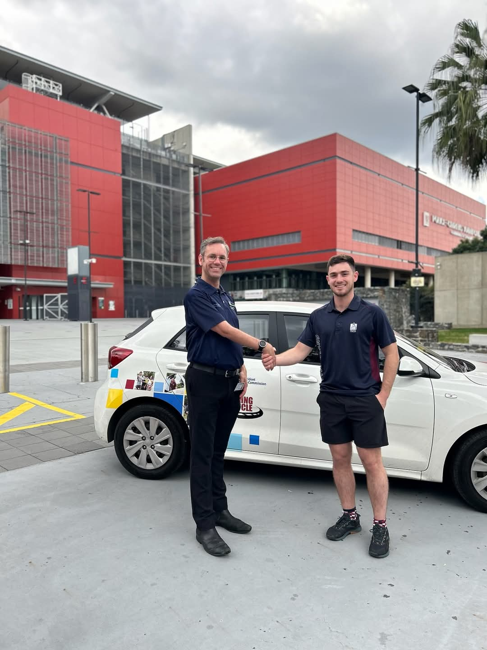
The Office of Fair Trading (OFT) engages with young people via the Buy Smart Program which aims to provide important consumer and financial literacy information to as many young people as possible.
The primary method for sharing this information is through teachers at school including in their classes. To assist, the OFT has a suite of resources for teachers, mapped to the curriculum and available free of charge on the OFT website. The OFT also offers classroom presentations by Fair Trading officers.
In 2024, the OFT commenced an expansion of Buy Smart to deliver consumer and financial literacy information through additional channels to reach the more vulnerable members of this cohort, including those who have disconnected from formal education pathways, those who are not living at home, and those living at home but requiring extra support.
OFT Community Engagement Officer Chris with PCYC Lang Park Manager Jordan after a workshop
As part of this expansion, the OFT trialled and refined a Buying a car workshop with the Police Citizens Youth Club (PCYC) participants of the following programs:
- Braking the Cycle – which supports young people by providing volunteer mentors who are experienced drivers, and the use of a registered vehicle to complete their logbook hours before taking their drivers licence test.
- Get Set for Work – which delivers training and support programs to unemployed or underemployed Queenslanders, focusing on a variety of vulnerable cohorts including young people in and transitioning from out-of-home care.
Feedback from early test sessions with participants and coordinators was highly positive. Students were deeply engaged and asked lots of questions, proving the importance and positive reception of providing ‘just-in-time’ information and advice. OFT is now working to deliver this workshop across Queensland with PCYC and other community organisations.

Top Blokes Foundation – Youth and Community Connection Project
The Top Blokes Foundation supports vulnerable young men from diverse backgrounds through a six-month mentoring program.
The Top Blokes Mentoring Program aims to strengthen social connection, mental health, and emotional resilience of culturally and linguistically diverse teenage boys, while improving engagement in the wider community.
Qualified youth workers are engaged as program mentors, who facilitate one-hour weekly workshops covering relevant topics.

The program is built into three distinct phases, covering Responsible Decision Making, Fostering Healthy Relationships and Embracing Diversity and Acceptance.
With funding support from the Queensland Government, Top Blokes Foundation started its mentoring program at five highly diverse schools in Brisbane, Logan and Toowoomba.
Each school identified a group of young men from diverse backgrounds struggling with their mental health at crisis level. Schools were seeing higher rates of mental health issues leading to violent and aggressive behaviours amongst their culturally and linguistically diverse male students.
Evaluation results from the first six months of this project showed amazingly positive results—82 per cent of participants reported improved mental health, 90 per cent of participants reported a reduction in risk-taking behaviours and anti-social behaviours, 90 per cent of participants reported improved relationships with friends and family and 87 per cent reported having better anger management strategies in place.
Young men and boys who have participated in Top Blokes programs have said:

“Top Blokes has helped me in every way. Mainly school, friends, understanding life and being a good man, taking care of myself.”
“Top Blokes has helped me with lots of mental challenges and made me more confident speaking with others.”

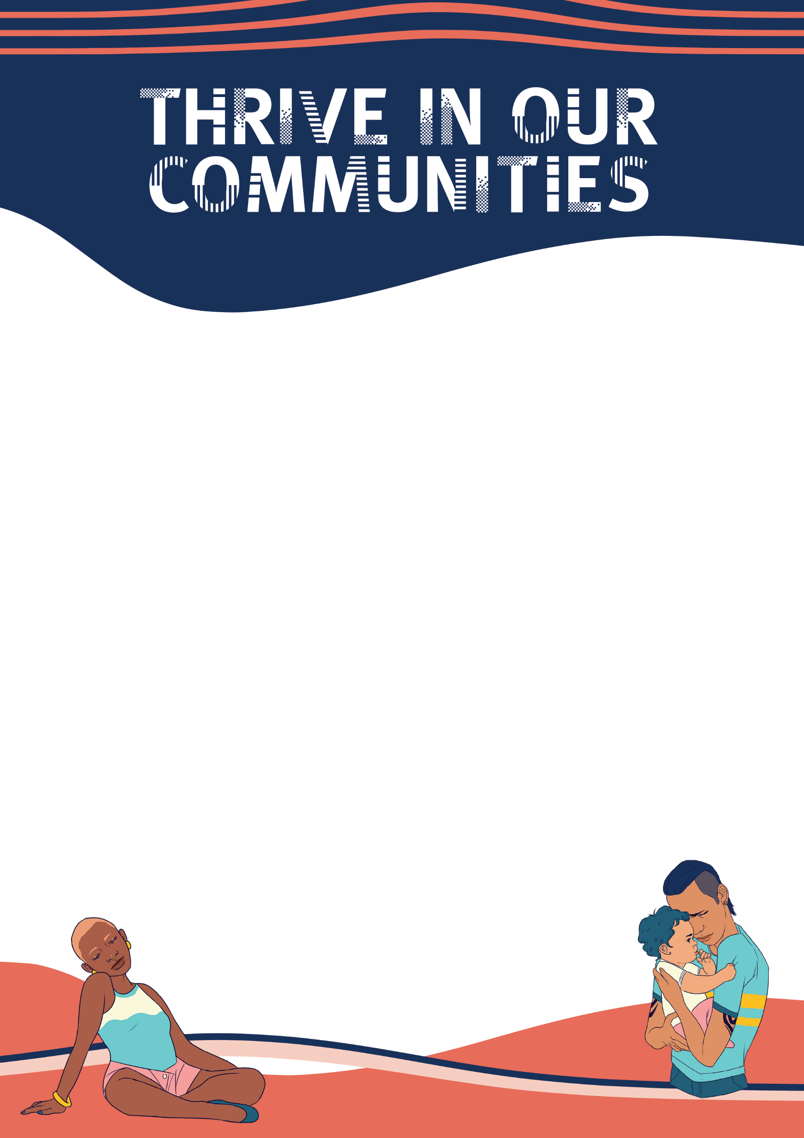

Thrive in our communities
Young people thrive in our communities knowing they are connected, celebrated and resilient.
This pathway highlights the importance of Queensland’s diverse communities and the positive impact that meaningful opportunities to drive change can have on young people, including those in rural, regional, and remote areas. It fosters connection by celebrating and embracing diversity, promoting alternative transport methods, and exploring systems related to science, climate change, and global issues, along with their long-term effects on communities.

Key 2024 highlights
- The Department of Primary Industries conducted 11 AgTech immersion events in Queensland schools over the past 12 months, including an immersive AgTech Meat Futures Camp in Toowoomba during which 98% of students reported a deepened understanding of engineering and technology careers in meat processing.
- The Department of Environment, Tourism, Science and Innovation delivered digital skills and coding training to 4,500 First Nations students across Queensland through the Deadly Coders Project, including developing and delivering 8 workshops in coding, design, robotics, app development, entrepreneurship and cyber security. The project was designed to raise awareness and interest in STEM, ignite enthusiasm for digital technology and build digital skills that the youth of today require for the jobs of tomorrow.

- The Office for Youth contracted two First Nations organisations to co-design and deliver the Together Helping Resilient Indigenous Voices Emerge (THRIVE) program, a pilot initiative in the Rockhampton region aimed at building the leadership skills of young First Nations parents and empowering them with the tools they need to scaffold the next generation of leaders.
- The Queensland Family and Child Commission received 230 applications for the Young, Black and Proud Scholarships (YBPS), awarding 125 scholarships to support First Nations young people to pursue their aspirations. In 2024, YBPS expanded Queensland-wide, and 374 scholarships have been awarded since 2018.

Case Studies

Queensland Indigenous Youth Leadership Program
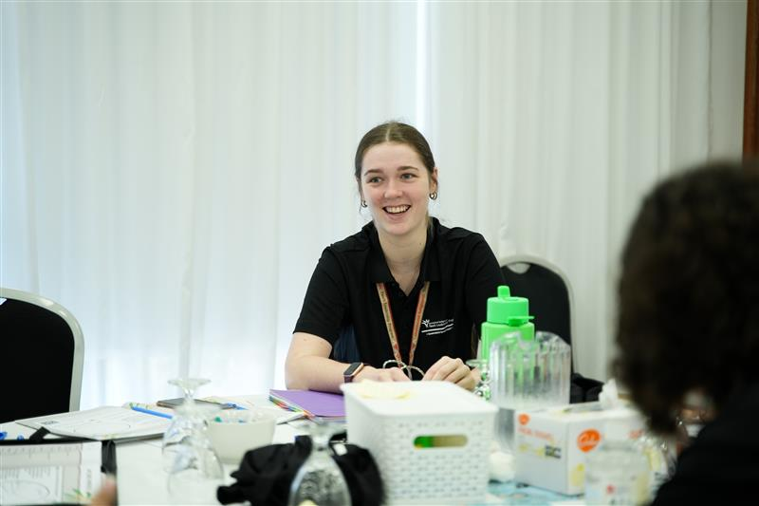
My name is Brianna Knight, and I participated in the Queensland Indigenous Youth Leadership Program (QIYLP) in 2021, attending again as a mentor in 2022 and 2024. This program fosters a community and culture of love, support and cultural safety like no other. It opened the door to many opportunities for me, one being membership on the First Nations Youth Strategy Engagement Group (FNYSEG) where I worked in consultation with the Office for Youth on the Young Queenslanders Strategy.
Brianna Knight during her time as a Mentor for the 2024 Queensland Indigenous Youth Leadership Program.

The opportunity to be a member of the FNYSEG was and has been one of the most critical parts of my life, becoming who I am, experiencing what is available, and being connected to other opportunities that present.
Being a part of the FNYSEG has increased respect and trust in government organisations, through the total trust and respect that has been provided to me throughout the entire experience by the Office for Youth team. I feel more confident and sure of myself and I know that there are people that are going out of their way to listen to and advocate for the voices of young people.
QIYLP has not only made an exponential difference for me, but also for many people that I know through the program. My passion and motivation to make change in my community is stronger and more present than ever after attending QIYLP. Attending again as a mentor this year gave me the opportunity to develop relationships and a network to support me in every journey that I take. I know that the Office for Youth and the QIYLP support team will always do their best to support us in our ventures and I hope that when I am in a position to, I will be able to leverage this support to run meaningful and relevant life skill programs within schools, and make a difference to students living in rural areas that may not have the luck to be in a position to learn these necessary skills.
The FNYSEG has linked myself and other members to a large range of other opportunities to work in consultation with other Government organisations and share our thoughts and opinions on policies, programs and services and how they are from the ground perspective, in real life instances.



