kicbox user guide
For young people
Version 2.0 - February 2019

Version control

Published | Version # | Author | Description of change/revision
January 2019 | 2.0 | DCSYW | Updated to accompany launch of kicbox promotional video.

Contents
Getting started with kicbox 4
What is kicbox 4
How to get kicbox 4
Accessing kicbox 4
Desktop (laptop/computer) 4
Mobile phone or a tablet 4
Setting up your profile 5
Navigating the app 6
My life 8
Storyline 8
Life Facts 10
My future 12
Important documents 14
Contact and support 15
My profile and settings 17
Calendar 20
Noticeboard 20
Who can contribute to kicbox? 21
Being safe online 22
Facts 23
Important legal Information 24
Frequently asked questions 25

Getting started with kicbox

What is kicbox
Having somewhere to store your personal information when you are in out of home care can be a bit tricky.
kicbox helps you to store your personal information such as photos, videos and documents, in one secure place. No matter where you are, you can record the important things and look back on them over time.
kicbox also provides more contemporary ways to communicate and connect with your Child Safety Team. Features include:
- a storyline of important events and memories in your life
- somewhere to store important documents, such as your birth certificate
- somewhere to record your goals and visions for your future
- the ability to record how you’re feeling
- a list of support contacts
- ways to contact your Child Safety worker – via direct private message or email

How to get kicbox
Your Child Safety team will help you get setup. The first step will be having a discussion with you about the appropriate use of kicbox and being safe online.
You will require a current email address to be able to access kicbox.
Your invitation will be sent to your email and this email will have a link to set up your kicbox username and password.

Accessing kicbox

Desktop (laptop/computer)
- Open a web browser (Internet Explorer, Chrome etc.)
- Type in the following address:
- https://kicbox.communities.qld.gov.au
- Log on to the application using your email address and the password you created.
- Add it to your favourite’s toolbar so that you can easily find it next time.

Mobile phone or a tablet
- You will need to register for kicbox before you can download the app.
- Go to the app store for Apple devices or the Play Store for Android devices.
- Search for kicbox
- Download the application
- Login using your email address and the password you created.

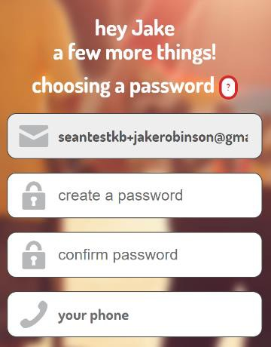

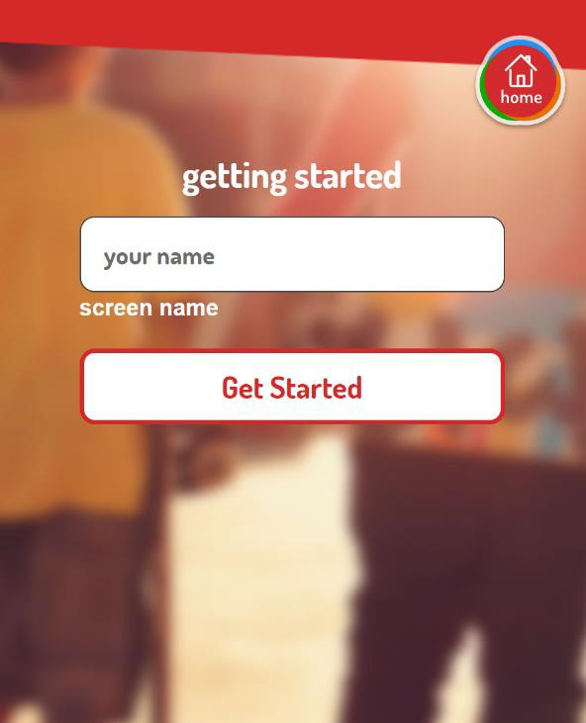Setting up your profile

Fill in your preferred screen name and then select ‘Get
Started’.
On the next screen you will need to:
- Create a password.
Your password needs to contain at least 8 characters and must include at least three of the following:
  - lower case letter (a-z)
  - upper case letter (A-Z)
  - number (0-9)
  - special character (!@#$%^&*)
Make sure you memorise the password you set, but be careful to keep this private and do not share it with anyone.
- Update your phone number, if required.
- Read through the Terms of Service and Privacy Policy and click sign up.

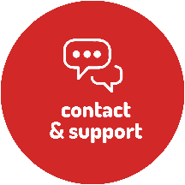

Navigating the app
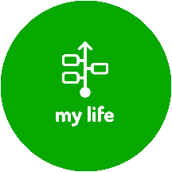
kicbox has four main navigation icons:

My life helps you to record your journey in care by uploading photos, describing
particular events and recording your thoughts and feelings. In this section you can navigate to:
- Storyline
- Life facts
My future helps you to visualise your life goals through words and images. In this section you can navigate to:
- Create new goal
- Goals I’ve made
Important documents provides a single place for storing all your documents, such as your birth certificate, certificate of Aboriginality, or school reports.
Contact and support lets you connect with your Child Safety team by sending secure and private messages.
In this section you can navigate to (if the detail is available):
- Your CSO’s profile (this is where you can find out how to contact your CSO)
- Community visitor
- Directory (details for support)

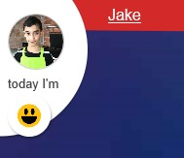
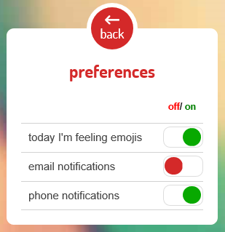

There are also some other key navigation areas around the screen.
My profile
Clicking on your our name or photo at the top left of your screen will take you to your profile information.
- Clicking on your name will take you to my profile & settings menu.
- Clicking on your photo will take you to change your profile photo or select an avatar.
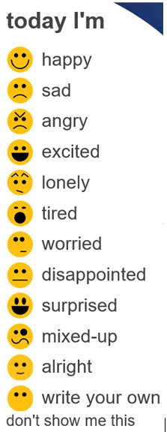 |  |  | Today I’m - mood Indicator  Select the mood emoji that represents how you are feeling at the time. This will be recorded onto your digital storyline.  If you don’t want to use this feature you can click on the don’t show me this at the bottom. If you select the ‘don’t show me this’ button you will be taken to the preferences screen. See below for more information.
Preferences
This screen allows you to customise some of your settings on your kicbox app. Clicking on the buttons will make them change to the opposite colour with red indicating off, green indicating on.
You can also access the preferences from the settings menu.
 |  |  | This icon will take you to the Calendar.
 |  |  | This icon is a short cut to existing chat messages.
 |  |  | This icon will take you to the Noticeboard
This icon displays the number of updates since you last logged in.
If there are no updates and you click on this icon, it will take you to your storyline.

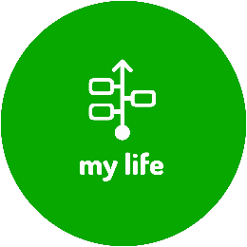
My life
My life helps you to record your journey in care by uploading photos, describing particular events and recording your thoughts and feelings.

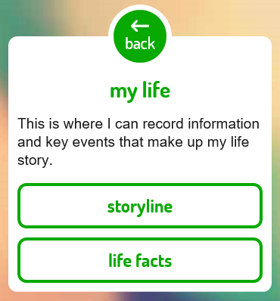Once you select ‘my life’ on the kicbox application, you will be directed to this screen.
There are two sections under the my life button:
  - Storyline
  - Life facts

Storyline

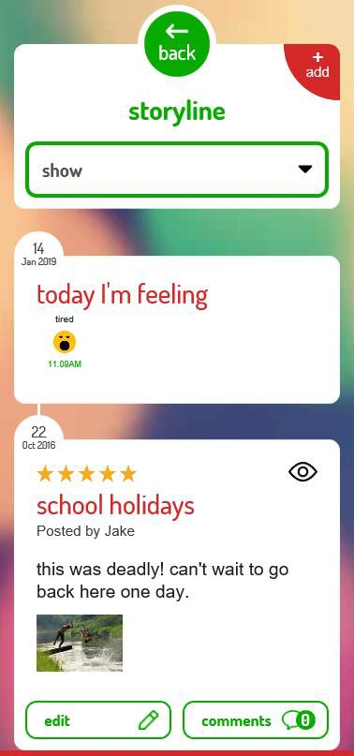The storyline is where you are able to record different milestones and memories in your life.
  - Select + add in the top right corner to create a storyline post.
  - You can upload images and videos onto your kicbox storyline.
  - When you change your mood indicator, this will be reflected on your storyline.
The digital storyline can also be contributed to by staff if they choose to upload photos/videos, milestones or memories.
Carers are also able to contribute to your kicbox digital storyline however they cannot see any of your kicbox information or storyline posts.
If there is something on your storyline you don’t want to see, tap the eye at the top right hand corner of each post and it will hide the post. You can always choose to show it again later.

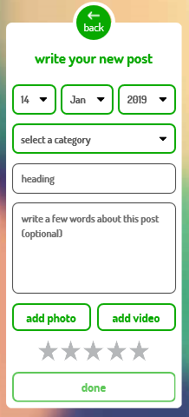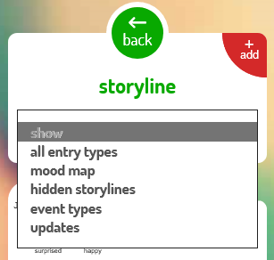

Complete a storyboard post by completing the suitable fields:
- Select the date of the memory or image you are uploading
- Choose from one of the categories
  - Child safety
  - Education
  - Family and culture
  - Friends
  - Health
  - My favourite things
  - Special moments
  - Where I live
  - Work
  - Other

- Enter a heading that describes the post you are about to upload
- Write a few words about the post
- Select to add a photo or video, if suitable
- You can then choose to add a star rating for the post by clicking on the stars
- Select done
You can filter your storyline posts by several categories. If you select one of the different options listed, you will only see the storyline posts under that category.

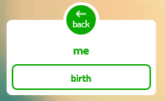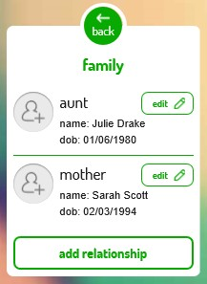

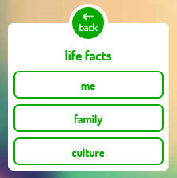Life Facts

Life facts is where you can enter information about yourself under
three categories:
- Me
- Family
- Culture
Me
The only category that falls under me is the ‘birth’ section. This is where you are able to complete all the details of your birth, where possible. You are also able to download your birth certificate from this page if your CSO has uploaded it into kicbox.
Select done when you have completed the information you wish to include.
Family
Selecting the family button will take you to your relationships recorded in kicbox.
Select the edit pencil to add a photo to the relationship. You are unable to change any of the other information.
Select add relationship and complete the fields to upload your own relationships, as necessary. Your CSO will see the relationship that
you have added.

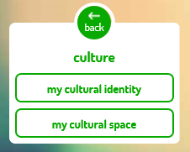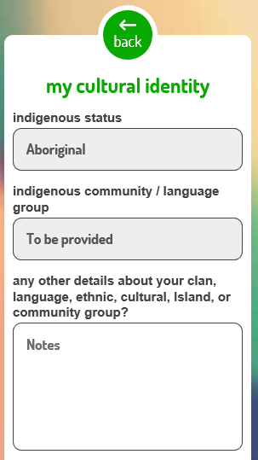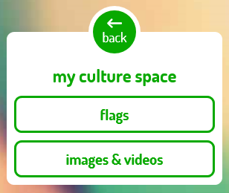

Culture
Two categories fall under the Culture section:
- My cultural identity
- My cultural space
My Cultural Identity is where you can input information about your indigenous status, community/language group and any other relevant details you wish to include.
This screen also allows you to be able to locate your mob on the David R Horton Aboriginal Australia Map.
My Cultural Space is where you can locate information and facts about different aspects of your cultural identity.

Flags – provides information and history on the Aboriginal, Torres Strait Islanders and Australian flag.

Images and Videos - provides a location for you and your CSO to record anything of significance about your culture (welcome to
country or a story from an elder)

My future
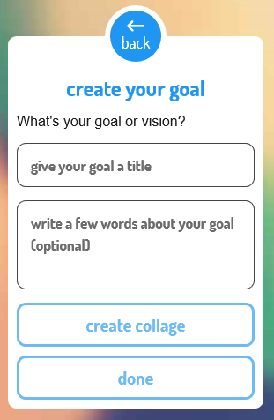My future helps you to visualise your life goals through words and images. There are two options to choose from: create new goal and goals I’ve made.

Create your goal
There are several different categories that you can choose to make a goal under:
- Education
- Career
- Place to live
- Relationships
- Health
- Living skills
- Money
- Sports & Interests
- Experiences
- Travel
When you select each category you will be asked to enter a title and write a few words about your goal.
You will also have the option to create a collage.
Step 1  Select the collage shape you wish to use. | Step 2  Upload photos from your camera roll to complete the collage.
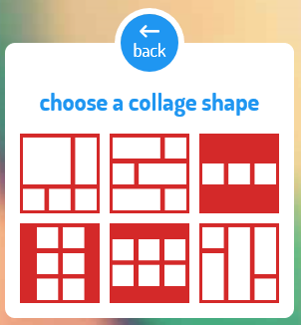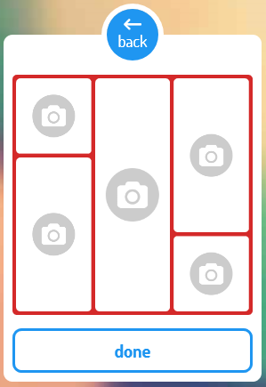

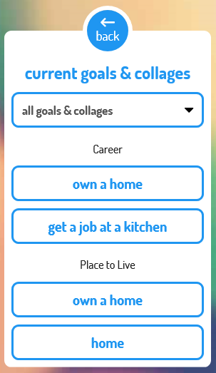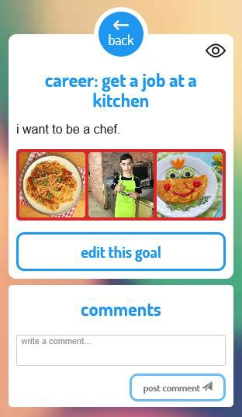

Current Goals & Collages
This is where you can locate all of the goals and collages you have previous located.
You are able to filter through your goals using the drop down list at the top of the screen.
Select the goal category that you are looking for and kicbox will only display this section.
Select the goal you are wanting to view.
From this screen you are able to edit and/or comment on your goal.
You are also able to hide the goal by clicking on the eye at the top right corner. Don’t worry, you can show it again later if you want
to.

Important documents
Important documents provides a single place for storing all your documents, such as your birth certificate, certificate of Aboriginality, or school reports.

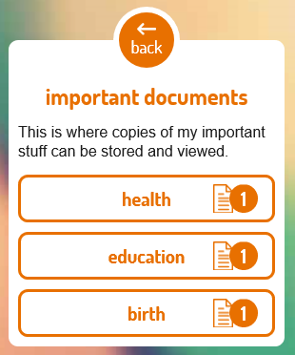Your Child Safety team are able to upload important documents into your kicbox profile for you to access when required.
The important documents come under several categories:
- Birth
- Family
- Education
- Culture
- Child Safety
- Health
- Travel
- Money Stuff
- Work
- Other
Click on the category to locate and select the document you want to download.

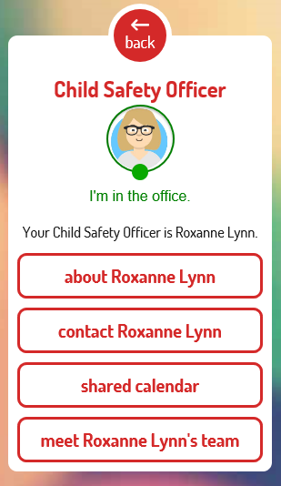

Contact and support
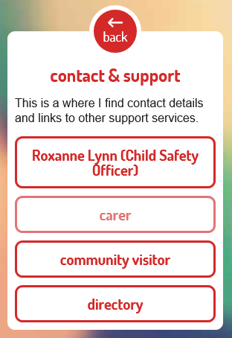Contact and support lets you connect with your Child Safety team by sending secure and private messages. The support directory provides access to several resources and organisations in one location.

The contact and support tab has 4 categories:
- Child Safety Officer allocated to you
- Carers Name
- Community visitor
- Directory
Note - If an area is greyed out, there is no information recorded under that category as illustrated in the carer section to the left.
The Child Safety Officer (CSO) button will take you to view your allocated CSO is and learn more about them.
- About Roxanne Lynn will take you to your CSO’s profile including a short introduction about who they are and what the enjoy doing.
- Contact Roxanne Lynn will direct you to your kicbox chat with Rachelle.
Note - please discuss suitable response timeframes with your CSO.
- Shared calendar is where you can input and request time to catch up with your CSO.
- Meet Roxanne Lynn’s team will show you who Rachelle works with. They might contact you from time to time if Rachelle is
away.

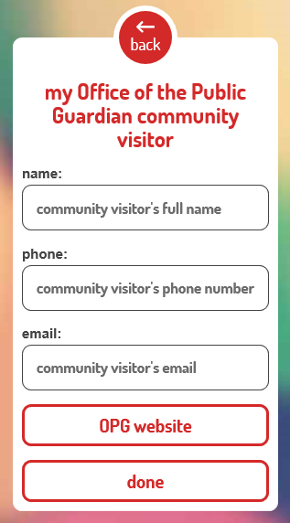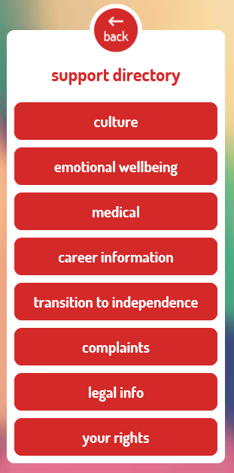

The community visitor section can be completed by you.
Enter in the required details into the fields and select done. This will save for you to refer to in the future.
The OPG website button will direct you to the Office and of Public Guardian website where you can find lots of information and people to speak with, if necessary.
The support directory provides internet links and contact details to important support agencies, legal information and other relevant organisations.

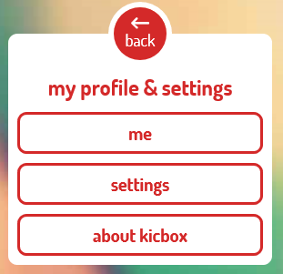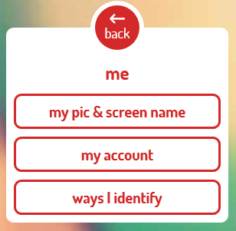

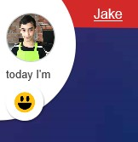My profile and settings

Click on your name at the top left hand side of the screen to be taken
to your profile and settings options within kicbox.
Within profile and settings there are three categories to select from:
- Me
- Settings
- About kicbox
The ‘me’ category is where you are able to input information about yourself.
- My pic and screen name is where you can update your chosen screen name and upload a photo of yourself or select an avatar.
- My account is where you can add or update your phone number. Your email address is also displayed there however you CSO will need to update it.
- Ways I identify is where you can record information regarding your culture, gender, sexual preference or disability.

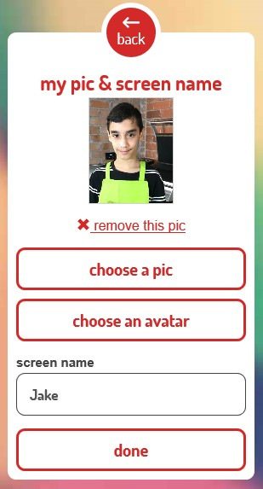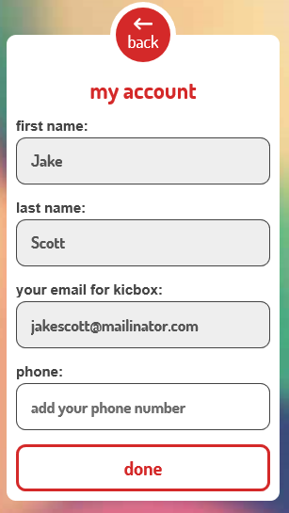

My pic and screen name is where you can update your picture or
choose an avatar for your kicbox profile.
You can also update your screen name in the free text field. Select done when you have made your changes.
The information recorded in my account mostly needs to be changed by your CSO. You will notice the areas that are greyed out you are unable to change. If you for any of the information to be changed, please let your CSO know.
You are able to input your phone number into the white field at the bottom of the screen. This will allow your CSO to have your current contact details if they need to get in touch with you.

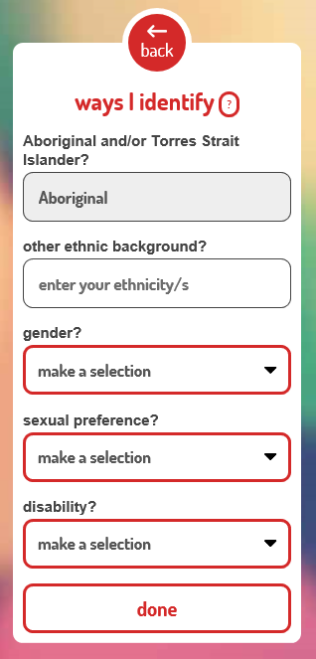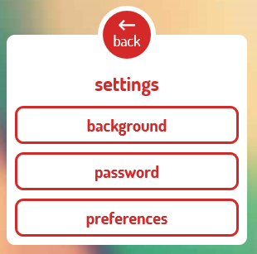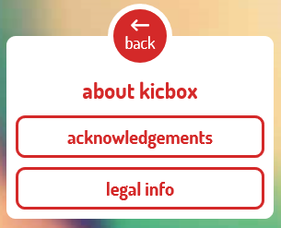

Complete the ways I identify screen with as much or as little
information as you like.
When you are happy with what you have entered, select done to save your information.
The ‘settings’ category is where you can make changes to your kicbox account.
Background allows you to choose a new look and feel of your kicbox profile.
Password is where you can change your password by sending an email to your registered email address.
Preferences allows you to turn off and on different features of kicbox.
The ‘about kicbox’ section displays acknowledgements and legal information about kicbox.

Calendar
Clicking on the calendar icon on the bottom left of the screen will open your shared calendar. Both your CSO and you can add calendar appointments.

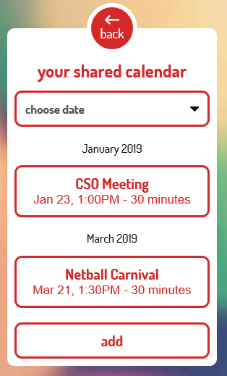Selecting the calendar icon will take you to your shared calendar screen. This screen will have all of the calendar appointments that you have added as well as those that your CSO has added.
To add a calendar invite, select add and complete the appropriate fields.
Your CSO will also be able to see any of the calendar appointments you make.

Noticeboard
The noticeboard icon at the bottom of the screen will notify you if there are any posts on the noticeboard. Posts are made by Child Safety staff that are using kicbox.

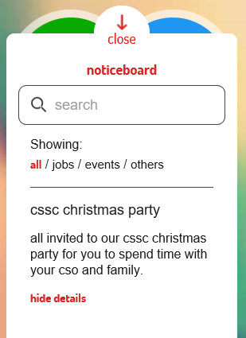There are four categories that the noticeboard can be divided into:
- All
- Jobs
- Events
- Others
You are also able to search for a specific event using the free text search bar at the top of the screen.

Who can contribute to kicbox?
Note: It is important that you know that whilst your carers may be able to contribute to your kicbox storyline if they have the Carer Connect application, they are not able to access kicbox or see any of the information that is displayed.
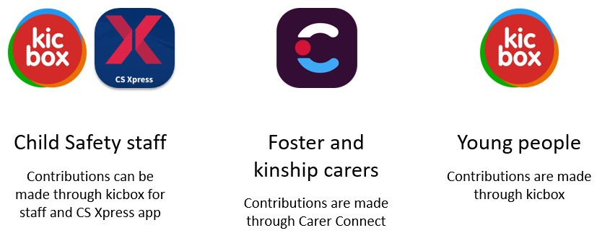

Foster and kinship carers can contribute to a child’s digital life story through Carer Connect.
- Carers can’t access kicbox – they can only contribute to it through Carer Connect.
- Currently, this functionality is only available for primary placements. A solution is being explored for licenced care services and respite placements.
- Carers can only contribute while the child/young person is in their care. When a placement event ends, they will no longer be able to make contributions.
- After a placement ends, the Carer will only see what they’ve contributed, but won’t be able to add, delete or change contributions.
- Carers won’t see what CS staff or a young person has posted in kicbox.

Child Safety Staff can contribute to a child’s digital life story through kicbox for staff and CS Xpress app.
- All children that have been in care automatically have a kicbox account.
- CS staff can contribute to an allocated child’s kicbox account using the CS Xpress or kicbox for staff platform.
- Once a young person has been invited to use the app, allocated CS staff can communicate with them through these platforms.
- CS staff will be notified of any contributions made by carers and/or YP using the app, for children on their case load, and can delete/modify posts.

Young people can build their own life story by contributing directly through the kicbox app.

Being safe online
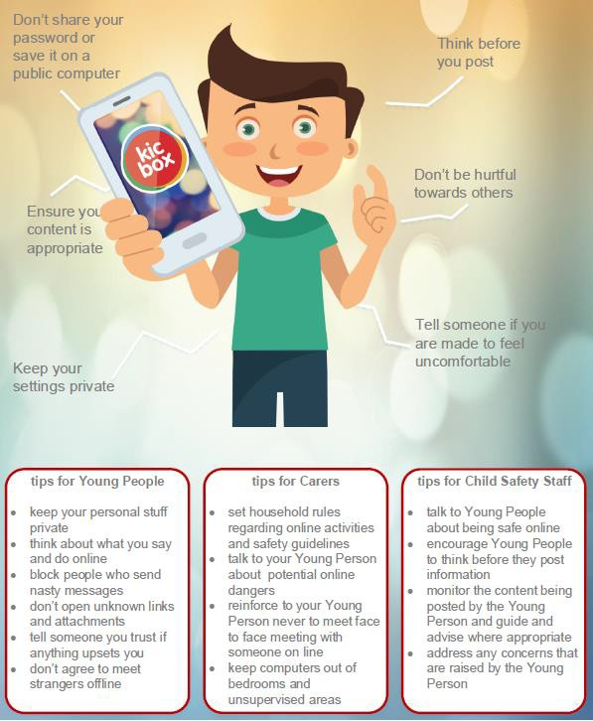

Facts
- kicbox does not replace face to face contact between you and your Child Safety team.
- kicbox utilises secure, modern technology to ensure that your personal information is safe and can only be seen by you and your Child Safety team.
- kicbox is different to Facebook. It is a secure place to store important documents and information that you may not wish to share publicly. It is also a way for you to communicate and share private information with your Child Safety team.
- Any content uploaded into kicbox that is inappropriate, discriminatory, disrespectful, or illegal will be removed from kicbox and your access may be temporarily restricted.
- Your Child Safety team will access kicbox on a regular basis and will respond to any communications within 48 hours during the working week.
- You will be able to see the availability of your Child Safety Team during working hours.
- You will also be able to see if your Child Safety team is out of the office for any period of time (such as on holidays) and an alternative contact.
- If you have any issues accessing or using the kicbox application, please discuss it with your Child Safety team.

Important legal Information
We want kicbox to be a safe, supportive and respectful space for you, and those who support you, to record memories of your life journey while in out of home care.
To help us do this, you agree that the information you record in kicbox will:
- be information you believe is true
- be respectful of other people’s privacy
- be material you own or you are allowed to use
- not be obscene, offensive, hateful, abusive, threatening or otherwise objectionable
- not promote discrimination, and
- not be illegal or evidence of an illegal act.
Any material that does not meet with the rules above may be removed from kicbox.
We regard the information in kicbox as your information. We will treat your personal information in accordance with the Information Privacy Act 2009.
However, the Department may use information in kicbox if it is necessary to do so for your protection or wellbeing.
The Department will only disclose information captured in kicbox to others if we are authorised or required to do so, for example:
- if you post something that indicates that you or someone else has been harmed or is at risk of being harmed, we will notify the police or other relevant authorities
- where information in kicbox is relevant to where you should live, we may include that information in court documents to inform the Magistrate when they consider your safety
- if you consent
- if we are required to do so by a court order or under a law, or
- to assist a police investigation.

Frequently asked questions
What if I tell my CSO I have been hurt by someone?
CSOs have lots of legal things they have to follow. One of those is that certain people – like the police – need to be informed about actions where an offence may have occurred. The CSO is also responsible for ensuring you are safe. The CSO would talk to you and people around you to make an assessment about this.

What if I tell my CSO that I don’t want to live with my parents or Carer?
Your CSO will need to record this information in a case note, as well as details of any other actions they have taken to follow up on this. A CSO may use the information in a court application about your child protection order. If this happens, a Magistrate could ask to see where it was first written, in which case your parents or Carer may see this information.

What if someone other than me asks to see my files?
People who request information formally through the Department can generally only receive information about themselves. Therefore, the information you put in to kicbox (which is about you and your life) is unlikely to be provided to anyone else.

What if I upload a photo onto kicbox that shows me doing something illegal?
Your CSO is able to see all your information in kicbox. This is important to ensure that you are safe. If you upload a photo of you doing something illegal or that is proof of an illegal act, your CSO is required by law to pass the evidence on to the police or relevant authority.

What happens if I am abusive about another person on kicbox?
If you post something on kicbox that is abusive, threatening or hurtful about another person - whether it is a parent, Carer or Departmental staff member - then your CSO will be required to record this information as a case note and remove the offending material from kicbox. In some cases, you may have your access to
kicbox limited to ‘read only’ for a period of time.

