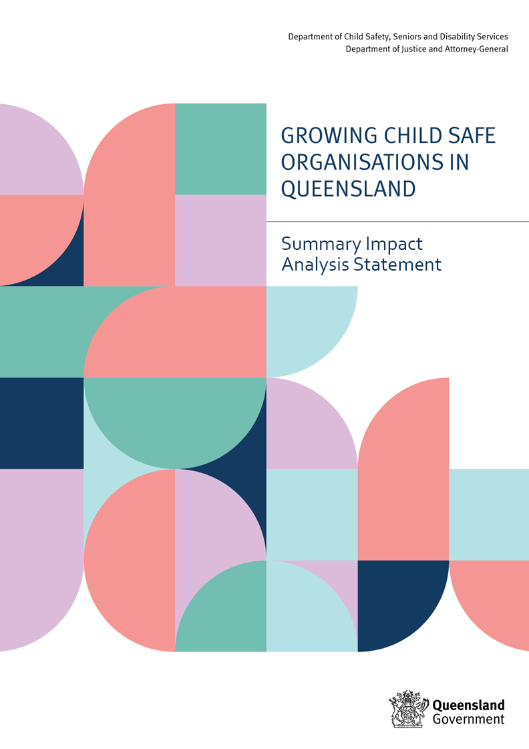

Summary Impact Analysis Statement

Details

Lead departments | Department of Child Safety, Seniors and Disability Services (Child safe standards)  Department of Justice and Attorney-General (Reportable conduct scheme)
Name of the proposal | Growing Child Safe Organisations in Queensland
Submission type | Summary Impact Analysis Statement
Title of related legislative or regulatory instrument | Child Safe Organisations Bill 2024
Date of issue | 5 February 2024

What is the nature, size and scope of the problem? What are the objectives of government action?
The five-year Royal Commission into Institutional Responses to Child Sexual Abuse (Royal Commission) found that tens of thousands of children experienced sexual abuse in institutional settings and that the sexual abuse of children has occurred in almost every type of institution where children live, learn and play. The Royal Commission concluded that many organisations entrusted with the care of children failed to protect them and keep them safe.

In order to improve the safety of children in institutions, the Royal Commission recommended that state and territory governments require the implementation of 10 child safe standards (CSS) and establish nationally consistent reportable conduct schemes (RCS). The proposal for Growing Child Safe Organisations in Queensland responds to these recommendations by establishing, through a legislative framework, an integrated child safe organisations (CSO) system comprising a CSS scheme and an RCS, located in a single oversight body.

Identifying the problem – risks to children and young people of institutional abuse
Children and young people in Queensland institutions
Queensland is home to more than one million children and young people under the age of 18, many of whom interact with various organisations throughout their childhood, including, for example, early childhood education and care, schools, health services, disability services, sport and recreation clubs and religious institutions. While the exact number of organisations that interact with children in Queensland is unknown, it is estimated to be significant at approximately 40,000 organisations.

Prevalence of child maltreatment in Queensland institutions
The Royal Commission concluded that while the prevalence of institutional child sexual abuse is significant, it was not possible to determine the true incidence of child sexual abuse across Australian organisations due to limited data and under-reporting. It recommended a nationally representative prevalence study (the Australian Child Maltreatment Study (ACMS)) which found that 40.2% of Australians aged 16–24 years old have experienced more than one form of child maltreatment, and 62.2% of all Australians have experienced at least one type of maltreatment as a child in any setting. As these figures include exposure to domestic and family violence, which does not occur in an institutional setting, the departments (Department of Child Safety, Seniors and Disability Services and the Department of Justice and Attorney-General) did not use the ACMS in the cost-effectiveness analysis in the Decision Impact Analysis Statement (DIAS) as a measure for estimating institutional maltreatment in Queensland. However, as the first comprehensive prevalence study in Australia, the ACMS highlights the magnitude of the problem that CSS and an RCS (the recommended government action) seek to address.
For the purpose of the impact analysis, noting the limited contemporary research and data available, the departments drew on a combination of sources to produce an estimate of approximately 12,148 cases of institutional child abuse occurring in Queensland every year. A full explanation of the prevalence estimates used in our cost-effectiveness analysis can be found in Part 1 of the DIAS.

Impacts of child abuse
Child abuse in institutional settings, including poor responses from organisations, has profound, lasting adverse impacts on people who experience it, as well as their networks, communities and broader society. The impacts of institutional child abuse are lifelong and devastating and can affect mental health; interpersonal relationships; physical health; sexual identity and behaviour; connection to culture; spirituality and religious involvement; and interactions with society. Childhood trauma can also negatively affect a person’s education, social participation, economic security, ability to secure and maintain employment and housing, and these impacts can be intergenerational. For Aboriginal and Torres Strait Islander peoples, impacts are exacerbated by the ongoing impact of dispossession and colonisation.

The Royal Commission found the estimated cumulative economic impact of child sexual abuse on wider society runs into the billions, with direct and indirect effects on social, cultural, public health and economic participation outcomes. The most significant costs to society relate to government expenditure on health care, increased need for government support and services, child protection, and crime. It is estimated, for the purposes of cost-effectiveness analysis, that the approximately 12,148 annual cases of child maltreatment in Queensland organisations have a total annual social cost of over $7 billion. For further detail on the cost-effectiveness analysis of the impact of incidents of child maltreatment, see Part 1 of the DIAS.

Objectives of government action
The Queensland Government’s goal is to prevent abuse and reduce the severity of harm children experience in Queensland institutions. To achieve this, there are two primary objectives of government action:
- To ensure the safety and wellbeing of children accessing services or facilities in Queensland institutions, recognising that no amount of abuse is acceptable, and all children deserve to grow up safe from harm.
- To ensure children who are at risk of experiencing, or have experienced, abuse in institutional settings are supported early, in a trauma-informed and appropriate way.

For more detail on the objectives of government action see Part 2 of the DIAS.

What options were considered?
Options for implementing child safe standards in Queensland
Option 1 – Maintain the status-quo
Existing child safe approaches would continue with no new legislation or regulation introduced to facilitate or oversee implementation of the CSS. Organisations would continue to voluntarily implement CSS, likely with inconsistency between organisations and sectors.

Option 2 – Establish a non-legislative model for CSS implementation, with a limited scope
A whole-of-government policy framework would be introduced to support organisations to implement CSS. There would be no central oversight or legislation. CSS obligations would be passed on to government-funded organisations via contracts and/or potentially incorporated into existing regulatory frameworks. Compliance would be voluntary for non-government organisations that are not funded by governments.

Option 3 – Establish a legislated regulatory model which requires in-scope organisations to comply with child safe standards
A legislative framework would be introduced requiring in-scope organisations to implement the CSS, overseen by an independent oversight body. Two sub-options were considered:
- a collaborative regulatory model, with an independent oversight body providing centralised oversight of organisations’ mandatory compliance with the CSS. Other relevant regulators and funding bodies collaborate with the CSS oversight body by advising it when they become aware of indicators that organisations have issues with CSS compliance; or
- a co-regulatory model, in which CSS functions and powers sit with existing government regulators and funding bodies, with a CSS oversight body only having responsibility for organisations for which there is no appropriate co-regulator (e.g. religious and sporting organisations).

Options for a reportable conduct scheme
Option 1 – Maintain the status quo
Current systems and obligations of organisations to protect children from harm would continue. Regulation would continue to vary across different sectors, with no cross-sectoral oversight of institutional responses to allegations of harm against children.

Option 2 – Direct government regulation of a nationally consistent reportable conduct scheme
An RCS would be introduced which is aligned with the model recommended by the Royal Commission. This would require direct government regulation to set up an independent oversight body that will have responsibility for administering the RCS, supported by legislation.

Integrated implementation of CSS and RCS
The impact analysis also evaluated the benefits of co-locating both functions in a single oversight body as an integrated CSO model. The benefits include:
- the CSS and RCS are complementary schemes which jointly contribute to keeping children safe and ensuring responses to allegations of abuse are appropriate, safe and child-focused;
- the CSS provides a foundation for organisations to develop child safe environments while the RCS provides a mechanism for transparent reporting of child abuse allegations;
- an integrated model enhances the ability to identify and respond to risks posed by individuals working with children across sectors; and
- appointing a single oversight body to oversee both schemes allows costs to be shared (e.g. administration, information and communications technology, reporting functions).

For more detail on options considered see Part 3 of the DIAS.

What are the impacts?
The departments used data from CSS and RCS schemes in other jurisdictions and research from the Royal Commission to estimate the impact of each option, i.e. how many incidents of child maltreatment need to be prevented to make the potential investment in CSS and an RCS cost effective. The departments found that if the recommended model reduced child maltreatment by 1.06% or more, its benefits would exceed its costs; and that implementing the recommended model would reduce annual prevalence of child maltreatment in Queensland institutions by an estimated 4%.

The intention in using these estimates is to compare and evaluate the options and determine if the proposed schemes will be cost-effective. They are deliberately conservative to provide confidence in the outcomes of the cost-effectiveness analysis. However, the departments consider CSS and RCS will reduce the prevalence of child maltreatment in institutions substantially more than 4%. The ultimate goal is to prevent child maltreatment in institutions altogether. Accordingly, the conclusion is that the recommended model is highly likely to be cost-effective and have a significant net benefit for Queensland.

The departments also considered how the impacts of CSS and RCS will affect key stakeholders including:
Children and young people
- CSS: Children and young people accessing services and facilities would be safer and benefit from increased quality of services, participation in decisions that affect them and cultural safety for Aboriginal and Torres Strait Islander children and young people.
- RCS: Children and young people accessing services would be at reduced risk of harm due to earlier detection of risks (which may reduce the impact of the abuse and prevent abuse of other children by the identified perpetrator), greater transparency in reporting allegations of abuse, and improved institutional investigations and appropriate responses to actual, or potential risk of harm from employees or volunteers.
Organisations
- CSS and RCS: Organisations would be subject to increased financial costs and administrative responsibilities, which would vary based on their existing policies and systems and the characteristics of their organisations and sector. Guidance and support in capacity building from the oversight body will be an important factor in mitigating the regulatory burden on organisations. Organisations will be able to self-identify as a child safe organisation, increasing services’ marketability as a preferred provider, as community awareness and expectations that organisations are child safe increase with greater community confidence in organisations. May reduce future liabilities associated with civil claims regarding child abuse.
- CSS: Organisations will benefit from access to a central repository of child safe resources to improve child safe practice, reducing the burden on organisations to become child safe.
- RCS: Organisations will benefit from earlier identification of risks of harm and improved reporting of, and responses to, incidents of abuse (through education, capacity building and penalties for serious non-compliance).
Government
- CSS and RCS: Government would experience initial and ongoing costs associated with establishing and funding the oversight body and establishment and ongoing costs for agencies to comply with CSS and RCS, and collaborate with the oversight body. Government would be able to realise cost efficiencies from leveraging existing regulatory/oversight systems to support the oversight body and understand the strengths and barriers of various sectors in relation to compliance.
- CSS: Government would support existing Queensland Government priorities and commitments, for example, embedding cultural safety for Aboriginal and Torres Strait Islander children in a child safe organisation supports the Queensland Government’s commitment to reframing the relationship with Aboriginal and Torres Strait Islander peoples.
Wider community
- CSS and RCS: Communities will benefit from the general awareness of child safe practices when choosing organisations with which to entrust their children. Communities will have greater confidence in organisations that deliver services to children.

For more detail on the impact analysis for each option, see Part 4 of the DIAS.

Who was consulted?
The Growing Child Safe Organisations in Queensland Consultation Regulatory Impact Statement (CRIS) was publicly released on 10 August 2023, with the consultation period closing on 22 September 2023.
Consultation activities included:
- Two online information sessions, attended by more than 170 people.
- A total of 63 written submissions were received.
- Targeted consultation with young people including with the CREATE Foundation; Queensland Family and Child Commission, Queensland Youth Parliament, Queensland Indigenous Youth Leadership Program and young people from Youth Empowered Towards Independence (YETI) in Cairns.
- A cross-sectoral consultation forum with over 20 key stakeholders in attendance in Cairns.
- Direct meetings with over 10 organisations and regulatory bodies across a variety of sectors including education, arts, transport, disability services, health services, housing, child protection and early childhood care to discuss the proposal and receive feedback.

What is the recommended option and why?
In consultation, all stakeholders agreed action is needed to improve the safety of children in Queensland organisations, with strong support for the Queensland Government to legislate CSS and introduce an RCS. Young people also strongly supported laws that require organisations to be safe for children. The recommended model as outlined below gives effect to this feedback.

Child safe standards
Option 3(a), a collaborative regulatory model supported by legislation, is the final recommendation for implementing CSS in Queensland because it will establish a consistent and coordinated approach to building a CSO system providing the most effective means for achieving the objectives of government action. While this option costs slightly more to implement than Option 3(b), its benefits are greater as it limits duplication and regulatory burden on organisations. This option was strongly supported in consultation because it was more likely to streamline compliance processes by embedding CSS in existing regulatory frameworks.

Reportable conduct scheme
Option 2, a nationally consistent reportable conduct scheme, is the final recommendation. Over time, it is expected there will be earlier detection of risks and incidents of child abuse, which will have positive impacts on children, organisations, government and the wider community. Introducing a Queensland RCS will produce the greatest benefits for children and young people and their families by creating safer environments. Supported by stakeholders in consultation, direct government regulation will establish a nationally consistent RCS which delivers against the objectives of government action. The Royal Commission noted that an RCS is the only model in Australia for independent oversight of institutional responses to complaints of child abuse and neglect across multiple sectors.

Integrated model for child safe organisations
The final recommendation to government is to establish an integrated CSO system with a single oversight body which includes:
- a collaborative regulatory model to implement mandatory CSS and ensure compliance by in-scope organisations (CSS Option 3(a)); and
- oversight of institutional child abuse complaints and allegations through a nationally consistent RCS (RCS Option 2).
The integrated approach allows for better cohesion and alignment between the two schemes and is more cost-effective than implementing the schemes separately, as indicated by independent modelling. It also offers more cohesive communication between the two schemes and establishes a single, expert body to support organisations undertaking CSO compliance activities. During consultation, an integrated model was supported, with organisations experienced in implementing CSS and RCS in New South Wales and Victoria noting their experiences have generally been positive.

Impact assessment
The tables below represent the expected costs and benefits for organisations and government to implement the recommended model (Table 1), and the total costs and benefits for society (Table 2), over the short-term (1 year) and long-term (10 years). These values are drawn from the same analysis used in the DIAS to produce the cost-effectiveness analysis (see Part 4 of the DIAS).

Table 1: Integrated CSO model - direct costs for organisations and government
 | First full year | First 10 years
Direct costs – Compliance costs  Reflects total costs for all organisations in scope to comply with CSS and RCS – see Part 4 of the DIAS, Table 39. | $18.22M | $407.58M
Direct costs – Government costs  Reflects total costs for government to establish and maintain the oversight body, and costs for government agencies to comply and administrate compliance with CSS and RCS – see Part 4 of the DIAS, Table 39. | $13.88M | $74.94M

Table 2: Integrated CSO model - total social costs and benefits
 | First full year | First 10 years
Total costs | $32.10M | $482.52M
Total benefits  Assumes an impact of reducing annual prevalence of child maltreatment in Queensland institutions by approximately 4%. See Part 4 of the DIAS for more detail on expected benefits. | $0  For the purposes of the impact analysis, benefits are taken to commence from the second year of implementation. See Part 4 of the DIAS for more detail. | $1,817.60M  To calculate this figure an annual benefit was estimated by multiplying the costs saved for one prevented case of child maltreatment ($614,309) by the number of cases prevented (assumed to be 4% of the total 12,148 cases). This annual benefit was then extended over 10 years (excluding year 1, see Part 4 of the DIAS for further explanation) and adjusted (using a discount rate of 7%) to reflect the lower present value of benefits that are realised in the future.
Net present value | Not estimated – as noted under the ‘What are the impacts?’ section above, options were evaluated for the probability they would have a net benefit. See Part 4 of the DIAS for more detail.

Signed

Deidre Mulkerin  Director-General  Department of Child Safety, Seniors and Disability Services | Hon Charis Mullen MP  Minister for Child Safety  Minister for Seniors and Disability Services  Minister for Multicultural Affairs
Date: 30 January 2024 | Date: 5 February 2024

