This factsheet is about what to do in a flood.

A flood is when water covers land and makes it hard for you to go outside.

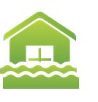

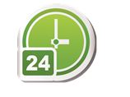
Floods can:
• happen at any time
• be slow or quick
• be dangerous.

Dangerous means you can get hurt.
For example, you can fall into the water and drown.

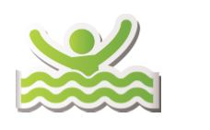

If there is a flood do not drive through water.

Flood

What can a flood do?
A flood can hurt you and your family.
A flood can damage your:
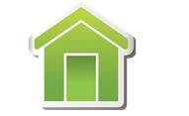
• house

• things in your house, for example furniture.

Damage means to break something.

How can I get ready for a flood?
To get ready for a flood you should:
• have an emergency kit
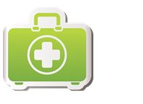

• plan what you and your family will do if there is a flood warning
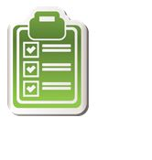

• get insurance for your house and things in your house. Insurance is money you might get from an insurance company when something goes wrong.

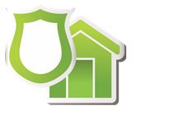

You should also:
• listen to ABC radio or TV for flood warnings

Flood

• put the things in your house up high

• visit our website
https://getready.qld.gov.au/be-prepared/

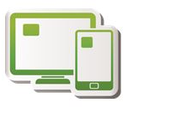
More information https://www.qld.gov.au/communityrecovery

