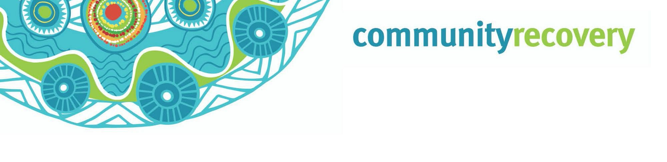

Grant 2: Yukwaymina Wukalakan Ma'aathan

Yukwaymina Wukalakan Ma'aathan Anan ma aathayn nintang, Inan thanh ngampang ma’aathayn wukalan erkam thee ayn puth awuch ngan yuk waymin an ngan ya’an thuthnam a waynang yoot an.

Wukal inaniy’ang $150 wanch pum thonam ak ang, a $750 wanch pam puk yoot tham an ang. Aak week an minchuw an ul ang anan uwan wukal an yuk waymin ak an.

Nint an yipmam uwan ang. Pek an wakan:
- Inan kaap ngan wayath awuch yipmam ma’athayn ngampang
- Kaap ng wayath awuch yuk waymin ngampram ampalman waya than ang, ya than waya yumpayn yipmam nint an uwan.
- Wukal kenam awuch an yumpayn
- Yukwaymina Wukalakan Ma'aathan Anan ma aathayn nintang
  - Wukal inan ngampirr –Nganth ak, wiywiy an nganth tham awuch an.
  - Awuch an yuk may an keengk namp.
  - Ngak- a ngak pantamp tham an.
  - Wukal aknakana ngul puth weerch ngampang.
This grant is not means tested.
A wukul ngeen ngeenan uwanan wukal ngeen ngeen ka’atham an tax altangan

Iknakan ngoonchan yuk https://www.communityrecovery.qld.gov.au an thath a yipmam waa’an thant yuk waymin a awuch an wayath kaapngan.
Nint wanakan kaangk iknakan wik kuchan a lut an nungk umpayn a. Nint kangk namp nungkram wantan ingan yipmang Moom Pian alalngan Queensland Government Department of Communities thathayn awuch niindam an nunth kaap ngan wayath. Wey inan putham ak an thowan kaangk niy. Inaniya waan ang nint an yuk inan kanaman yumpinang a an than thathayn ul puth nint wukul an uwan ul.
Ingan thowan 1800 173 349 an thanang wukal a awuch ak an enkan

Nint nungkeram inan nint nintam an umpan online an ang wukul an nungk umpayn keycard’ng an ang. Nungkeram wanakan thathayn application an ang aniya wukul an ngoonchuw ulang. Inan kanaman helpimin nintangang. Aniya wukul an noonk account’ng umpayn thathan ATM kanam an ngoonch wukul an ang.

Wey inan putham ak an thowan kaangk niy. Ingan wik thowan putham akan waa ayn 1800 173 349 or visit www.qld.gov.au/communityrecovery

Essential Services Hardship Assistance- Wik

