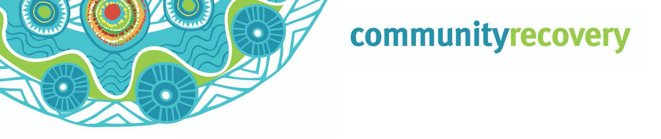

Wunt tha’iy an a kaap an thee uwalan ang ngamp an erkam ma yalmathnak yuk waymin anangan.

Yeelal Inan Kankanam Lat

Yeelal ngeen a?

Ngak yeelal ang ingan Queensland ngampang mayiw ngak aknakam kenh mayiw erkam ang

Ke tha’ang maakan ngak yeelal ngan mayiw akk ang – Wee nyath ngak way ang, an nintang kemp wayathiw a wunin.

Ngak ngan aak mayuw ang nint ang ngan thinth ke wenghan ang yipmam minam wunan a nint ngantam ngeeyan thon ngan ang.

Inan Queensland Government ngan pam moom pian ngan waanthan ngeeyan patham a ngankang pian. Yipmam minam wunan.

Nint wey waa’an ngak yeelal an matmatan a ma aathan nungkeram ang plan ngeen an yipmam minam wey an wompayn.

A RACQ Get Ready Queensland, www.qld.gov.au

Wantak an nintang wantiw?
- An nint kemp wee weeyam a kemp waay ngank wee weeyam wunin. An nint ke weep wunin, weep wayathin, man kul a ngak ul mungkin. Kampan nungkeram an minam pian thanang a nungkerak man thamp. May minh min mungkan, weep min wunan, a tv thathan a radio ngeeyan.
- Nint puk thamp ay? Ma pathathan thanang ang, ke than waawaa ayn yootant kaap an, ngank min wunan. Waa’an wanakan wanch pam yoot ngan ma aathan than wee weeyan kampan aak min koyam yumpayn. A puk many niindam an yipmam ngank min wunayn
- Ku a ku waak a minh bullock, minh ninthan (pig) thak an ney ay? Ma yalmathan thanang a yipmam minam wunayn aak kaap ngan. Nint aak min uwan thant yipmam angan wunayn, a may ngeen an munkayn, aak petch we’irr uwan a. Engkan ku a ku waak an ang man wantin thangang weey alathanang.
- Awuch a yuk waymin nungkeram an thuthnam ulan wunin. Nint kan minam aak aniy yumpan ay? Nint insurance thamp awuch yumpayn a yuk waymin an koyam thee’ayn ay?
- Nintang ma yalmathan ayn ang a anan nungk ma aathayn an nintang, yipmam anman min yuk waymi thak an pian. Nint ngul awuch ak an.

Ma yalmathan puth ngul yeelalang mayi:

- Ma yalmathnak awuch ngan ang: ma yalmathnak keengk keengk ang yipmam nint kaap ang ke wipan, chill thak a, awuch ngan ngak thak an yumpan kankanan.

- Ma yalmathnak awuch ngan ang: ngantam ngeeyan thum nhoom a yipmam minan wunan aak kap thonam ngan. Awuch thak an minam yumpanak ang wiy an yipmam minam thamp.
- Ma yalmathan yuk waymin opirr ak an: Ma yalmathan yuk waymin opirr ak an aak kap thonam akam, kankanang kaap’am.
Inan thatan https://getready.qld.gov.au/be-prepared/
Ma yalmathnak kankanang wunt

- Ma yalmathan aak pech wantan Wik yumpan ngeen awuch ngan yuk waymin thak an umpan.
- Pam wanch nungkerang thinth an a wunthan, thanang ma aathan a waa’an ngan an umpayn.
- Ku a Ku’waak an keengk keengk kon ngam pekan yipmam karrpam kalan.
- Ngeeyan yuk radio a tv ngan thathan yipmam nungk waa’ow wantin an ngak a wuntan iy.

Download the
Self Recovery app
Visit our website www.qld.gov.au/ communityrecovery

