## Community Support

It is normal for families and individuals to experience a range of reactions to unexpected events, including disasters, job loss and changing circumstances. For some, financial loss may mean seeking income support; for others it could mean revising retirement plans or changing household spending.

Regardless of the circumstances, distress is a common and natural response to unexpected events.

This brochure contains a range of general local and community support services available to individuals and their families experiencing financial and emotional hardship as a result of an unexpected event or changed work or financial circumstances.

Further information is available at <https://www.qld.gov.au/community/disasters-emergencies/recovery-after-disaster> or by phoning the Community Recovery Hotline **1800 173 349.**

You can also download the free Self-Recovery app from the Apple or Android Stores

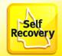

## Queensland Government (QGOV)

For all other government enquiries 13 74 68

## General Community Support Services

DV Connect Mensline 1800 600 636

DV Connect Womensline 1800 811 811

Relationships Australia 1300 364 277

Beyond Blue Info Line 1300 224 636

Lifeline Telephone Counselling 13 11 14

Kid’s Help Line 1800 551 800

Gambling Help Line 1800 858 858

Parentline 1300 301 300

Salvation Army 13 72 58

Seniors Enquiry Line 1300 135 500

Australian Red Cross 1300 554 419

RSPCA 1300 264 625

St Vincent de Paul Society 3010 1096

## Workplace Services

Fair Work Ombudsman 13 13 94

National Customer Service Line 13 62 68

## Services Australia

Medicare – General Enquiries 13 20 11

Centrelink Australian Apprenticeships 13 36 33

Centrelink Employment Services 13 28 50

Farmer Assistance Hotline 13 23 16

## Legal and Advocacy Services

Legal Aid Queensland 1300 651 188

Basic Rights Queensland 1800 358 511

Australian Financial Complaints

Authority 1800 367 678

## Financial Counselling

National Debt Hotline 1800 007 007

## Consumer Advice

Office of Fair Trading 13 74 68

# **Community Support Services**

Brisbane Region

## Your Home

Brisbane City Council 3403 8888

Redland City Council 3829 8999

SES - Flood / Storm Emergency 13 25 00

Tenants Queensland 1300 744 263

Residential Tenancies Authority 1300 366 311

Smart Service Qld - Qld Govt Info &

Services 13 74 68

Homeless Hotline 1800 474 753

Insurance Council of Australia 1300 728 228

Telstra - Crowd Support 13 22 00

Optus – Customer Service 13 39 37

Energex – General Enquiries 13 12 53

Energex Emergency (24/7) 13 19 62

Ergon Energy – Customer Service 13 10 46

Ergon Energy – Life Threatening

Emergencies (24/7) 13 16 70

Origin Energy and Gas 13 24 61

13HEALTH 13 43 25 84

## North Brisbane Area

**Support and Advisory Services**

CO.AS.IT Community Services Inc 3262 5755

Lifeline 13 11 14

Nundah Community Centre 3260 6820

Zillmere Community Centre 3865 2880

Communify Queensland 3510 2700

Australian Red Cross - Milton 1300 554 419

Picabeen Community Assoc 3354 2555

The Community Place 3857 1152

## Inner City Brisbane Area

**Support and Advisory Services**

New Farm Neighbourhood Centre 3358 5600

Centacare 1300 236 822

Micah Projects Inc 3029 7000

Brisbane Youth Service 3620 2400

HART 4000 3004 0100

## South Brisbane Area

**Support and Advisory Services**

East Brisbane Community Centre 3896 1300

St David's Neighbourhood Centre 3274 3240

Elorac Place Community Centre 1300 865 307

Sherwood Neighbourhood Centre 3379 6963

Acacia Ridge Community Centre 3277 4893

HUB Neighbourhood Centre 3372 3770

Inala Community House 3372 1711

Benarrawa Community Development

Association 3379 9925

Kyabra Community Association 3373 9499

## Bayside/Redlands Area

**Support and Advisory Services**

Redland Community Centre 3245 2117

Yulu-Burri-Ba Aboriginal Corporation for

Community Health

(North Stradbroke Island) 3409 9596

Bay Islands Community Services 3409 1177

**Emergency Relief**

Southside Community Care 3343 1441

Redland Community Centre 3245 2117

## Material Goods Assistance

**All Areas**

Salvation Army Queensland Divisional

Headquarters 3222 6666

Salvos Stores Brisbane 3368 6340

Lifeline Head Office 3253 4000

## Emergency Relief

**All Areas**

Wesley Mission Queensland 1800 448 448

Salvation Army 13 72 58

St Vincent de Paul Society 3010 1000

SVDPS – Qld Statewide Assist 1800 846 643

## Other Services

Crime Stoppers Australia 1800 333 000

Animal Welfare League Qld 3631 6800

General Enquiries 5509 9000

Elder Abuse Helpline 1300 651 192

Poisons Information Centre 13 11 26

Commonwealth Respite and

Commonwealth Respite & Carelink Centres 1800 052 222

CR&CC 1800 059 059 (A/H)

Qld Community Support Scheme 1800 600 300

Commonwealth Ombudsman 1300 362 072

Energy & Water Ombudsman 1800 662 837

Telecommunications Industry

Ombudsman 1800 062 058

## Your Business

Apprenticeships Hotline 1800 210 210

Department of Agriculture & Fisheries

General Enquiries 13 25 23

Qld Rural & Industry Development

Authority 1800 623 946

## Interpreter Services

Telephone Interpreter Service 13 14 50

**For emergency response including Police, Fire and Ambulance 000**

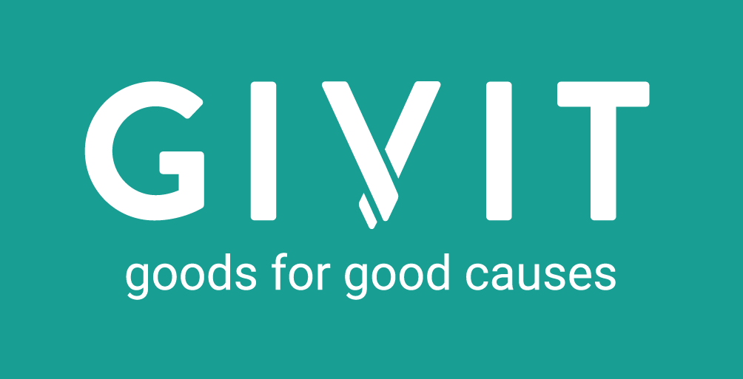To donate visit [www.givit.org.au](http://www.givit.org.au)