Cyclone

This factsheet is about what to do in a cyclone.

A cyclone might cause:

- strong winds

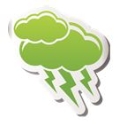

- big thunderstorms

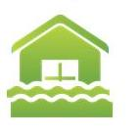

- floods.

A cyclone can be dangerous.
Dangerous means you can get hurt.

If there is a cyclone warning you should stay inside until the storm is over.
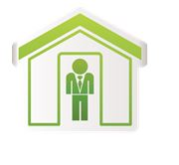

What can a cyclone do?

A cyclone can hurt you and your family. A cyclone can damage your:
- house

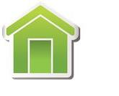
- things in your house, for example furniture.

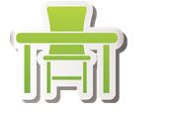

Damage means to break something.

How can I get ready for a cyclone?

To get ready for a cyclone you should:

- have an emergency kit

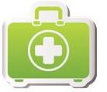

- plan what you and your family will do if there is a cyclone warning
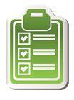

- get insurance for your house and things in your house. Insurance is money you might get from an insurance company when something goes wrong

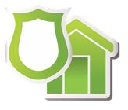

You should also:

- listen to ABC radio or TV for cyclone warnings

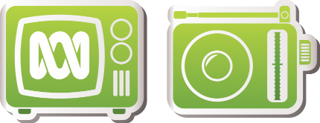

- make your house and garden safe
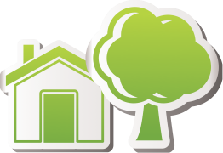

Cyclone

- visit our website
https://getready.qld.gov.au/be-prepared/

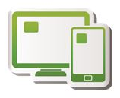

More information

https://www.qld.gov.au/communityrecovery

