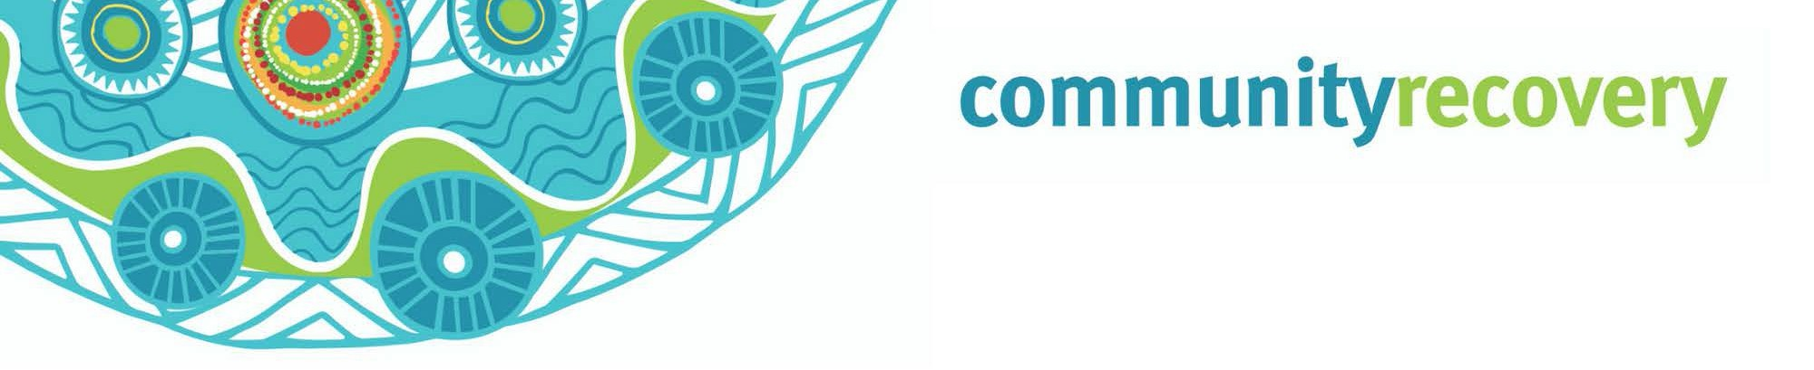Wunt tha’iy an a kaap an thee uwalan ang ngamp an erkam ma yalmathnak yuk waymin
anangan. WunhathanInan Kankanam Lat

Ngeen ang aak an wunhathan eh?

Yinaman aak an ikan yampek an a, wikwik kenang wompan ang, aak palpuw an iknang.

Aak an ikan

- In pek an aak karrkan thumthum a penchan
- Kuntuw an ikan aak ngan.
- Aak an yupmathan
- Yoot mul wunthan puth yuk thayan an enchthan.

A puth weey weey an aak an ikiw aak wayngul thaniw:
- Nganth ak an a, yuk wik an thownamp(telephone) wayathuw
- Yuk waymin nanth wunayn inan ngan, awuch many ak an, a ngak waymiythan
- Wunt pian ang aak michathan yuk waymin wayathan
- Yeelal pian patham

Ngantam ngeeyan keekan, kangan a mamam.

A RACQ Get Ready Queensland, www.qld.gov.au a http://www.getthru.govt.nz/disasters/earthquake/ thathan

Wantak an nintang wantiw?

- An nint kemp wee weeyam a kemp waay ngank wee weeyam wunin. An nint ke weep wunin, weep wayathin, man kul a ngak ul mungkin. Kampan nungkeram an minam pian thanang a nungkerak man thamp. May minh min mungkan, weep min wunan, a tv thathan a radio ngeeyan.

- Nint puk thamp ay? Ma pathathan thanang ang, ke than waawaa ayn yootant kaap an, ngank min wunan. Waa’an wanakan wanch pam yoot ngan ma aathan than wee weeyan kampan aak min koyam yumpayn. A puk many niindam an yipmam ngank min wunayn

- Ku a ku waak a minh bullock, minh ninthan (pig) thak an ney ay? Ma yalmathan thanang a yipmam minam wunayn aak kaap ngan. Nint aak min uwan thant yipmam angan wunayn, a may ngeen an munkayn, aak petch we’irr uwan a.
Engkan ku a ku waak an ang man wantin thangang weey alathanang.

- Awuch a yuk waymin nungkeram an thuthnam ulan wunin. Nint kan minam aak aniy yumpan
ay? Nint insurance thamp awuch yumpayn a yuk waymin an koyam thee’ayn ay?

- Nintang ma yalmathan ayn ang a anan nungk ma aathayn an nintang, yipmam anman min yuk waymi thak an pian. Nint ngul awuch ak an.

Ma yalmathnak erkam aak an wunhathan:

- Ma yalmathnak awuch ngan ang aak an yupmow ang aak an wunhathan ngul ngamperam yuk waymin palpuy thee ang a wayathiw.
- Ma yalmathnak awuch ngan ang, ngantam ngeeyan thum nhoom a yipmam minan wunan aak kap thonam ngan. Awuch thak an minam yumpanak ang wiy an yipmam minam thamp.
- Ma yalmathan yuk waymin opirr ak an: Ma yalmathan yuk waymin opirr ak an aak kap thonam akam, kankanang kaap’am.
Inan thatan https://getready.qld.gov.au/be-prepared/
Ma yalmathnak kankanang wunt

- Ma yalmathan aak pech wantan Wik yumpan ngeen awuch ngan yuk waymin thak an umpan.
- Pam wanch nungkerang thinth an a wunthan, thanang ma aathan a waa’an ngan an umpayn.
- Ku a Ku’waak an keengk keengk kon ngam pekan yipmam karrpam kalan.
- Ngeeyan yuk radio a tv ngan thathan yipmam nungk waa’ow wantin an ngak a wuntan iy.

Download the
Self Recovery app

Visit our website www.qld.gov.au/ communityrecovery

