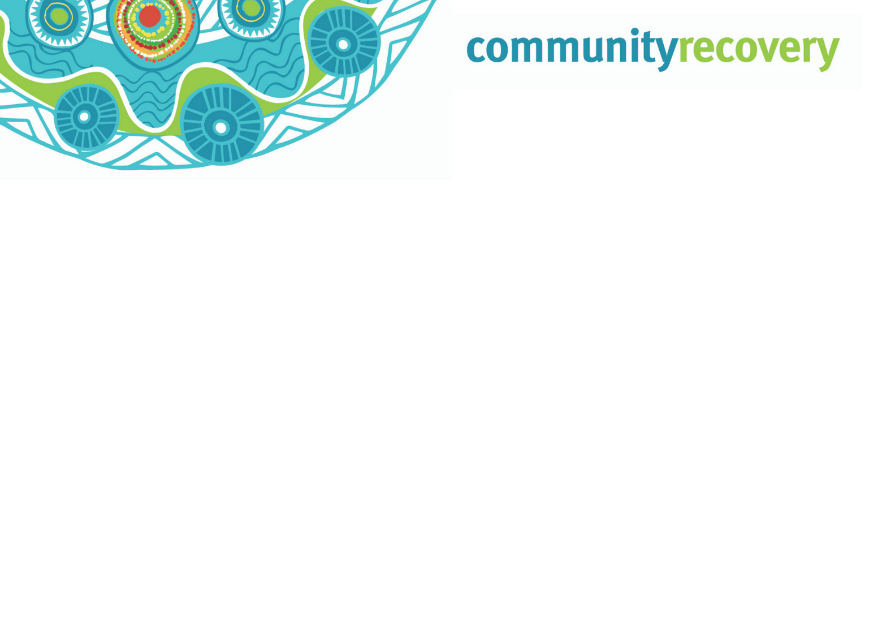
Support and financial assistance available (help with money)

The Queensland Government helps people and communities that have been affected by a disaster such as bushfires, bad storms, floods, earthquakes and cyclones.

We can help you to get the support and services you need, including counselling, free donations of goods and services, and housing services.

Through the Department financial help (money) may also be provided to people affected by a disaster who need help to recover.

Emergency Hardship Assistance

This grant is for important things you need straight after a disaster (food, clothing, medical supplies or temporary accommodation). Payments are $180 for a single person or up to $900 for a family of 5 or more.

Essential Services Hardship Assistance

This grant is for people who have lost one or more essential services (for example: electricity, gas, water or sewerage) for more than 5 days, and because of this are having problems. Payments are
$150 for a single person or up to $750 for a family of 5 or more.

Essential Household Contents Grant

This grant helps people who do not have insurance or are unable to claim insurance. It helps them to replace or repair important household items lost or damaged in the disaster. Payments are up to
$1765 for a single person or up to $5300 for a couple or family. Your ability to get this grant will depend on your level of income.

Structural Assistance Grant

This grant helps people who do not have insurance or are unable to claim insurance to repair their main home from damage caused by a disaster. Payments are up to $10,995 for a single person or up to $14,685 for a couple or family. Your ability to get this grant will depend on your level of income.

Essential Services Safety and Reconnection Scheme

This grant helps people to reconnect or repair essential services on your main home that are lost or damaged by the disaster (for example: electricity, gas, water or sewerage). The scheme covers up to 4 essential service reconnections up to the value of $200 each. The total cost of repairs made to damaged service items is up to $4200.

How to Apply

Applications for the above grants can be made online at www.communityrecovery.qld.gov.au or you can phone the Community Recovery Hotline on 1800 173 349 and a Customer Service Officer will help you to complete the application. You can also visit a Community Recovery Hub if one is open. For further information visit.www.qld.gov.au/community/disasters-emergencies.

