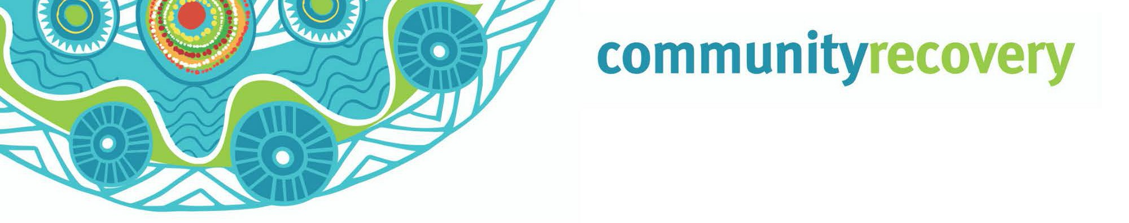When e gor come po mina nuthakyn bad weather ya weh Qld, e nor gad time por think bout ‘ip’ e gor happen, mepla have to think bout ‘what time’ e gor happen

If we meke plan straight now, e gor be easy por pixem apta

How por Ready Yuplaself por Mina nuthakyn Bad Weather

Wanem e Severe Weather?
Ol mina bad storm e can strike anytime. Sometimes we nor sabe wanem gor happen ene e can cause damize for ouse blo yu, ol pipol can get hurt mina bad ip yu nor gor be prepared.

When big storm e come, e can gud ol ice e fall down, ol nuthakyn big wind, e can meke flood, lighting ene heavy rain that can meke damize po’ property blo yu en em can cause injury.

When cyclone e come e can meke ol big rain en ol nuthakyn big wind that gor meke property bor yu fly waseh missile an damize em, plus e gor be nutherkine rough dher lo passage en meke ol big waves lo some beaches.

Listen proper po ol news bout weather en’e ol warnings thempla gor spik an propa tek note weh ol forecasts when the storm season e start (November-April).

Dhemwan ol e talk about ya e po’ help e yu, ah let e yu know wanem yu have to mekem weh ouse po be ready wen e gad all mina nutherkine bad weather.

Take notice dhemwan, sah propa something!

Source: RACQ Get Ready Queensland and www.qld.gov.au

Wanem problems e might go mekem po’ yu?
- E can cause you po’ mood swings. Wase might yu can’t sleep or e hard po focus en’e sum pipol wase wande drink caus ol e fil mina wild weh ol something. Yu muss loogout yourself prapa po’ lookout pamle bor yu. Yu might go cause ol health problems ip yu nor gor kai kai en sleep. E good you gor still socialize weh ol nuther pipol an pamle lo Facebook.
- You gad pikinini ah? Mek shor thempla feel safe, no more panic, en’e meke ol’ normal duties bor yu weh house. Try nor por let e dhempla luk weh tv ene’ listen ol radio warnings. Nor let e thempla listen ol big marn talk about the storm - bombie ol e gor fright. Yarn po’ dhempla wiskine ol pamle’s gor clean up apta en keep seek po’ thempla ‘ol everything go be right’.
- Yu gad pets or livestock? E mina important yu meke plan po dhempla so ol go be olrite weh the storm! Think about weh dhempla gor stap, wannem kai kia en exercise ol go need en ip thempla e orite weh ol nuther animals ah pipol. Pind out ip e olrite po tekem gor por the
evacuation centre.
- Ol belongings bor yu might gor dammiz lor the storm en’e yu gor have to replace dhemwan. Yu be put away dhem something bor yu prapa? Yu gad insurance po’ pixi house bor yu an replace dhem something blo yu?
- Yu provide e care po sombebody whoda elderly lo house bor thempla ah? E good you go meke plan lo dhempla
an ol e gree an yu mek sure ol e gor gad support en’e dhempla gor feel safe en’e well.

Mekeh eberything ready por bad weather:

  - Mekeh house ene business blor yu straight: e mina good ip yu mekem straight wantime, before the season e come. Ip yu stap weh e be gad flood, look wane ol something blor yu inside weh ouse por
move em, so e nor gor damiz ene mekem straight weh council blor yu por gedi ol sunbag ene sun por stap e water from come inside lor ouse blor yu

  - Meke one emergency bag: meke ol something stret ol the time ene 3 months before storm season gor come. E mina important yu gad wan emergency bag ready, dhiswan e help e yu po’ stahp strong en survive weh ol mina nuthakyn bad weather.
  - Mekem straight po gor: Talk weh ol pamle so yupla gor sabe wanem po’ mekem ene meke wan list so yupla nor figet ol something.
Go dher lor https://getready.qld.gov.au/be-prepared/ po pind out more about wiskine yu meke everything ready por wan disaster.
  - Look out po ol neighbours blo you: meke friend weh them neighbours blo yu ene aske thempla if ol need help weh anything. When the cyclone e ober, gor find out weh thempla ip ol e orite e’ne talk por thempla about wanem yu gor mekem.
  - Planeh emergency po’ ol pet: yu might can’t thek e them pet weh yu gor por ol shelter so yu gor have to meke nother plan en’e emergency kit po’ ol pet blo yu.
  - Put yu name down for warnings en alerts en’e tune in: talk po’ council bor yu speak thempla po’ put e name blo yu down po’ gedi ol warnings en alerts. Listen po’ the radio en watch tv po’ sabe wanem e happening weh the weather or yu can gor po’ the Bureau of Meteorology website.

Download the

Self Recovery app
Visit our website www.qld.gov.au/ communityrecovery

