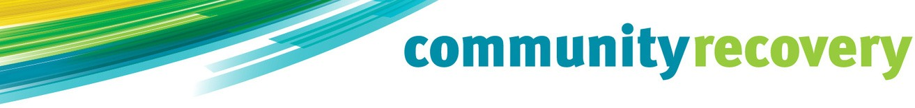

Structural Assistance Grant

What is a disaster?
A disaster might be a:

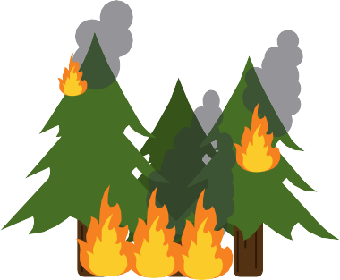
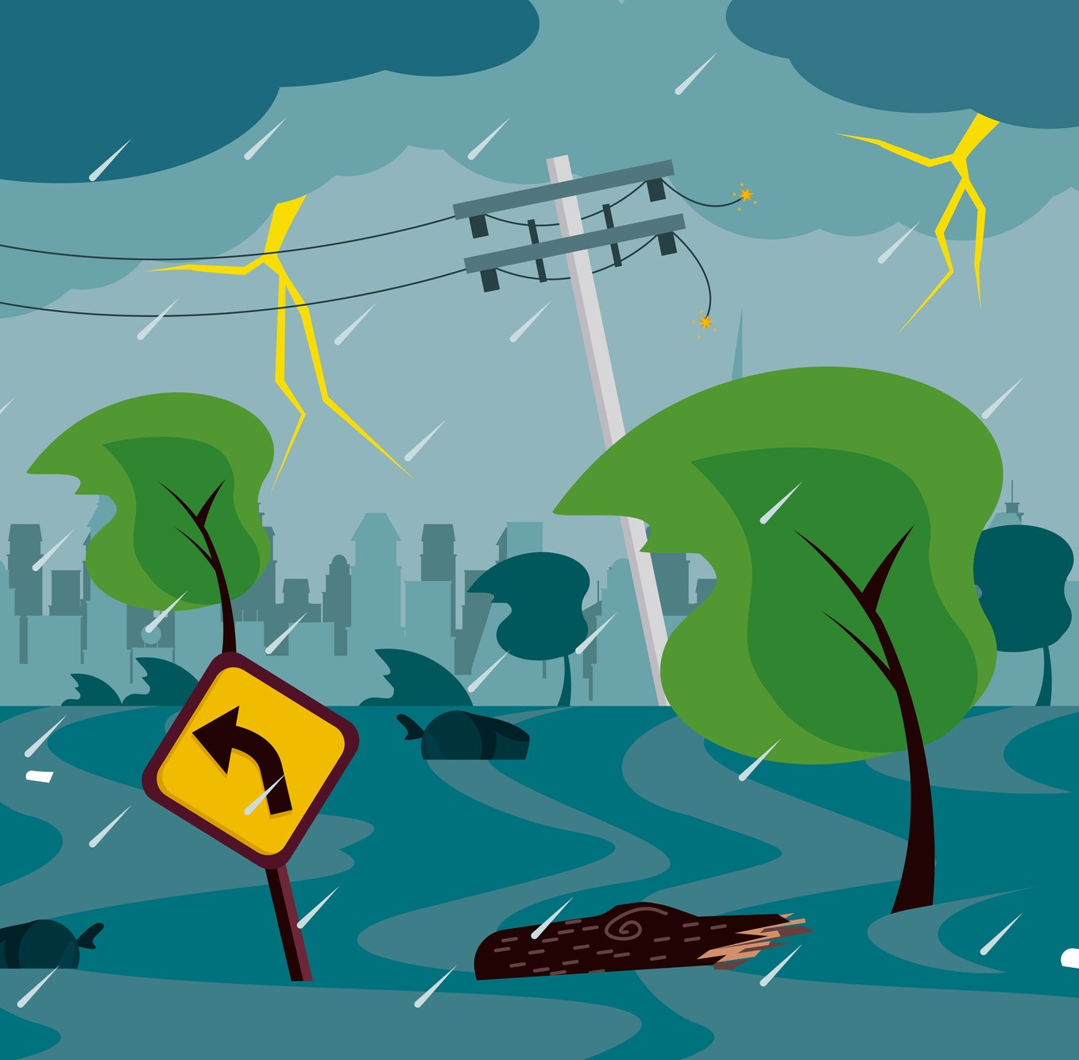
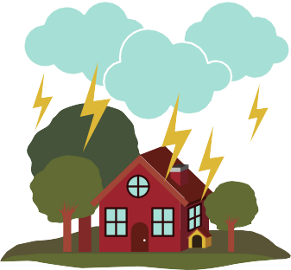

Bushfire Flood Severe Storm Earthquake Cyclone

What are grant payments for?
You can ask for money if you:
Need to fix your home Do not have insurance
Insurance is money you might get from an insurance company when something goes wrong

How much is the grant payment?

The grant payment is:
Up to $50,000

Can I get a grant payment?
To get a grant payment you must:
Own and live in a house, caravan or boat in the disaster area
Not have insurance money or can not claim insurance. Insurance is money you might get from an insurance company when something goes wrong
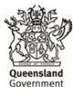
Have an income test. An income test means we check the money you get from your job before we give you a grant.

How can I apply for the grant?

Call the Community Recovery Hotline on
1800 173 349

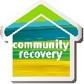
Visit a Community Recovery Hub

Fill in the application form on our website,
www.communityrecovery.qld.gov.au

How will I get my money?

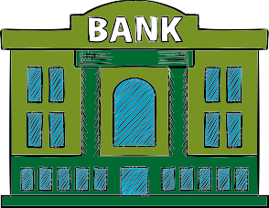
If we say yes to your grant payment you will get:

Money in your bank

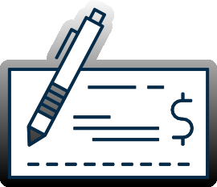
Or

A cheque sent to you in the mail

