Supplementary material 4:
Options for the Child Safe Standards
There are a number of ways the child safe standards (CSS) could be implemented in Queensland to help organisations better prevent, detect and respond to child abuse and prioritise the safety and wellbeing of children in their care.
We have developed three options, see below, for implementing CSS in Queensland. These options and the potential impacts on organisations, children and young people, government and the community are explored in detail on pages 40 to 48 and 78 to 88 of the Consultation Regulatory Impact Statement (CRIS).
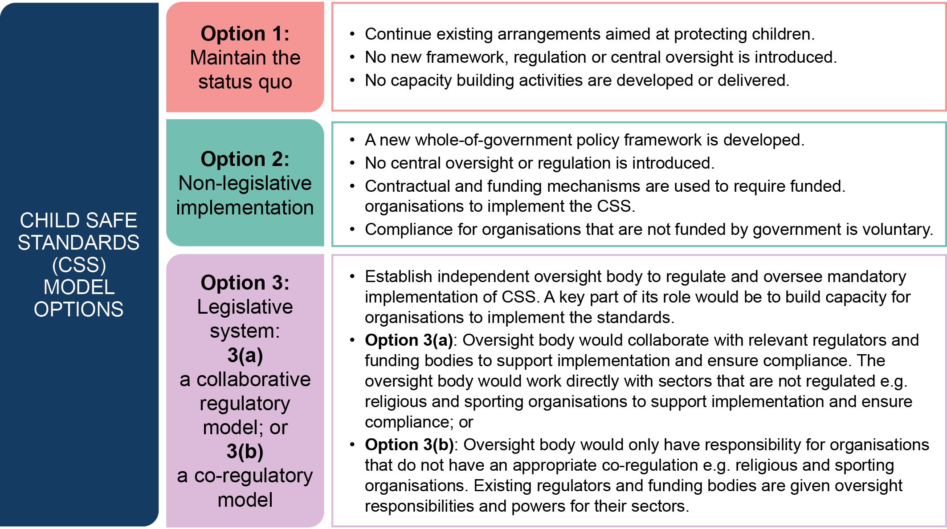

Based on the analysis we undertook in the CRIS, our preferred option is to create legislation requiring relevant organisations to comply with the standards, as set out in Option 3(a). This may look like:
- new legislation requiring organisations in scope to implement the CSS
- CSS that are principles-based and outcomes focussed, with organisations in scope able to embed the CSS in a way that makes sense for their particular service delivery contexts, in line with a legislative framework and published guidance from the CSS oversight body
- capacity building to support organisations to implement the CSS will be a core feature of the CSS oversight body’s functions, including as an initial regulatory response to non-compliance. The oversight body will also have monitoring and enforcement powers in the legislation
- a CSS oversight body that takes a collaborative approach with existing regulators to support CSS compliance, in a way that is intended to boost the oversight capacity of the CSS body, while minimising regulatory burden and duplication for organisations and regulators. The oversight body and regulators would establish a consistent and coordinated approach to building child safe organisations that can build on existing processes. For organisations with no existing relevant regulatory arrangements, the oversight body will adopt the role of regulator
- there could be a phased approach to implementation, with time for preparation activities and a phasing-in of sectors to the scheme over time.
We want to hear from you about:
Option 1
- Do you support the Queensland Government taking no further action to implement the CSS in Queensland, with organisations able to choose whether to adopt the CSS? Why or why not?
Option 2
- Do you support the Queensland Government using contractual/funding arrangements to require compliance with the CSS, supported by a policy framework, instead of legislation?
Option 3
- Do you support the Queensland Government legislating a system for mandatory compliance with the CSS? Why or why not?
- If an independent CSS oversight body was established, which approach do you support:
  - existing sector regulators should work collaboratively with the CSS oversight body to maximise effectiveness of the scheme for their sectors, with the main regulation and enforcement of the CSS resting with the CSS oversight body (Option 3(a))? or
  - existing sector regulators should have a formal role in regulating and enforcing compliance with the CSS, with potential powers and functions delegated to them in legislation (Option 3(b))?
- Do you have suggestions as to how the CSS oversight body could collaborate (or regulate) with sector regulators, to streamline and support the operation of the CSS?
- How should the CSS oversight body work with organisations to support, monitor and oversee compliance with the CSS? Does this change based on factors such as existing sector regulation and peak bodies, an organisation’s size and resources, and the risk profiles of particular sectors and organisations?
- How can the CSS oversight body best help create cultural change to prioritise the safety and wellbeing of children and young people in organisations as well as the community?
For the full list of consultation questions, please see the CRIS and / or the template for feedback provided. We would like to hear from you whether you respond to all, or only some, of the questions.

