

2021–22 Annual report for local government activities under the Food Act 2006

2021–22 Annual report for local government activities under the Food Act 2006

Published by the State of Queensland (Queensland Health), November 2022
This document is licensed under a Creative Commons Attribution 3.0 Australia licence.
To view a copy of this licence, visit creativecommons.org/licenses/by/3.0/au
© State of Queensland (Queensland Health) 2022
You are free to copy, communicate and adapt the work, as long as you attribute the State of Queensland (Queensland Health).

For more information contact:
Food Safety Standards and Regulation, Department of Health, Queensland Health,
PO Box 2368, Fortitude Valley BC QLD 4006,
email foodsafety@health.qld.gov.au, phone (07) 3328 9310.
An electronic version of this document is available at www.qld.gov.au/foodpantry

Contents
Summary 1
Key findings from the 2021–22 reporting period 2
Scope 3
Regions and local governments 3
Licensable food businesses 5
Food business categories 7
Food safety supervisors 8
Food safety programs 9
Food business inspections 10
Inspection categories 10
Complaints 11
Complaint-related inspections 12
Enforcement activities 14
Seizures 15
Improvement notices 15
Prescribed infringement notices 15
Suspension and cancellation of a licence 16
Prosecutions 17
Employees in food regulation 17
Conclusion 19
Further information 19
Local government responses for 2021-22 20

Summary
The 2021–22 Annual report for local government activities under the Food Act 2006 provides information on food regulatory activities under the Food Act 2006 (Food Act) undertaken by local governments in Queensland for the 2021–22 financial year.
The Food Act is the primary food safety legislation in Queensland and applies to Queensland food businesses (excluding State food businesses such as public hospitals, state schools and correctional centres). The objectives of the Food Act are to ensure food for sale is safe and suitable for human consumption, to prevent misleading conduct in relation to the sale of food and to apply the Australia New Zealand Food Standards Code (the Food Standards Code).
Queensland Health Public Health Units and local governments are responsible for enforcing compliance with the Food Act. As such, these agencies are accountable to the community for ensuring that acceptable food safety standards are being achieved by food businesses.
It should also be noted that as Queensland Health is the lead agency in the management of foodborne illness outbreaks, misleading conduct related to the sale of food, and food labelling and compositional requirements, the statistics in this report do not reflect the total number of enforcement actions undertaken annually under the Food Act, only those undertaken by local government.
In Queensland, local governments are responsible for:
- licensing food businesses
- accrediting food safety programs
- undertaking compliance monitoring activities, and
- enforcing certain offences under the Food Act and chapter 3 of the Food Standards Code.
This involves inspections and enforcement of food safety legislation in retail, manufacturing and food service sectors and extends to complaint investigations relating to food businesses including collaboration with Queensland Health in relation to foodborne illness investigations.
The information regarding food regulatory activities provided to Queensland Health by local government contributes directly to the development and overall administration of the Food Act and informs the status of food safety in Queensland. Information includes:
- statistical information on annual activities for each local government
- consolidated information by region, and
- an examination of trends for standard parameters.
Local government responses for 2021-22 are provided at the end of this report.

Key findings from the 2021–22 reporting period
- The number of licensed food businesses in Queensland was 32,126, which is a decrease compared to 2020–21 figures (32,427 businesses). Approximately two thirds (67%) of these businesses (21,656) were from the Brisbane and Moreton region, which is similar to
2020–21 (68%).
- A total of 70 local governments had at least one licenced food business compared to 68 local governments in the 2020–21 reporting period.
- The statewide percentage of compliance for food businesses to have a food safety supervisor was 96%.
- The statewide percentage of licensed food businesses that were compliant with the requirement for them to have an accredited food safety program was 99%.
- A total of 23,937 routine inspections were conducted in the 2021–22 reporting period for licensed food businesses. This figure does not include re-inspections or complaint-related inspections. This compares with 23,315 routine inspections conducted in 2020–21.
- A total of 3,796 complaints were received by local governments regarding licensed food businesses, representing a 13% increase from 2020–21 (3,346). Inspections were conducted for 78% of food complaints, compared with 65% for 2020–21. This inspection rate is similar to complaint inspections prior to 2020–21 – that is, 82% in 2019–20 and 79% in 2018–19.
- Statewide, there were approximately 177 employees committed to food regulation for the 2021–22 reporting period, which is approximately 0.6 employees per 100 licensed food businesses. This compares to a similar level of employees for the 2020–21 reporting period (180).
- 43%, or 30 out of 70 local governments with licensed food businesses reported that they use contractors. This is an increase from 2020–21, where 40%, or 27 out of 68 local governments with licensed food businesses used contractors to perform some food regulation tasks.
- Enforcement activity reporting identified:
- a 36% increase in improvement notices issued (3,115, compared to 2,284 in 2020–21)
- a similar number of prescribed infringement notices (PINs) issued (298 compared to 295 in 2020–21)
- the same number of licences suspended after a show cause notice (5) as 2020–21
- a 49% increase in the number of licences immediately suspended (58 compared to 39 in 2020–21)
- a decrease in the number of prosecutions undertaken by local governments (45, compared with 49 in 2020–21).

Scope
The local government data is presented by geographical regions defined by the Australian Bureau of Statistics to reflect the location of people and communities. Queensland’s population is clustered around the cities and coastlines. Approximately half of the Queensland population lives in the greater Brisbane area. Accordingly, there is major variation in the distribution of food businesses, the capacity of local governments and other factors that may limit regional comparisons.
While this report provides activity data on select types of regulatory action undertaken, it does not include a full range of strategies and tools (such as voluntary food safety training and educational/promotional food safety strategies) that regulators may use to assist and engage with food businesses to achieve and maintain compliance with the Food Act.
The data also does not take into account that inspection, complaint and enforcement activity data may include food businesses that do not require a licence.
Targeted compliance and regulatory actions undertaken by local governments are determined by local priorities and are not prescribed by the State. This provides local government with the discretion to target regulatory compliance activities within their boundaries and contributes to the variation in food safety compliance activities between local governments.
The methodology for collecting the data consists of a self-reporting survey that may be subject to misclassification or user error. Whilst care has been taken to clarify potential data discrepancies, some errors may not be easily identified and may therefore remain.

Regions and local governments
In Queensland, there are 77 local governments and one Town Authority (Weipa), which is administered by the mining company, Rio Tinto. The Weipa Town Authority acts in the role of a Local Authority, with staff that would normally be associated with a local government. Therefore, for the purposes of this report, Weipa Town Authority is considered as a local government.
A map of local government areas can be found at: www.statedevelopment.qld.gov.au/__data/assets/pdf_file/0019/42454/local-government-area-boundaries.pdf.
To align with previous local government reports, the data for the 2021–22 reporting period has been grouped into nine geographical areas, based on the local government regions used by the Australian Bureau of Statistics (Table 1). These regions are identified in Figure 1.

Table 1 Local government regions
Region | Local governments
Brisbane and Moreton | Brisbane, Gold Coast, Ipswich, Lockyer Valley, Logan, Moreton Bay, Noosa, Redland, Scenic Rim, Somerset and Sunshine Coast
Mackay and Fitzroy | Central Highlands, Gladstone, Isaac, Livingstone, Mackay, Rockhampton and Woorabinda
Wide Bay Burnett | Banana, Bundaberg, Cherbourg, Fraser Coast, Gympie, North Burnett and South Burnett
Far North | Aurukun, Cairns, Cassowary Coast, Cook, Croydon, Douglas, Etheridge, Hope Vale, Lockhart River, Mapoon, Mareeba, Napranum, Northern Peninsula, Pormpuraaw, Tablelands, Torres, Torres Strait Island, Weipa, Wujul Wujal and Yarrabah
Northern | Burdekin, Charters Towers, Hinchinbrook, Palm Island, Townsville and Whitsunday
Darling Downs | Goondiwindi, Southern Downs, Toowoomba and Western Downs
North West | Burke, Carpentaria, Cloncurry, Doomadgee, Flinders, Kowanyama, McKinlay, Mornington, Mt Isa and Richmond
South West | Balonne, Bulloo, Maranoa, Murweh, Paroo and Quilpie
Central West | Barcaldine, Barcoo, Blackall-Tambo, Boulia, Diamantina, Longreach and Winton

Figure 1 Map of local government regions
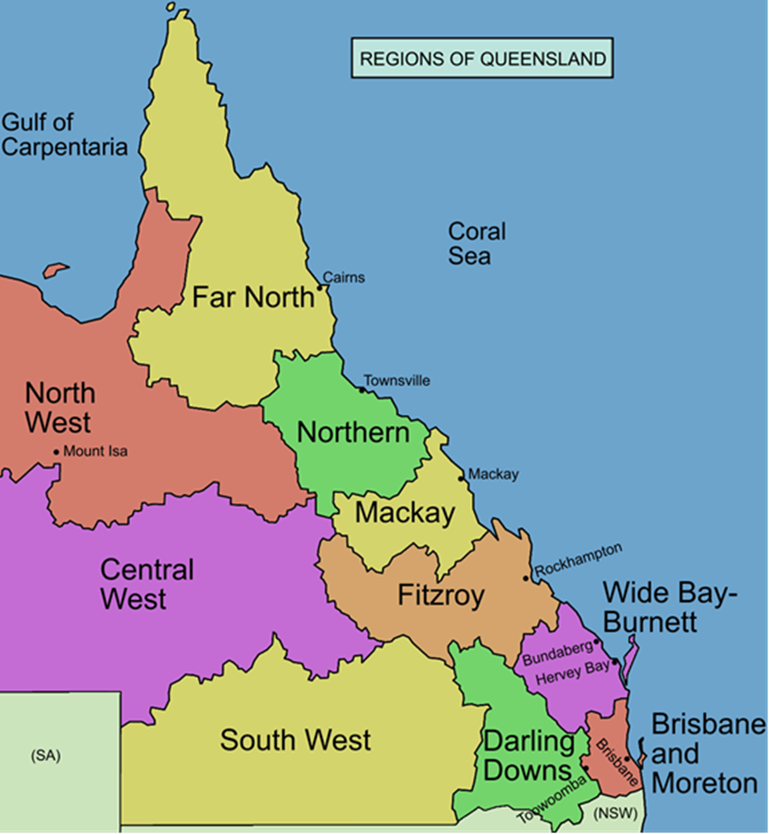

Licensable food businesses
Certain food businesses are required to be licensed by local governments under the Food Act, including:
- food manufacturers (e.g. manufacturers of bakery products)
- food businesses selling unpackaged food by retail (e.g. restaurants or catering businesses)
- non-profit organisations that sell meals on at least twelve occasions in a year (e.g. Meals on Wheels).
Some licensing exemptions apply under the Food Act to food businesses in these general categories, including (but not limited to):
- the sale of pre-packaged food only
- the sale of whole fruit and vegetables or drinks such as tea, coffee, soft drink and alcoholic beverages
- primary producers of eggs, dairy, meat and seafood that are accredited by Safe Food Production Queensland under the Food Production (Safety) Act 2000.
The number of licensed food businesses in Queensland was 32,126, similar to 2020–21 (32,427 businesses). Figures for the number of licensed food businesses since the 2011–12 reporting period is represented in Figure 2.

Figure 2 Licensed food businesses annual trend
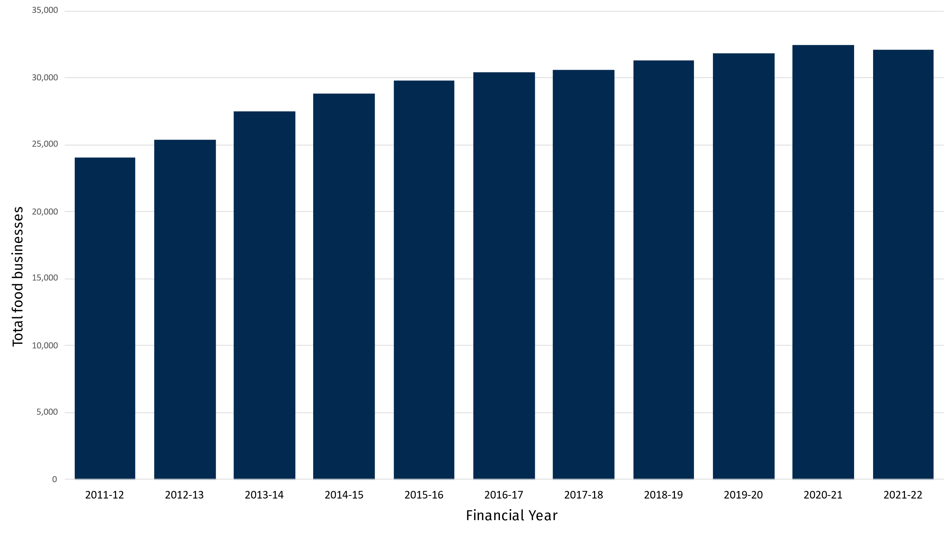
Approximately two thirds (67%) of all licensed food businesses (21,656) were from the Brisbane and Moreton region, consistent with 2020–21 (68%). The geographical prevalence of licensed food businesses in Queensland by region is reflected in Figure 3 and is related to population density. The size of each circle in Figure 3 represents the number of licensed food businesses for the local government in that location.

Figure 3 Distribution of Queensland licensed food businesses
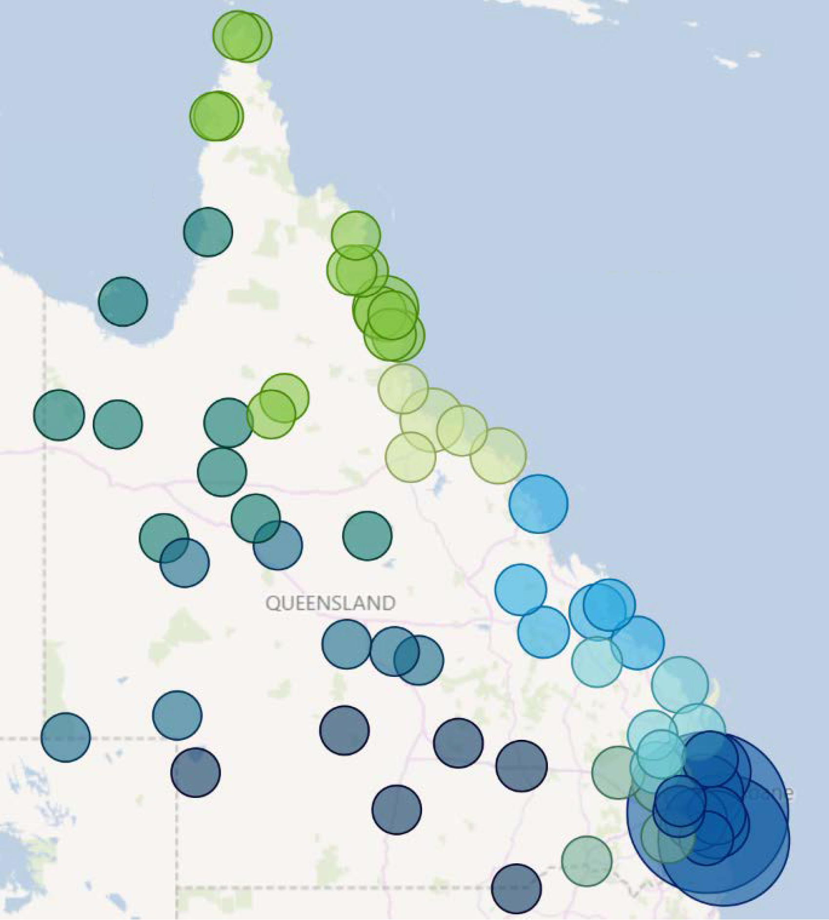
Regions
Brisbane and Moreton - 67% (21,656)
Central West - 0.5% (163)
Darling Downs - 5.2% (1,680)
Far North - 7.2% (2,321)
Mackay and Fitzroy - 6.6% (2,125)
North West - 0.7% (228)
Northern - 5.6% (1,813)
South West - 1% (311)
Wide Bay Burnett - 5.7% (1,829)
Of the 78 local governments, the following seven local governments reported more than 1,000 licensed food business, representing 65% (21,001) of licensed food businesses statewide:
- Brisbane City Council – 7,662
- Cairns Regional Council – 1,164
- Gold Coast City Council – 5,619
- Logan City Council – 1,304
- Moreton Bay Regional Council – 2,002
- Sunshine Coast Regional Council – 2,219
- Townsville City Council – 1,031.
A total of 8 local governments reported having no licensed food businesses, compared to 10 in 2020–21. A total of 11 local governments reported having less than 10 licensed food businesses, compared to 10 local governments in 2020–21.

Food business categories
Categorising food businesses can allow local governments to prioritise food safety tasks such as inspections, which can assist with planning and ensuring that adequate resources are available.
Local governments were asked to specify their primary method of categorising of licensed food businesses, from the following list:
- business type (restaurant, childcare, etc.)
- simple risk-based (high, medium, low)
- business function (temporary, mobile, fixed etc.)
- business size (floor size etc.)
- other
- no category used.
Figure 4 shows the rates of food business categorisation reported, which identifies the two most common methods as business type and simple risk based, consistent with the previous reporting period.

Figure 4 Food business categorisation
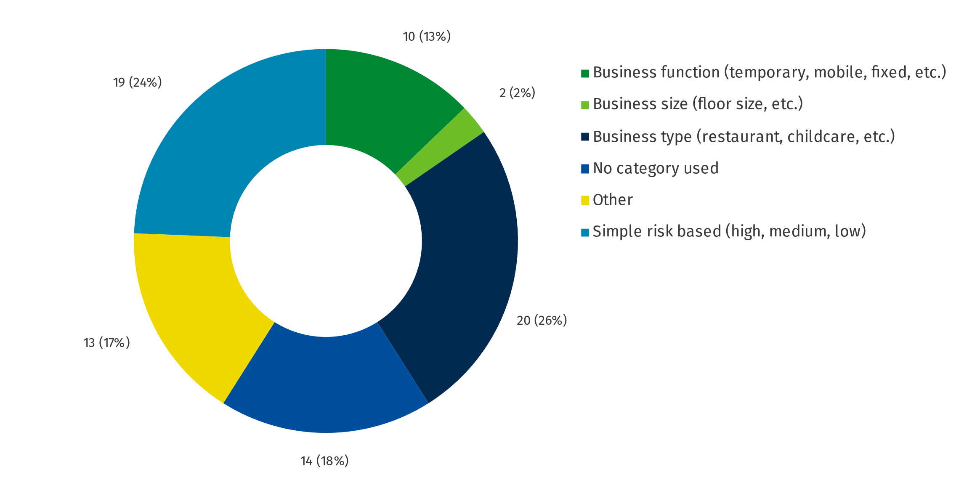

Food safety supervisors
Section 86 of the Food Act requires licensable food businesses to have at least one nominated food safety supervisor. Food safety supervisors provide an important role in food businesses as they must know how to recognise, prevent and alleviate food safety hazards. They must have skills and knowledge in matters relating to food safety relevant to the food business and have the authority to supervise and give directions about matters relating to food safety to persons who handle food in the food business. Anyone who meets these requirements may be a food safety supervisor, which may include the business owner, the licensee, a manager or employee.
The food safety supervisor compliance rate has been steadily increasing, as shown in Figure 5, reaching 96% compliance in 2021–22.

Figure 5 Licensed food businesses with a food safety supervisor over time
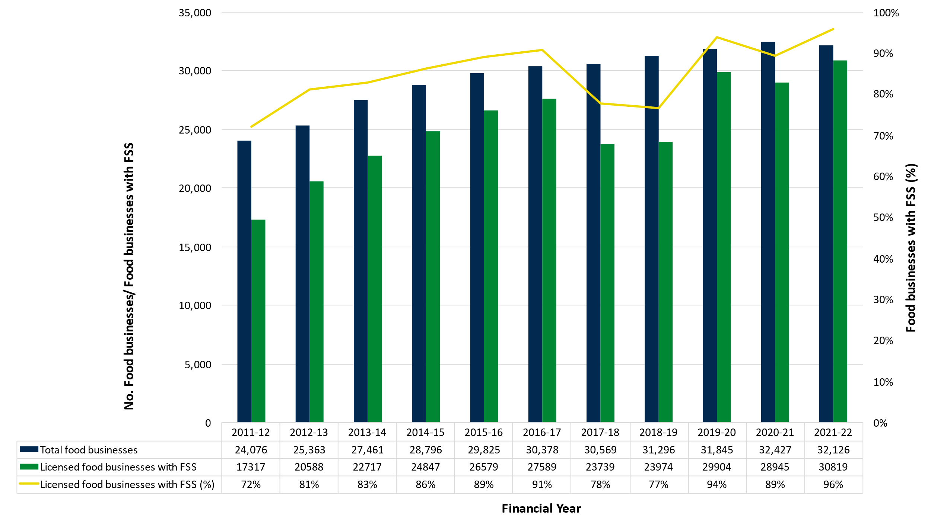

Food safety programs
The introduction of food safety programs (FSPs) for certain sectors of the food industry was part of a national review and assessment which aimed to reduce the incidence of foodborne illness, reduce regulatory burden on the food industry and provide consistent food regulation and standards across Australia.
Under the Food Act, certain high-risk licensed food businesses are required to have a FSP accredited by their local government if:
the food business involves off-site catering
the primary activity of the food business is on-site catering
the food business is undertaken as part of the operations of a private hospital
a facility that processes or serves potentially hazardous food to six or more vulnerable persons (e.g., childcare and aged care centres)
a facility whose principal activity is processing ready-for-consumption food that includes potentially hazardous food, for delivery by a delivered meals organisation to six or more persons at a time.
- As shown in Figure 6, the compliance rate for relevant food businesses to have a food safety program has been steadily increasing since 2012 and during this reporting period there was a 99% compliance rate.

Figure 6 Food safety program compliance rate
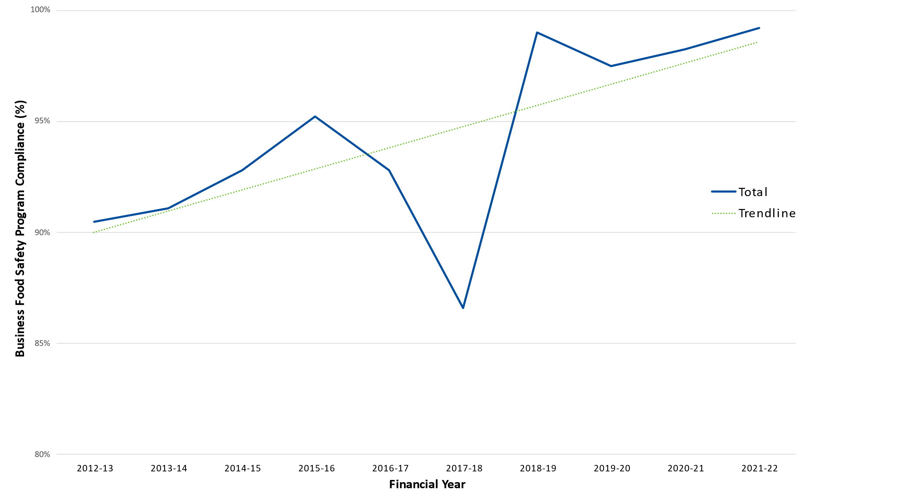

Food business inspections
Local governments inspect licensed food businesses to assess compliance with the Food Act, the Food Safety Standards (Chapter 3 of the Food Standards Code) and the licence conditions of the food businesses. The Food Act does not specify the frequency of inspections. Local governments conduct routine inspections based on factors such as the risk category of the food business (e.g., high, medium or low) and the compliance history of the business. The frequency of inspections may also provide an indication of a local government’s capacity to assess compliance of a food business with their legislative requirements in relation to food safety.
A total of 28,850 routine inspections and re-inspections were conducted in the 2021–22 reporting period for licensed food businesses. Figure 7 provides a representation of the type and number of inspections undertaken annually.

Inspection categories
Local governments were requested to report on routine inspections and re-inspections. Table 2 shows the number and proportion of inspection types conducted during the 2021–22 reporting period for each region.

Table 2 Numbers and type of inspections undertaken
Region | Licensed food businesses (FBs) | Total inspections |  | Routine inspections |  | Re-inspections
Region | Licensed food businesses (FBs) | Total | per 100 FBs | Total | % | Total | %
Brisbane & Moreton | 21,656 | 19,404 | 0.9 | 16,264 | 75 | 3,140 | 14
Mackay & Fitzroy | 2,125 | 2,015 | 0.95 | 1,654 | 78 | 361 | 17
Wide Bay Burnett | 1,829 | 1,140 | 0.62 | 939 | 51 | 201 | 11
Far North | 2,321 | 2,281 | 0.98 | 1,859 | 80 | 422 | 18
Northern | 1,813 | 1,885 | 1.04 | 1,507 | 83 | 378 | 21
Darling Downs | 1,680 | 1,283 | 0.76 | 1,005 | 60 | 278 | 17
North West | 228 | 395 | 1.73 | 344 | 151 | 51 | 22
South West | 311 | 397 | 1.28 | 248 | 80 | 49 | 16
Central West | 163 | 150 | 0.92 | 117 | 72 | 33 | 20
Total | 32,126 | 28,850 | 0.9 | 23,937 | 0.75 | 4,913 | 0.15

Figure 7 Food business inspection rate over time
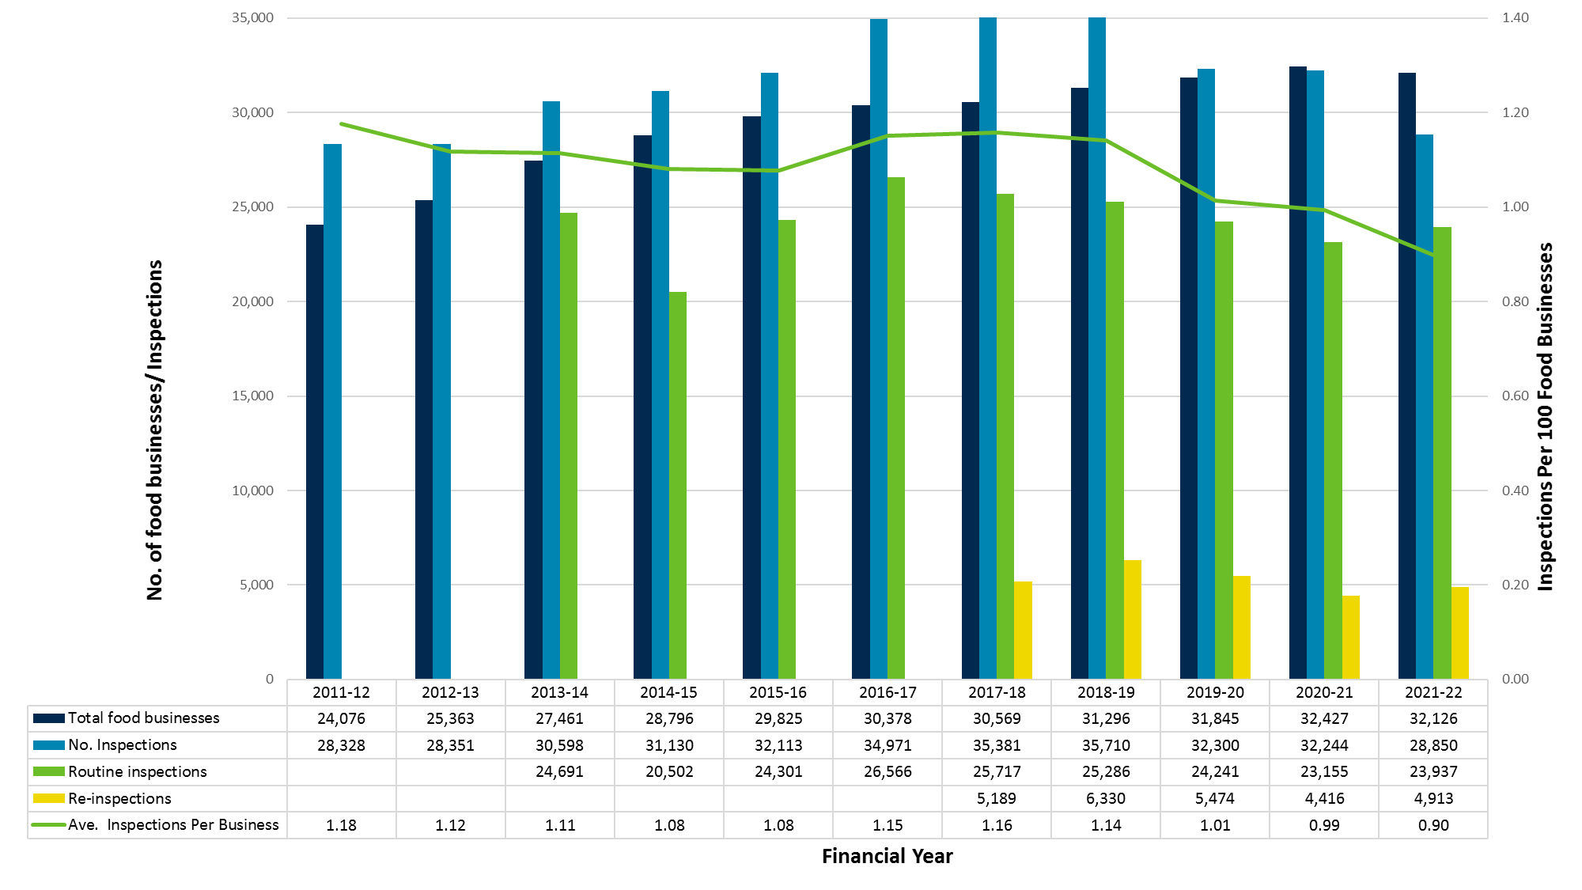

Complaints
Local government receive a variety of complaints from the public regarding unsafe practices at food businesses or regarding food purchased. Some examples of complaints include dirty or unhygienic food premises, undercooked food, poor food handling practices, vermin or animals in a food premises and alleged foodborne illness. The number and type of complaints received can vary greatly.
Local governments were requested to provide the total number of complaints about food businesses that they received during the reporting period. They were not asked to categorise these complaints due to the complexities associated with varying data collection methodologies within individual local governments.
Since 2012–13, more than 3,000 complaints are received annually about food businesses in Queensland (Figure 8). During this reporting period, 3,796 complaints were received, which is an increase of 13% from 2020–21 (3,346). Table 3 provides information for each region on the number of food complaints and complaints per 100 food businesses.

Table 3 Regional complaints about food businesses
Reporting period | 2021–22 |  |  | 2020–21
Region | Licensed food businesses (FBs) | Complaints | Complaints per 100 FBs | Licensed food businesses (FBs) | Complaints | Complaints per 100 FBs
Brisbane & Moreton | 21,656 | 2,859 | 13.2 | 22,056 | 2,412 | 10.9
Mackay & Fitzroy | 2,125 | 197 | 9 | 2,111 | 203 | 9.6
Wide Bay Burnett | 1,829 | 172 | 9.4 | 1,808 | 175 | 9.7
Far North | 2,321 | 170 | 7.3 | 2,262 | 257 | 11.4
Northern | 1,813 | 174 | 9.6 | 1,791 | 139 | 7.8
Darling Downs | 1,680 | 176 | 10.5 | 1,661 | 141 | 8.5
North West | 228 | 38 | 17 | 222 | 7 | 3.2
South West | 311 | 7 | 2.3 | 331 | 12 | 3.6
Central West | 163 | 3 | 1.8 | 185 | 0 | 0
Total | 32,126 | 3,796 | 11.8 | 32,427 | 3,346 | 10.3

Complaint-related inspections
The number of complaint-related inspections undertaken compared with the number of complaints received provides an indication of whether complaints are being investigated via food business inspections. For this reporting period, inspections were undertaken for 78% (2,948) of food complaints, compared with 64% (2,050) for 2020–21. This is a significant increase in food complaint-related inspections since the last reporting period, however it is similar to the inspection rates in 2019–20 (82%) and 2018–19 (79%). The reduction in food complaint-related inspections in 2020–21 may be due to the re-allocation of investigative resources to COVID-related complaints, as this was the period in which COVID-related restrictions were in place for food businesses.
The number of complaints per 100 food businesses and the inspection rate for complaints over time is shown in Figure 8, noting that complaint-related inspection data for the reporting periods prior to 2014–15 was unavailable.

Figure 8 Number of food complaints and complaint-related inspections over time
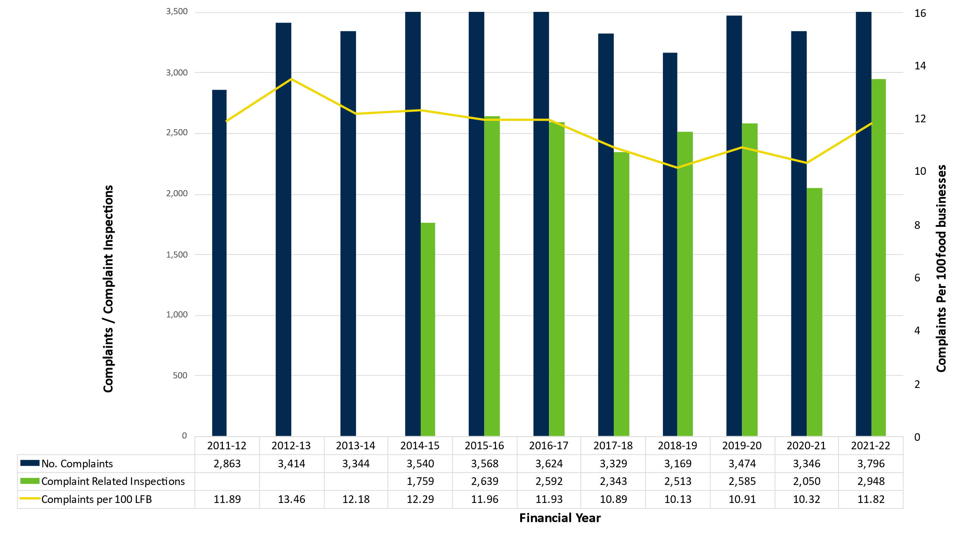

Enforcement activities
The Food Act provides a suite of enforcement options. The enforcement action taken by a local government should be graduated and proportionate to the severity of the non-compliance observed and any history of non-compliance. When considering enforcement data, it is important to note that in addition to enforcement actions, local governments use non-punitive actions such as education to assist food businesses achieve or maintain compliance with the Food Act. This report does not capture information from local governments in relation to other strategies used.
A summary of the enforcement activities undertaken by Queensland local governments by region is shown below in table 4. Consistent with previous years, the main type of enforcement activity undertaken by local government was the issuing of improvement notices, followed by PINs as the second most common enforcement tool.

Table 4 Enforcement activities undertaken under the Food Act 2006 by region
Region | Licensed food businesses (FBs) | Improvement notices |  | PINs |  | Licence suspensions |  | Prosecutions
Region | Licensed food businesses (FBs) | Total | Per 100 FBs | Total | Per 100 FBs | Total | Per 100 FBs | Total | Per 100 FBs
Brisbane & Moreton | 21,656 | 2,633 | 12.1 | 221 | 1 | 49 | 0.2 | 45 | 0.2
Mackay & Fitzroy | 2,125 | 46 | 2.2 | 3 | 0.1 | 3 | 0.1 | 0 | 0
Wide Bay Burnett | 1,829 | 48 | 2.6 | 2 | 0.1 | 2 | 0.1 | 0 | 0
Far North | 2,321 | 58 | 2.5 | 16 | 0.7 | 3 | 0.1 | 0 | 0
Northern | 1,813 | 75 | 4.1 | 8 | 0.4 | 1 | 0.1 | 0 | 0
Darling Downs | 1,680 | 248 | 14.8 | 45 | 2.7 | 5 | 0.3 | 0 | 0
North West | 228 | 5 | 2.2 | 3 | 1.3 | 0 | 0 | 0 | 0
South West | 311 | 1 | 0.3 | 0 | 0 | 0 | 0 | 0 | 0
Central West | 163 | 1 | 0.6 | 0 | 0 | 0 | 0 | 0 | 0
Total | 32,126 | 3,115 | 9.7 | 298 | 0.9 | 63 | 0.2 | 45 | 0.1

Seizures
An authorised person has the power to seize a thing under the Food Act in certain circumstances, for example as evidence of an offence under the Food Act. A total of three seizures were undertaken in 2021–22, which was the same as in 2020–21.
Moreton Bay Regional Council undertook a seizure of contaminated food preparation equipment and Torres Shire Council undertook seizures of unsuitable food items.

Improvement notices
Improvement notices are utilised by local governments to address a variety of non-compliances within a food business. This may include issues such as the need to remedy cleaning, maintenance or structural contraventions or unsafe food handling practices. Improvement notices must provide food businesses with a reasonable timeframe to remedy any stated non-compliance.
Improvement notices remain as the most utilised enforcement action (Figure 9). The number of improvement notices issued in this reporting period (3,115) is an increase of 36% from 2020–21 (2,284). Brisbane and Moreton issued 85% (2,633) of the total number issued (3,115).

Prescribed infringement notices
Prescribed Infringement Notices (PINs) may only be issued for offences that fall within the guidelines for eligible offences that have been acknowledged as PIN offences under the State Penalties Enforcement Regulation 2014. Only certain offences under the Food Act have been prescribed as PIN offences. PINs can be issued when offences pose a moderate threat to human health and safety, or where there are indications of previous, current and ongoing non-compliance, such as failure to comply with a licence condition (section 51(1)) or failure to comply with the Food Standards Code (section 39(1)). The penalty unit values for PINs are relative to the severity of the offence.
While the issuing of PINs remains the second most frequently used type of enforcement activity (Figure 9), the number of PINs issued within the 2021–22 reporting period (298) also remained relatively the same as in 2020–21 (295).

Figure 9 Improvement notices and Prescribed Infringement Notices
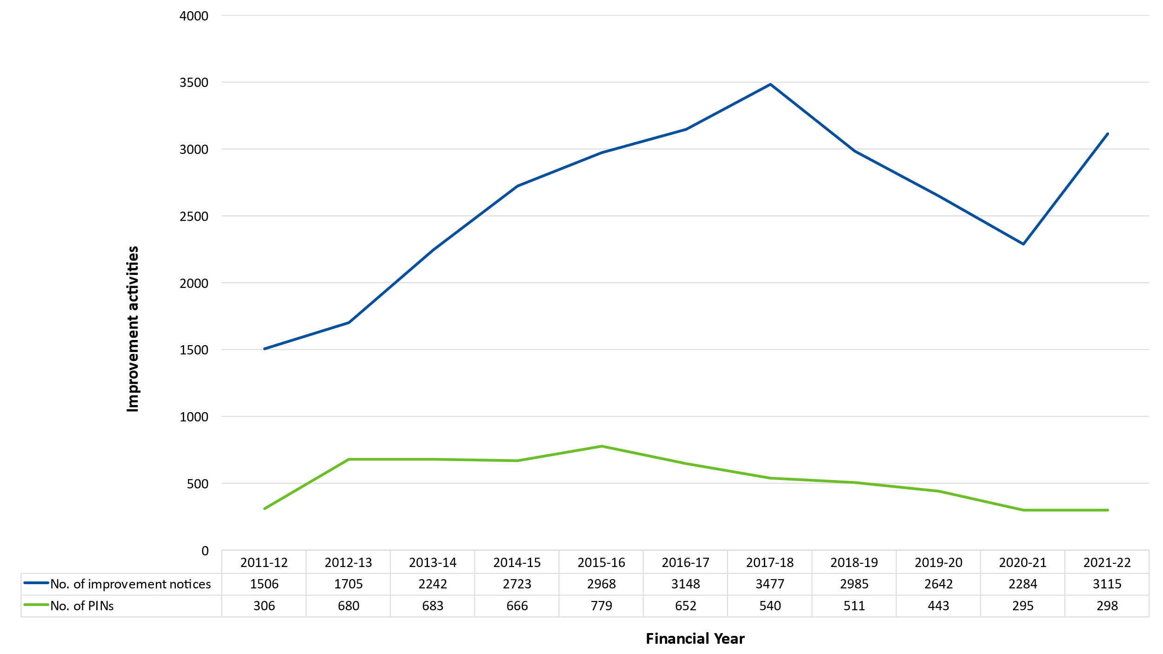

Suspension and cancellation of a licence
Section 78 of the Food Act allows local governments to suspend or cancel a licence when:
- the licensee is not, or is no longer, a suitable person to hold a licence
- the licensee has not complied with the accredited food safety program and the non-compliance is likely to result in a high risk to public health or safety
- the licence was issued under false or misleading representation.
Licences can be suspended or cancelled following a show cause notice. Local governments can use the show cause notice provisions prior to taking proposed action such as suspending or cancelling the licence.
Licences may be immediately suspended if a ground exists to suspend or cancel the licence and it is necessary to suspend the licence immediately because there is an immediate and serious risk to public health or safety.
During this reporting period, there was a total of 58 immediate licence suspensions and 5 licence suspensions after a show cause process (Figure 10). One licence was cancelled after a show cause process.
The number of food businesses that surrendered their licence was 494 compared to 813 in 2020–21. It is possible, that this may be related to COVID-related restrictions that were in force for food businesses in 2020–21.

Prosecutions
Prosecutions are usually initiated if there is a high threat to human health and safety, or if there is a known or expected ongoing non-compliance. Consequently, prosecutions are the least common, most resource-intensive enforcement tool utilised by Local Government.
For this reporting period, a total of 45 prosecutions were undertaken, all of which were within the Brisbane and Moreton region (Figure 10).
Figure 10 Annual trend in enforcement activities
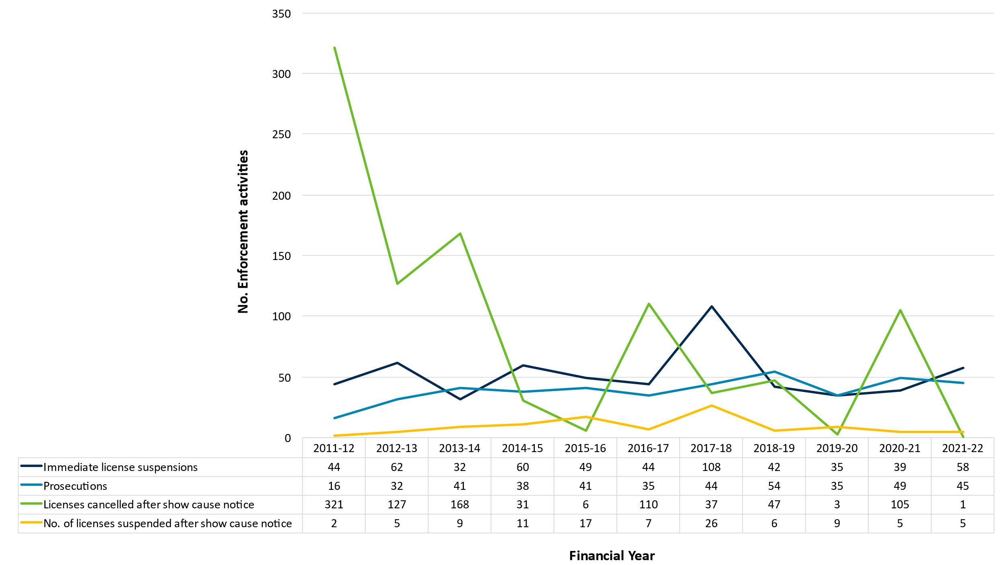

Employees in food regulation
Most local government employees working in food regulation are environmental health officers (EHOs). It is important to note that EHOs are responsible for many areas in addition to food regulation, particularly those in rural and remote locations.
In some rural and remote areas, food regulation is carried out by contract EHOs employed on an as-needs basis. In some of the Indigenous communities, environmental health workers may fulfil this function as part of their duties. To support Aboriginal Shire Councils and to build the skills of environmental health workers, EHOs from local Public Health Units often provide advice on food safety issues and inspecting food businesses operating within the area.
Table 5 shows the number of full-time equivalent (FTE) employees committed to food regulation for 2021–22 in each region compared to the previous reporting period. Statewide, there were approximately 177 employees committed to food regulation for the 2021–22 reporting period, a 2% decrease from 2020–21 (Figure 11).
43%, or 30 out of 70 local governments with licensed food businesses reported that they use contractors. This is an increase from 2020–21, where 40%, or 27 out of 68 local governments with licensed food businesses used contractors to perform some food regulation tasks.
Region | 2021–22 |  |  | 2020–21
Region | Licensed food businesses | FTE employees committed to food regulation | FTE employees per 100 FBs | Licensed food businesses | FTE employees committed to food regulation | FTE employees per 100 FBs
Brisbane & Moreton | 21,656 | 87.8 | 0.4 | 22,056 | 88.35 | 0.4
Mackay & Fitzroy | 2,125 | 12.8 | 0.6 | 2,111 | 18.5 | 0.9
Wide Bay Burnett | 1,829 | 13.4 | 0.7 | 1,808 | 13.8 | 0.8
Far North | 2,321 | 29.1 | 1.3 | 2,262 | 27.07 | 1.2
Northern | 1,813 | 7.6 | 0.4 | 1,791 | 8.5 | 0.5
Darling Downs | 1,680 | 7.4 | 0.4 | 1,661 | 6.75 | 0.4
North West | 228 | 8.1 | 3.6 | 222 | 6.5 | 2.3
South West | 311 | 5.3 | 1.7 | 331 | 6.6 | 2
Central West | 163 | 5.7 | 3.5 | 185 | 3.9 | 2.1
Total | 32,126 | 177.2 | 0.6 | 32,427 | 179.97 | 0.6

Table 5 Employees committed to food regulation per region

Figure 11 Employees committed to food regulation
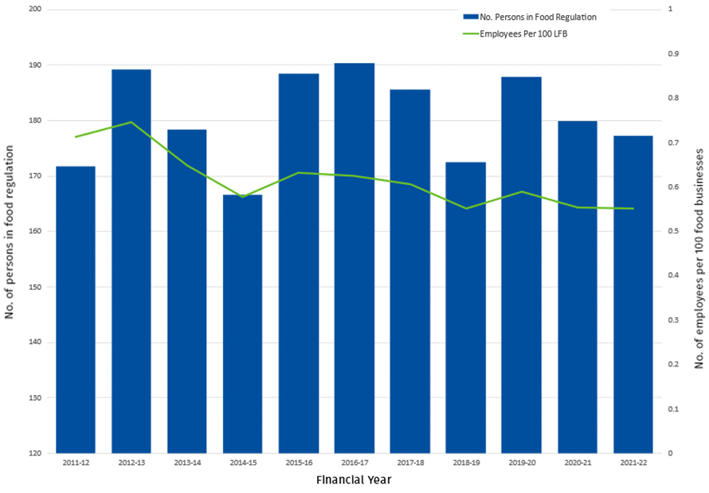

Conclusion
Results presented in this report demonstrate that licensed food businesses have high rates of compliance with legislated requirements.
A realistic aspiration of a food regulatory system is to ensure that a food business is subject to the same amount of regulatory scrutiny and enforcement, whether in a major city or a remote area. The key to ensuring consistency is inspection frequency. It is reasonable to anticipate that inspection frequency should be based on risk, including compliance history, with high-risk businesses inspected more regularly than lower risk businesses. However, inspection data captured in this report does not provide the discrimination necessary to compare regulatory oversight between local governments. To do so requires inspection numbers to be provided for non-licensed food businesses and to be based on a universal definition for risk and a specified frequency for each risk level. This will require a change in how local governments categorise food businesses.
Caution should also be applied when comparing local government food regulatory activities. As local governments do not have unlimited time and personnel, it is reasonable that resources are directed to activities that are anticipated to deliver high quality food safety outcomes e.g., providing information to businesses in a language other than English. This may influence the number of inspections that a local government needs to undertake.
Resources allocated to COVID-19 specific compliance activities over the past three reporting periods may have impacted the number of food business inspections undertaken in some areas, particularly complaint-related inspections.
Despite these constraints, this report allows local governments to broadly compare their results with those of other local governments with similar remoteness, numbers of licensed food businesses and numbers of persons committed to food regulation.

Further information
For further information in relation to the content of this report, please contact Food Safety Standards and Regulation via email foodsafety@health.qld.gov.au, or phone (07) 3328 9310.

Local government responses for 2021-22
Local government | Population | Licensed food businesses | Businesses with a food  safety supervisor | High risk businesses  requiring accredited FSP | High risk businesses with  an accredited FSP | Routine inspections | Re-inspections | Most inspections for one  premises | Complaints | Complaint inspections | Authorised persons | Employees committed to  food regulation (FTE) | Contractors used in food  regulation (FTE) | Improvement notices | Seizures | PINs | Licences surrendered | Licences suspended after  show cause notice | Licences immediately  suspended | Licences cancelled after  show cause notice | Prosecutions
Aurukun SC | 1,101 | 7 | 7 | 1 | 1 | 7 | 0 | 1 | 0 | 0 | 0 | 0 | 0.1 | 0 | 0 | 0 | 0 | 0 | 0 | 0 | 0
Balonne SC | 4,320 | 45 | 45 | 1 | 1 | 45 | 1 | 2 | 0 | 0 | 1 | 0.5 | 0 | 0 | 0 | 0 | 0 | 0 | 0 | 0 | 0
Banana SC | 14,513 | 122 | 116 | 5 | 5 | 130 | 40 | 4 | 11 | 8 | 2 | 1 | 0.13 | 4 | 0 | 0 | 0 | 0 | 0 | 0 | 0
Barcaldine RC | 2,849 | 45 | 45 | 0 | 0 | 12 | 1 | 2 | 0 | 0 | 1 | 0.1 | 0.1 | 0 | 0 | 0 | 0 | 0 | 0 | 0 | 0
Barcoo SC | 308 | 7 | 7 | 0 | 0 | 7 | 2 | 2 | 0 | 0 | 0 | 0.01 | 0.04 | 0 | 0 | 0 | 0 | 0 | 0 | 0 | 0
Blackall-Tambo RC | 1,905 | 38 | 38 | 3 | 3 | 38 | 0 | 1 | 1 | 1 | 1 | 0.5 | 0 | 0 | 0 | 0 | 0 | 0 | 0 | 0 | 0
Boulia SC | 458 | 6 | 6 | 1 | 1 | 5 | 5 | 2 | 0 | 0 | 1 | 0 | 1 | 0 | 0 | 0 | 0 | 0 | 0 | 0 | 0
Brisbane CC | 1,242,825 | 7,662 | 6,905 | 616 | 612 | 5,478 | 720 | 5 | 1,070 | 828 | 40 | 25 | 0 | 824 | 0 | 92 | 103 | 4 | 42 | 0 | 43
Bulloo SC | 337 | 17 | 18 | 1 | 1 | 12 | 0 | 1 | 0 | 0 | 2 | 1 | 1 | 0 | 0 | 0 | 0 | 0 | 0 | 0 | 0
Bundaberg RC | 99,215 | 539 | 309 | 34 | 34 | 371 | 27 | 7 | 45 | 35 | 3 | 1.8 | 0 | 14 | 0 | 1 | 0 | 0 | 0 | 0 | 0
Burdekin SC | 16,692 | 124 | 124 | 9 | 9 | 133 | 63 | 4 | 9 | 9 | 4 | 1.5 | 0 | 2 | 0 | 4 | 0 | 0 | 0 | 0 | 0
Burke SC | 419 | 10 | 9 | 0 | 0 | 0 | 0 | 0 | 0 | 0 | 2 | 0.25 | 0.15 | 0 | 0 | 0 | 0 | 0 | 0 | 0 | 0
Cairns RC | 253,748 | 1,164 | 1,164 | 83 | 83 | 992 | 280 | 5 | 95 | 54 | 10 | 7.5 | 0 | 40 | 0 | 13 | 0 | 0 | 3 | 0 | 0
Carpentaria SC | 2,090 | 28 | 28 | 0 | 0 | 30 | 0 | 1 | 3 | 2 | 1 | 0 | 0.03 | 0 | 0 | 0 | 0 | 0 | 0 | 0 | 0
Cassowary Coast RC | 29,157 | 261 | 261 | 21 | 21 | 209 | 5 | 2 | 5 | 5 | 2 | 1 | 1 | 8 | 0 | 0 | 0 | 0 | 0 | 0 | 0
Central Highlands RC | 27,836 | 195 | 171 | 7 | 7 | 101 | 11 | 3 | 5 | 8 | 3 | 0.95 | 0.7 | 0 | 0 | 0 | 16 | 0 | 0 | 0 | 0
Charters Towers RC | 11,794 | 96 | 96 | 0 | 0 | 96 | 43 | 3 | 10 | 10 | 1 | 0.5 | 0 | 0 | 0 | 0 | 0 | 0 | 0 | 0 | 0
Cherbourg ASC | 1,194 | 3 | 1 | 2 | 2 | 0 | 0 | 0 | 0 | 0 | 0 | 0.5 | 0 | 0 | 0 | 0 | 0 | 0 | 0 | 0 | 0
Cloncurry SC | 3,644 | 26 | 26 | 1 | 1 | 26 | 0 | 1 | 0 | 0 | 2 | 0.2 | 0 | 0 | 0 | 0 | 1 | 0 | 0 | 0 | 0
Cook SC | 4,511 | 88 | 88 | 2 | 2 | 90 | 20 | 5 | 5 | 5 | 1 | 1 | 0 | 0 | 0 | 0 | 2 | 0 | 0 | 0 | 0
Croyden SC | 266 | 3 | 3 | 0 | 0 | 1 | 0 | 1 | 0 | 0 | 0 | 0.1 | 0.1 | 0 | 0 | 0 | 0 | 0 | 0 | 0 | 0
Diamantina SC | 266 | 7 | 7 | 0 | 0 | 7 | 7 | 2 | 0 | 0 | 1 | 0 | 1 | 1 | 0 | 0 | 0 | 0 | 0 | 0 | 0
Doomadgee ASC | 1,387 | 0 | 0 | 0 | 0 | 0 | 0 | 0 | 0 | 0 | 0 | 0 | 0 | 0 | 0 | 0 | 0 | 0 | 0 | 0 | 0
Douglas SC | 12,337 | 215 | 215 | 15 | 15 | 113 | 7 | 3 | 11 | 3 | 2 | 1.4 | 0 | 0 | 0 | 1 | 0 | 0 | 0 | 0 | 0
Etheridge SC | 714 | 20 | 20 | 0 | 0 | 20 | 0 | 1 | 0 | 0 | 1 | 0.1 | 1 | 0 | 0 | 0 | 0 | 0 | 0 | 0 | 0
Flinders SC | 1,500 | 12 | 12 | 0 | 0 | 6 | 0 | 0 | 0 | 0 | 1 | 0.5 | 0 | 0 | 0 | 0 | 0 | 0 | 0 | 0 | 0
Fraser Coast RC | 111,032 | 525 | 525 | 51 | 51 | 131 | 32 | 5 | 72 | 59 | 7 | 3.75 | 0 | 13 | 0 | 1 | 0 | 0 | 0 | 0 | 0
Gladstone RC | 63,515 | 308 | 281 | 19 | 19 | 374 | 75 | 4 | 45 | 18 | 2 | 1.5 | 0 | 24 | 0 | 2 | 20 | 0 | 0 | 0 | 0
Gold Coast CC | 625,087 | 5,619 | 5,619 | 840 | 840 | 3,517 | 1,356 | 12 | 583 | 605 | 57 | 17.1 | 0 | 1,155 | 0 | 73 | 0 | 0 | 0 | 0 | 1
Goondiwindi RC | 10,310 | 97 | 96 | 2 | 3 | 85 | 75 | 3 | 2 | 2 | 2 | 1 | 0 | 75 | 0 | 0 | 0 | 0 | 0 | 0 | 0
Gympie RC | 53,242 | 329 | 329 | 17 | 17 | 115 | 60 | 2 | 21 | 21 | 5 | 2.5 | 0.75 | 8 | 0 | 0 | 3 | 0 | 2 | 0 | 0
Hinchinbrook SC | 10,920 | 78 | 78 | 6 | 6 | 78 | 10 | 2 | 3 | 3 | 1 | 0.6 | 0 | 0 | 0 | 0 | 0 | 0 | 0 | 0 | 0
Hope Vale ASC | 976 | 4 | 4 | 1 | 1 | 4 | 1 | 2 | 0 | 0 | 0 | 0 | 1 | 0 | 0 | 0 | 0 | 0 | 0 | 0 | 0
Ipswich CC | 229,208 | 923 | 923 | 116 | 116 | 594 | 169 | 7 | 112 | 112 | 7 | 4.5 | 0 | 57 | 0 | 9 | 0 | 1 | 1 | 0 | 1
Isaac RC | 22,046 | 184 | 179 | 3 | 3 | 43 | 0 | 1 | 11 | 3 | 1 | 2 | 0 | 0 | 0 | 0 | 7 | 0 | 0 | 0 | 0
Kowanyama ASC | 1,079 | 1 | 1 | 1 | 1 | 1 | 1 | 2 | 0 | 0 | 0 | 1 | 0 | 0 | 0 | 0 | 0 | 0 | 0 | 0 | 0
Livingstone SC | 39,398 | 221 | 210 | 17 | 17 | 169 | 26 | 5 | 10 | 4 | 2 | 2 | 0 | 7 | 0 | 0 | 10 | 0 | 1 | 0 | 0
Lockhart River ASC | 640 | 0 | 0 | 0 | 0 | 0 | 0 | 0 | 0 | 0 | 0 | 1 | 0 | 0 | 0 | 0 | 0 | 0 | 0 | 0 | 0
Lockyer Valley RC | 41,101 | 191 | 191 | 21 | 21 | 127 | 25 | 5 | 11 | 11 | 3 | 1.2 | 0.4 | 3 | 0 | 0 | 0 | 0 | 0 | 0 | 0
Logan CC | 345,098 | 1,304 | 1,304 | 150 | 150 | 1,773 | 307 | 12 | 589 | 518 | 20 | 14 | 3 | 392 | 0 | 5 | 0 | 0 | 0 | 0 | 0
Longreach RC | 3,647 | 42 | 42 | 3 | 3 | 30 | 0 | 1 | 1 | 1 | 1 | 1 | 1 | 0 | 0 | 0 | 0 | 0 | 0 | 0 | 0
Mackay RC | 121,691 | 661 | 661 | 46 | 44 | 400 | 70 | 5 | 53 | 53 | 4 | 2.75 | 0 | 15 | 0 | 1 | 0 | 0 | 2 | 0 | 0
McKinlay SC | 836 | 0 | 0 | 0 | 0 | 0 | 0 | 0 | 0 | 0 | 0 | 0 | 0 | 0 | 0 | 0 | 0 | 0 | 0 | 0 | 0
Mapoon ASC | 432 | 164 | 164 | 11 | 10 | 112 | 9 | 3 | 6 | 6 | 1 | 0.6 | 0 | 0 | 0 | 0 | 0 | 0 | 0 | 0 | 0
Maranoa RC | 12,825 | 236 | 236 | 8 | 8 | 156 | 48 | 4 | 28 | 28 | 1 | 0.5 | 0.2 | 5 | 0 | 0 | 0 | 0 | 0 | 0 | 0
Mareeba SC | 22,858 | 12 | 12 | 0 | 0 | 15 | 0 | 2 | 0 | 0 | 0 | 0 | 1 | 0 | 0 | 0 | 2 | 0 | 0 | 0 | 0
Moreton Bay RC | 476,340 | 2,002 | 2,002 | 235 | 235 | 1,398 | 277 | 4 | 102 | 102 | 17 | 7 | 0 | 32 | 1 | 2 | 0 | 0 | 0 | 0 | 0
Mornington SC | 1,025 | 1 | 1 | 0 | 0 | 0 | 0 | 0 | 0 | 0 | 1 | 0 | 0 | 0 | 0 | 0 | 0 | 0 | 0 | 0 | 0
Mount Isa CC | 18,727 | 128 | 128 | 15 | 15 | 256 | 40 | 25 | 35 | 45 | 4 | 4 | 0 | 5 | 0 | 3 | 0 | 0 | 0 | 0 | 0
Murweh SC | 3,971 | 42 | 42 | 1 | 1 | 42 | 2 | 2 | 0 | 0 | 1 | 0.2 | 0 | 1 | 0 | 0 | 0 | 0 | 0 | 0 | 0
Napranum ASC | 883 | 0 | 2 | 0 | 0 | 0 | 0 | 0 | 0 | 0 | 0 | 0 | 0 | 0 | 0 | 0 | 0 | 0 | 0 | 0 | 0
Noosa SC | 56,298 | 510 | 489 | 27 | 27 | 350 | 65 | 4 | 71 | 9 | 7 | 0.6 | 0 | 36 | 0 | 19 | 0 | 0 | 0 | 0 | 0
North Burnett RC | 10,068 | 98 | 98 | 8 | 8 | 83 | 10 | 2 | 5 | 5 | 2 | 1.5 | 0.1 | 0 | 0 | 0 | 0 | 0 | 0 | 0 | 0
Northern Peninsula Area RC | 2,781 | 15 | 15 | 0 | 0 | 0 | 0 | 0 | 0 | 0 | 0 | 0 | 0 | 0 | 0 | 0 | 0 | 0 | 0 | 0 | 0
Palm Island ASC | 2,098 | 0 | 0 | 0 | 0 | 0 | 0 | 0 | 0 | 0 | 0 | 0 | 0 | 0 | 0 | 0 | 0 | 0 | 0 | 0 | 0
Paroo SC | 1,679 | 26 | 26 | 0 | 0 | 23 | 23 | 2 | 1 | 1 | 1 | 0 | 1 | 0 | 0 | 0 | 0 | 0 | 0 | 0 | 0
Pormpuraaw ASC | 611 | 0 | 0 | 0 | 0 | 3 | 0 | 0 | 0 | 0 | 0 | 0 | 0 | 0 | 0 | 0 | 0 | 0 | 0 | 0 | 0
Quilpie SC | 698 | 17 | 17 | 0 | 0 | 14 | 14 | 2 | 0 | 0 | 1 | 0 | 1 | 0 | 0 | 0 | 0 | 0 | 0 | 0 | 0
Redland CC | 159,222 | 669 | 664 | 80 | 80 | 753 | 121 | 7 | 90 | 34 | 9 | 5 | 1 | 31 | 0 | 13 | 85 | 0 | 1 | 1 | 0
Richmond SC | 761 | 10 | 10 | 1 | 1 | 10 | 10 | 2 | 0 | 0 | 2 | 0 | 1 | 0 | 0 | 0 | 0 | 0 | 0 | 0 | 0
Rockhampton RC | 81,968 | 555 | 523 | 44 | 44 | 565 | 179 | 5 | 73 | 62 | 8 | 2.7 | 0 | 0 | 0 | 0 | 5 | 0 | 0 | 0 | 0
Scenic Rim RC | 42,984 | 386 | 381 | 15 | 15 | 32 | 12 | 5 | 36 | 36 | 3 | 1 | 0 | 8 | 0 | 5 | 0 | 0 | 0 | 0 | 0
Somerset RC | 25,057 | 171 | 171 | 10 | 10 | 140 | 4 | 3 | 10 | 10 | 3 | 3 | 0 | 5 | 0 | 0 | 3 | 0 | 0 | 0 | 0
South Burnett RC | 32,996 | 213 | 213 | 13 | 12 | 109 | 32 | 4 | 18 | 18 | 3 | 1.4 | 0 | 9 | 0 | 0 | 35 | 0 | 0 | 0 | 0
Southern Downs RC | 36,290 | 360 | 320 | 15 | 15 | 130 | 7 | 2 | 19 | 4 | 3 | 2.75 | 0 | 2 | 0 | 0 | 0 | 0 | 0 | 0 | 0
Sunshine Coast RC | 342,541 | 2,219 | 2,127 | 143 | 143 | 2,102 | 84 | 3 | 185 | 32 | 11 | 5 | 0 | 90 | 0 | 3 | 0 | 0 | 0 | 0 | 0
Tablelands RC | 26,244 | 230 | 228 | 8 | 8 | 187 | 29 | 3 | 13 | 13 | 2 | 1 | 0 | 0 | 0 | 1 | 38 | 0 | 0 | 0 | 0
Toowoomba RC | 173,204 | 942 | 942 | 96 | 80 | 603 | 176 | 5 | 131 | 47 | 6 | 3 | 0 | 168 | 0 | 41 | 30 | 0 | 4 | 0 | 0
Torres SC | 3,421 | 35 | 4 | 4 | 4 | 35 | 12 | 6 | 7 | 1 | 5 | 5 | 2 | 1 | 2 | 1 | 0 | 0 | 0 | 0 | 0
Torres Strait Island RC | 4,124 | 0 | 0 | 0 | 0 | 0 | 0 | 0 | 0 | 0 | 0 | 1.8 | 0 | 0 | 0 | 0 | 0 | 0 | 0 | 0 | 0
Townsville CC | 192,768 | 1,031 | 1,014 | 94 | 94 | 1,022 | 175 | 6 | 136 | 75 | 11 | 4 | 0 | 70 | 0 | 3 | 134 | 0 | 1 | 0 | 0
Weipa TA | 4,100 | 38 | 38 | 0 | 0 | 32 | 15 | 3 | 0 | 0 | 2 | 0.25 | 1 | 4 | 0 | 0 | 0 | 0 | 0 | 0 | 0
Western Downs RC | 33,843 | 281 | 281 | 16 | 16 | 187 | 20 | 5 | 24 | 24 | 2 | 0.5 | 0.1 | 3 | 0 | 4 | 0 | 0 | 1 | 0 | 0
Whitsunday RC | 37,152 | 484 | 484 | 16 | 16 | 178 | 87 | 3 | 16 | 11 | 1 | 1 | 0 | 3 | 0 | 1 | 0 | 0 | 0 | 0 | 0
Winton SC | 1,129 | 18 | 18 | 1 | 1 | 18 | 18 | 2 | 1 | 1 | 1 | 0 | 1 | 0 | 0 | 0 | 0 | 0 | 0 | 0 | 0
Woorabinda ASC | 1,019 | 1 | 0 | 1 | 0 | 2 | 0 | 2 | 0 | 0 | 1 | 0.2 | 0 | 0 | 0 | 0 | 0 | 0 | 0 | 0 | 0
Wujal Wujal ASC | 276 | 0 | 0 | 1 | 1 | 0 | 0 | 0 | 0 | 0 | 0 | 1 | 0 | 0 | 0 | 0 | 0 | 0 | 0 | 0 | 0
Yarrabah ASC | 2,505 | 5 | 5 | 0 | 1 | 10 | 5 | 4 | 6 | 6 | 1 | 1 | 0.1 | 0 | 0 | 0 | 0 | 0 | 0 | 0 | 0
Total | 5,156,138 | 32,126 | 30,819 | 2,958 | 2,935 | 23,937 | 4,913 | Ave: 3.2 | 3,796 | 2,948 | 304 | 155 | 21.9 | 3,115 | 3 | 298 | 494 | 5 | 58 | 1 | 45

2021 Census data was used to present Local Government area population; obtained from the Australian Bureau of Statistics via www.abs.gov.au/census

