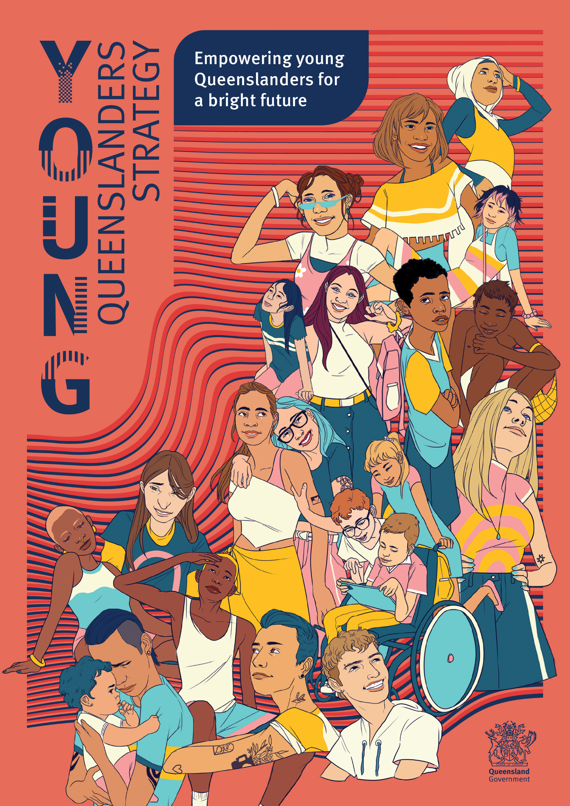

Acknowledgement
The Queensland Government proudly acknowledges and deeply understands that Aboriginal and Torres Strait Islander peoples are the First Australians and traditional custodians of the lands, waters, and seas we are all fortunate to enjoy across our State. We recognise their profound and unbreakable connections to their country, their stories and their distinct rich and diverse cultures. It is our utmost priority to honour and show our deep respect to Elders, both past and present, for their invaluable contributions to our society.
We value and embrace our responsibility to ensure equity, strength, and advancement through shared decision-making and ensuring culturally safe and responsive services for Aboriginal and Torres Strait Islander young Queenslanders. We strive to improve life outcomes for Aboriginal and Torres Strait Islander peoples through collaborative efforts as individuals, communities, and governments.
We are immensely proud of the remarkable First Nations leadership, unparalleled excellence, and unwavering spirit of partnership that helped formulate this strategy. We are firmly committed to actively listening to the voices and values of First Nations young Queenslanders, supporting them on their journey to self-determination and empowering them to shape their own bright future.
We recognise the pivotal role played by First Nations young Queenslanders in our communities, and we are dedicated to empowering and supporting them as emerging leaders. We are committed to help unleash their full potential to build a prosperous future for themselves, their families, and our communities.
As we thoughtfully reflect on the past and boldly envision the future, we actively walk together on our shared journey of reconciliation. We firmly believe that all Queenslanders are equal and will continue to work to ensure the rich diversity of Aboriginal and Torres Strait Islander cultures and communities across Queensland are fully recognised, respected, and valued.
This Acknowledgement was written by Liahni Truscott, Senior Program Officer within the Office for Youth in the Department of Housing and Public Works. Liahni is responsible for delivering the Queensland Indigenous Youth Leadership Program and is a proud Wakaya woman who is passionate about promoting cultural change and safety.

Contents
Acknowledgement 2
Artwork 4
First Nations Youth Strategy Engagement Group message 5
Youth Strategy Engagement Group message 6
Young Queenslanders Strategy: empowering young Queenslanders for a bright future 7
For all young people 9
Foundational principles 10
Pathways on the journey of life 11
Pathways on the journey of life 12
Participate 13
Participate: Amelia Shaw 14
Participate: creative piece 15
Cultivate their futures 16
Cultivate their futures: Rachel Baxter – soaring high in aviation 18
Cultivate their futures: creative piece 20
Live their best lives 22
Live their best lives: Rianna Druery 24
Live their best lives: creative piece 25
Thrive in our communities 27
Thrive in our communities: Seleena Blackley 29
Thrive in our communities: creative piece 31
Our shared journey forward 33
Language statement 34

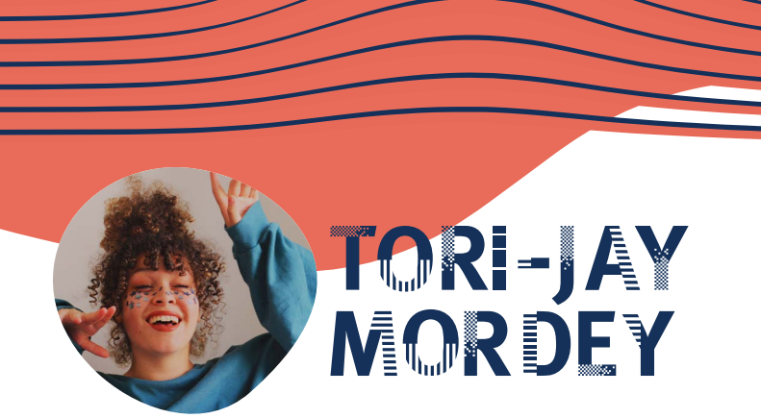

Artwork
Tori-Jay Mordey is an established Indigenous Australian illustrator and artist based in Meanjin/Brisbane. Growing up she openly shared both her Torres Strait Islander and English heritage, which is often reflected in her contemporary Indigenous art practice. She produces work based around her family and siblings as a way of understanding herself, her appearance and racial identity. Despite moving to the big city for her artistic practice, Tori-Jay still considers Thursday Island her home—amongst the smell of the salt water and the feeling of sand underneath her feet.

First Nations Youth Strategy Engagement Group message
We are the First Nations Youth Strategy Engagement Group. We are Aboriginal and Torres Strait Islander peoples from nations, communities, and countries from across Australia who call Queensland home.
We’re young, proud and loud. We’ve stepped up to inform the Young Queenslanders Strategy for all Queensland’s young people. We have our voice and we have lots to say. We have a vision for a strong and deadly future.
As young Aboriginal and Torres Strait Islander Queenslanders, we have heard from our community, from our parents, brothers and sisters. We have learned the stories of the past and heard the songs of our ancestors. We have dreamt of a new beginning and understand our place is actualising it.
Walking this path together, not alone, we can break the intergenerational cycle and the effects of trauma. We will achieve a future where Aboriginal and Torres Strait Islander young people’s voices are continually heard, recognised, and trusted. A future where we have closed the gap between Aboriginal and Torres Strait Islander peoples and non-Indigenous peoples. A future where our people have treaties that recognise our sovereign right to the land, seas and skies. A future where we have a voice that’s valued, and we are supported to lead decisions that affect us. We see a future where our culture is respected and celebrated by all Queenslanders.
There is much to do, and our Elders are growing old. One day it will be our responsibility to teach the next generation. We do this for them, we do it for all of us. To all Queenslanders, we invite change, we ask that you walk this journey with us to a ‘Deadly’ future.
First Nations Youth Strategy Engagement Group

Youth Strategy Engagement Group message
This strategy is for the young people of Queensland who inspired us to advocate, our families and communities who supported and cared for us, and the young people of tomorrow, for whom this strategy was made.
We have shared our diverse and unique perspectives throughout this process, but we acknowledge that young Queenslanders are infinitely more diverse than the membership of the Youth Strategy Engagement Group. We want this strategy to reflect and respond to the needs of every young person and ensure that they are continuously involved in decisions made on our behalf.
Our vision is that every young Queenslander is safe, supported and cared for into adulthood. We want to be empowered, valued, and respected, and we want our voices to be heard now and into the future. This strategy is just the first step in a long journey, but it is a step towards a better future and a step we’ve taken together. We encourage every young person to continue this journey. Use your voices and your passion and together we will make a brighter future.
Youth Strategy Engagement Group

Young Queenslanders Strategy: empowering young Queenslanders for a bright future
Our vision: Queensland’s young people are empowered to actively participate, cultivate their futures, live their best lives, and thrive in our communities
The landscape of our society is constantly changing, and this evolution is more significant for our young people, aged 12 to 25, who are on their journey towards adulthood. As a government, we recognise that as times change, so do the most important issues faced by young people.
Whether it’s building new relationships or skills, starting your first or fourth job, moving out of home and into the rental market or purchasing your first property, tackling school or university, or learning to drive – every chapter in each person’s story plays a key part in who they are, how they connect, and how they thrive. All young people should be able to move through these chapters of life with confidence, purpose and support.
To make this possible, young people need the right support at the right time as well as resources and systems that grow and adapt with them. But more than that, they need to be seen as co-creators of the policies, programs and services that shape their lives. Their knowledge, insight and lived experience must be central to how we plan and deliver solutions.
Our young people deserve a seat at the decision-making table, and genuine opportunities to work collaboratively with government to create innovative solutions for the issues that impact them now, and into the future. This strategy is grounded in that belief: that sustainable change happens when young people are partners in shaping it.
We’ve listened carefully to what young Queenslanders have shared. Now it’s time to act – by embedding their voices and ideas into government action, and delivering responses that reflect their diversity, strengths and ambitions.
To support this, we’ll periodically release Sentiment Snapshots. These reports will offer a point-in-time view of young people’s diverse experiences, perspectives, and ideas for a brighter future. Co-developed with young Queenslanders, each Snapshot will inform how this strategy is delivered over time.
Every young person deserves to be seen, heard and supported. These insights will help us stay focused and accountable to respond to what matters and create meaningful change alongside the young people who know their lives best.
This ongoing process of listening, partnering and adapting will continue throughout the life of the strategy. It will shape future action plans and reflect our long-term commitment: that young people are not just the reason for this work – they are active stewards of it, every step of the way.

We believe every young person in Queensland has the power and potential to thrive—and that it’s our shared responsibility to remove the barriers that stand in their way. Stronger, more connected communities aren’t built by reacting to problems after they emerge. They are built by investing early in young people’s wellbeing, and in the systems that support their success.
Young people across Queensland have told us that they want to feel safe, connected with community and to have meaning in their lives. While many young people are already well on their journey to success, some feel they are unprepared for adulthood and want to obtain real-world skills that will better equip them to be ‘ready for life’.
It is time young people felt empowered to take control of their lives and to design the map that will guide their individual pathways towards self-determination, regardless of their circumstances, lived experiences, abilities, age, culture or where they are on their journey.

For all young people
As we continue to build more inclusive communities, young people have the space and opportunity to explore their individual identities and reflect on how their experiences, relationships and backgrounds can influence their lives.
Each person's identity is made of different pieces. Each element may have their own needs and when they are brought together, they may interact or conflict in unique ways. Intersectionality is the concept that examines how these different aspects of identity intersect and interact, shaping a person's perspectives and experiences. As we continue growing as a society, our understanding of these dynamics and the corresponding support a person may need will refine as we gain better understanding of intersectionality.
There is a clear need for us to work together to create strong systems, relationships, and supports that will affect environments and outcomes for young people as they navigate the pathways on their own journey through life.
Ensuring our programs, interventions, and services are accessible for all young people is at the heart of our vision for the future. We commit to working together across government to build a more equitable and supportive environment for everyone, particularly those who may face greater challenges in accessing opportunities as they navigate life’s ups and downs, such as the impacts of discrimination, financial or relational stress, social isolation and loneliness, and other stressors. Our commitment is made to all young people including young people who:
- are Aboriginal and/or Torres Strait Islander
- identify as women, girls, non-binary, or gender diverse
- have lived experience of disability or chronic illness
- are Culturally and Linguistically Diverse
- identify as LGBTQIA+
- are based in regional or remote areas
- are young carers or parents
- are currently struggling to find a job or retain employment
- are in need of addiction support services
- have experience of the justice system
- have experience of homelessness or housing stress
- have experience with of out-of-home care
- are impacted by domestic and family violence and abuse.

Foundational principles
The Young Queenslanders Strategy helps us to create the systems, structures and enablers that will support and empower every young person to navigate their lives with confidence as they learn to participate, cultivate the skills they need, live their best lives, and thrive in our communities, generating economic and ecological prosperity and common wellbeing for current and future generations to enjoy.
The Young Queenslanders Strategy is underpinned by five foundational principles that will guide us towards effecting meaningful change for young people:
Equity and access supporting young Queenslanders in our communities with fair and flexible access to the programs and services they need.
Informed decision-making supported by the responsible and ethical collection, use and sharing of data that accurately represents young Queenslanders.
Rights affirming approach which recognises the dignity and worth of all human beings and fosters an environment where young people are empowered, respected, and provided with the necessary conditions to exercise their rights in line with the Human Rights Act 2019.
Empowerment to develop the autonomy of young people and promote their inherent capacity for self-determination.
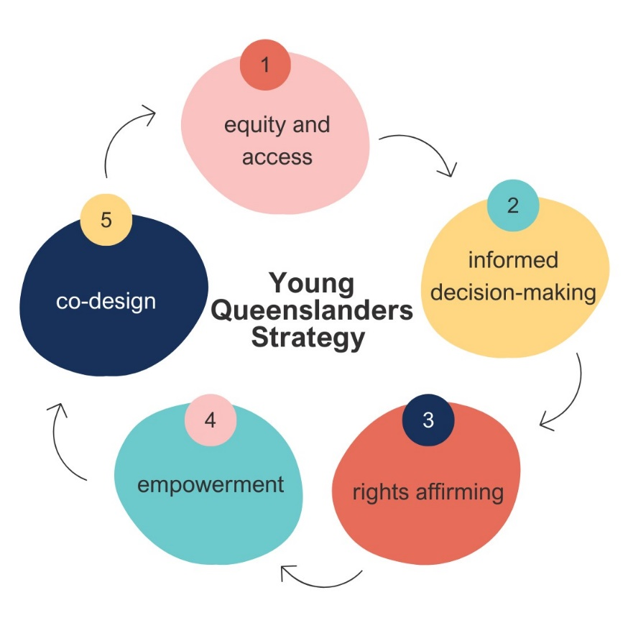
Co-design to respectfully and meaningfully create alongside young people ensuring their contributions are valued regardless of their age, abilities, culture, or circumstances.

Pathways on the journey of life
Life is a journey, and there is no ‘one size fits all’ approach to navigating its early stages.
The Young Queenslanders Strategy recognises a young person’s right to choose the pathways they take in life.
Whether you remember internet dialup and the fear of picking up a landline while someone was browsing the web, or you arrived with a smartphone in your hand – each generation has a distinct perspective and cultural identity influenced by the historical events and societal changes that mark their lives.
Every young person represents a unique set of perspectives, talents, and aspirations that contribute to the richness and diversity of our shared social tapestry in Queensland.
This strategy will accelerate us towards a Queensland where young people are empowered to build ‘identity capital’– a valuable collection of personal assets and resources people amass as they navigate life and construct their identity. These assets range from education, skills, experiences, achievements, to social connection and will support them on their individual journey to connect and contribute to our communities.
Building on the foundational principles, the strategy provides a framework to respond to the themes that we heard during consultation, and the hopes and aspirations of young Queenslanders. Through the delivery of adaptable programs and services, we will support and guide young Queenslanders on their pathways to:
Participate in the world around them through exploration and positive influence.
Cultivate their futures supported by access to tailored opportunities that nurture their unique needs and interests.
Live their best lives empowered and equipped with the information, resources and support they need to get there.
Thrive in our communities knowing they are connected, celebrated and resilient.

Pathways on the journey of life
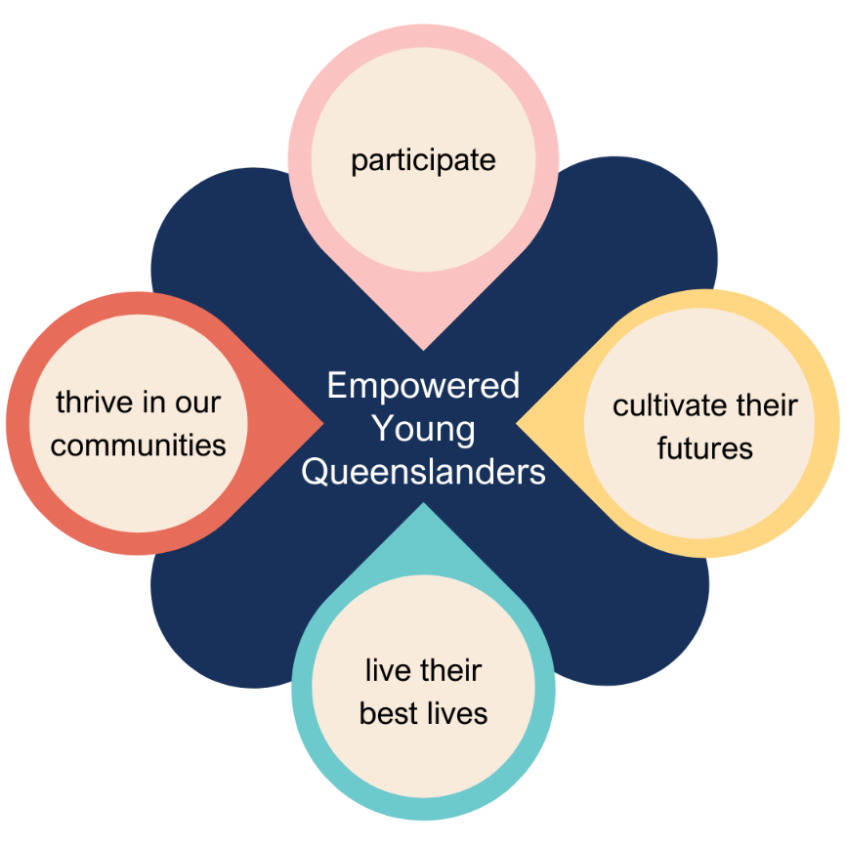
Underpinned by our foundational principles, this framework encompasses key themes identified by young people. It serves as a map for our collaborative actions and will incorporate new themes identified by young people throughout the life of the strategy, to drive positive change.

Participate
Young people participate in the world around them through exploration and positive influence.
Taking part in the decisions that influence the world around us helps us feel included, heard, and respected by our community and peers, giving us a sense of meaning and purpose in our lives.
Inviting young people to explore and genuinely participate in the various systems around them makes them feel valued and opens pathways for them, enabling them to drive enduring impacts on our communities and engage in shaping the future of our state for generations to come.
Beyond this, when young people are meaningfully engaged throughout the design and implementation of policies and programs, they provide crucial, creative, and innovative insights back to us that can address the intricate needs of their cohort.
The Young Queenslanders Strategy provides increased opportunities for young people to collaborate with us in the ways that work for them, ensuring every young Queenslander continues to be afforded the fundamental right to take part in public life and our communities. Our model is built on the mutual exchange of value, connecting with young people from all walks of life, storytelling, and curiosity for the collaborative ‘next’.
We will strengthen our commitment to providing young people with the knowledge they need to actively participate in truth telling. Their voices will be respected, valued, and meaningfully actioned, allowing them to play a significant role in the collective journey towards healing and reconciliation.
We recognise the diverse perspectives of young people and invite them to join us to create dynamic and collaborative solutions to the issues that impact them now and into the future.
Young people have identified key themes that will guide our actions under this pathway:
Responsive government
Educational programs
Genuine participation, co-design and influence
“Hold regular youth engagement opportunities in every electorate. Foster innovative ideas and support young people …to achieve their potential and further their passion for positive change.”
“I think the younger generation should be able to give the government opinions on what we want to shape our world into.”

Participate: Amelia Shaw
Amelia Shaw exemplifies the transformative power of engaging young people in government processes and educational programs. The Queensland Government supports YMCA’s Queensland Youth Parliament, which provides a mock parliamentary process to develop leadership and communications skills in young people representing all constituencies across Queensland.
Amelia’s journey began in 2008 when she participated in Queensland Youth Parliament, becoming a Youth Member for Townsville. Over the years, her involvement has grown, culminating in her appointment as a director of the National Board in 2020 and is currently serving as the Vice President of Y Queensland. In 2023, Amelia took her passion for youth engagement global with an appointment to YMCA of Asia Pacific Board as Vice President.
Taking part in this program scaffolded Amelia to create enduring impacts on her community and ignited Amelia’s passion for promoting young voices and ensuring their representation in conversations about Queensland’s future. In 2012, Amelia helped found the National Indigenous Youth Parliament which saw 50 young Indigenous Australians from across the country come together to write and present pieces of legislation to Federal Parliament.
Embodying the belief that “leadership isn’t about being somebody, it’s about doing something”, Amelia’s journey underscores the critical importance of young people participating in government processes and educational programs. Through her involvement in Youth Parliament, she has demonstrated that empowering young voices leads to informed and inclusive decision-making.
Amelia’s commitment to supporting new young voices, advocating for inclusivity, and collaborating with government and communities underscores the importance of empowering the next generation of leaders. This, in turn, contributes to fostering an ongoing cycle of empowerment.
As we celebrate Amelia’s achievements, we recognise the capability of every young person to drive meaningful change when our communities provide them with the opportunities and the support they need.


Participate: creative piece
Cody is a writer studying marketing and writing at UQ. He enjoys writing Young Adult and Middle Grade fantasy, with a creative mission to create more fiction for young people by young people. He works as Queensland Writers Centre's Community Officer, where he looks after membership, the Writing Friday program, and other community-focussed programs and events.
“For my piece, I considered participation in both public life and personal life. I feel that having a say is just as much about taking control of your personal life as putting your voice out there. That's why I wanted to write about the person who, to me, has always represented both sides of that.”
Every day
I used to think life was something that happened to you.
It was a lot easier that way. Go to school five days a week, watch YouTube seven nights, and let the bigger picture sort itself out. When you’re young, it usually does. Then one day you find yourself in a McDonald’s drive-thru on the worst day of your life asking mum to order a cheeseburger.
My nana Claudia Hargreaves was an anomaly of a woman. Never before has there been someone with such a drive for kindness, but such rigidity as a piano teacher. I was her last student, when she was 86 years old. And while she had a heart that rivalled the power supplied by splitting the atom, she left no wriggle room for missing practice. When I was her student, I had to practise every day. Just like she used to play the piano every day.
We saw her death coming from long away. First her memories started slipping. Then any kind of conversation became impossible. There was the day she was moved into hospital. But it was the day I came to visit her and saw what she’d become – saw how delicate she was now – that it sunk in. It was only once I was sitting in the McDonald’s drive-thru that night, waiting for a cheeseburger, that I realised who she really was.
She was the woman who danced in the street at the end of the Second World War. She was the woman who became a piano teacher when women weren’t supposed to be working. Who kept teaching music till she was 86 years old. She raised three kids, and lost her husband three decades too soon. And every day, she played the piano.
Life didn’t happen to Claudia Hargreaves. She made it happen. She made her future. And everything she touched, she made good. Just good.
That night in the McDonald’s drive-thru, I decided that a life where I was even half as good as her was the only life worth living. I decided that if I want to be a writer, I can’t just sit back and wait for it to happen. I have to make it happen.
I still play the piano every day I can. But it isn’t something that just happens to me anymore. It’s the best choice I make every day.

Cultivate their futures
Young people cultivate their futures supported by access to tailored opportunities that nurture their unique needs and interests.
As we grow and build our identity and personal and professional networks, we cultivate ‘identity capital’ and a sense of responsibility and empathy for our peers and the local community – which generates a desire to move towards future goals.
Young people deserve an environment that allows them to learn about who they are and who they want to be. Systems and programs should be responsive and attuned to individual needs, ensuring that each young person can chart a unique course towards personal and professional fulfillment.
Our holistic approach recognises the importance of self-discovery by combining traditional forms of experience such as education and training, with access to volunteering, research, and job opportunities to support young people to develop skills they need now and to build successful careers in the fields that interest them. This multidisciplinary approach provides economic and social opportunities for young people as well as practical benefits for the world around us.
The Young Queenslanders Strategy supports the delivery of enhanced educational and learning opportunities to inspire young people to learn and grow. This leads to a diverse range of responsive occupational pathways and evolving positive transitions from school to work and provides opportunities for them to collaboratively solve the challenges they face.
Empowering young people to respond to their environment and circumstances in ways which motivate and interest them can spark life-long passions that can be nurtured and developed as they flourish into adulthood, cultivating and improving the future of Queensland as a whole.
We recognise the importance of artistic and creative expression in capturing varied perspectives, building skills, and harnessing the meaning of our experiences through form. Through creative activities, including those that contribute to the environment around us, we generate a sense of wellbeing and belonging in our communities and raise awareness of the connection we have to each other through our shared stories. Embracing the boundless potential of our young people and their unique perspectives, we’ll champion their innovative contributions, propelling us boldly into the future.
Young people have identified key themes that will guide our actions under this pathway:
Careers and employment
Business and entrepreneurship
Education and training
Building creative and innovative generational futures
“[Government] should provide school students with more resources to research and experience their desired career. Educate school students on real life workplace problems/situations, showing how they can resolve or know when to report workplace unfairness or abuse.”

Cultivate their futures: Rachel Baxter – soaring high in aviation
Rachel Baxter's path from a high school student passionate about aviation to becoming a respected figure in the aerospace industry illustrates the positive role immersive school industry programs can play in shaping the careers of young Queenslanders.
Facilitated by the Aerospace Gateway to Industry Schools Program, Rachel's story is a seamless blend of education, determination, and strategic support to elevate young talents into thriving professionals.
From her early days at Aviation High School in Brisbane, Rachel's curiosity soared beyond the traditional classroom. Diving into aerospace electives, she embraced the unique opportunity to explore the aviation sector, a journey that led her to work experience at Qantas Hangar 3. This wasn't just any school project; it was Rachel's first real taste of the aerospace world, a pivotal moment that shaped her future ambitions.
Rachel's decision to pursue an aviation trade, stepping away from the conventional university path, showcases the Queensland Workforce Strategy's core value of fostering diverse career pathways. Her involvement with the Aerospace Gateway to Industry Schools Program provided invaluable industry insights and highlighted the importance of tailored education programs in unlocking doors to specialised fields.
The crowning moment of her high school career was being awarded the Female Aircraft Maintenance Engineer (FAME) Aeroskills Scholarship by Aviation Australia. This achievement wasn't merely an accolade; it was a launching pad that propelled her into an apprenticeship with Boeing Defence Australia, marking the beginning of her professional journey in aviation.
However, Rachel's trajectory wasn't without its turbulence. A medical reaction to her work environment led to a significant career pivot, demonstrating her resilience and adaptability. Transitioning to a role as a Security Officer at Northrop Grumman Australia, Rachel continued to soar, proving that with the right mindset and support, challenges can lead to new opportunities.
Beyond her professional achievements, Rachel's story is also one of inspiration and mentorship. As an ambassador for Women in Aviation Australia, she lights the way for young women aspiring to aviation careers.
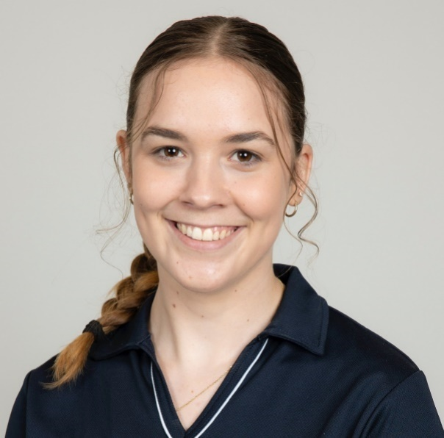
Rachel's journey is a testament to the effectiveness of the Aerospace Gateway to Industry Schools Program and its alignment with the goals of the Queensland Workforce Strategy to strengthen and grow Queensland’s workforce. Her story demonstrates how the right mix of school and real-world experience can bridge the gap between young aspirations and professional success, ensuring a vibrant future for Queensland's workforce and industries.

Cultivate their futures: creative piece
Svetlana Sterlin writes prose, poetry, and screenplays in Meanjin. She has been recognised in the 2023 Richell Prize and the State Library of Queensland Young Writers Award. Much of her work deals with coming of age amid uncertainty, which is why the theme of young people cultivating their futures spoke to her. Her writing appears in Island, Westerly, Meanjin, Cordite, the Australian Poetry Anthology, and elsewhere. A swimming coach and former swimmer, she ties most things back to swimming, including her online publication, swim meet lit mag.
On Grieve Road
We’re going somewhere. A dip in the road foretells of the valleys ahead.
Our destination is the same as every other day: the swimming pool from which we’re about to be evicted. Its sides are lapped by water a few shades too blue for my father’s paling eyes. He’ll inspire us to swim smarter, not harder. Our warm muscles will ache as we laugh and splash and tease.
Damp air swirls through the window; it tastes of sunlight and warmth and twirls through my hair.
We’re descending the last hill on Grieve Road. Time has leached colour from the brick walls and picket fences flitting by.
The sun bakes the cement and brick and metal, and us, too.
A flash of blue and red; the glare of sunlight catching on police tape. The putrid parody of yellow is enough to warn potential trespassers away. I make a mental note to use this line in the memoir I’m writing for class.
I twist around to peer through the rear window. ‘What was that?’
‘I don’t know,’ says Dad.
In the last seven months, various uniformed figures have parked vans in the otherwise empty driveway and ducked under the yellow tape.
Half of the tape disappeared from the fence a few weeks ago. One flimsy strip remains, tied to a tree beside the house, closing off the backyard.
The windows reveal only hollow rooms; the driveway remains empty.
Dad’s tenure ends; my swimming career, too. We stop driving along Grieve Road, but I can’t let go of what happened there. Like my father, I should forget about it, let it sink into the past along with the last decade: my swimming career, Dad’s first steady job, my transition from childhood to adulthood.
At the end of semester, I submit my memoir. I graduate from university. I’m not sure what to do with my writing degree.
Dad suggests that I write an exposé on the circumstances of his redundancy and send it to a newspaper. I could, but I don’t.
I make excuses: ‘What if we get sued for defamation or something?’ But that’s not what’s stopping me from writing it.
Likewise, when I ask Dad what he thinks happened on Grieve Road, he encourages me to research, to write about it. ‘It’s what your best at, isn’t it?’
I scour the Internet, but when the pixelated images I find don’t divulge any information, when the news outlets don’t report on it, I open my laptop and fill the hollow rooms and the empty driveway with a story that paves the way to my future. Like water spilling over the pool’s edges, my words fill the empty spaces with memories of my friends, of what it was like to strive towards something as a team, to be part of a community, to leap from one goal to the next, always reaching for something higher up ahead.
Among the lessons my father taught us is that, for better or worse, the future is a reflection of the past.

Live their best lives
Young people are enabled to live their best lives empowered and equipped with the information, resources and support they need to get there.
As we grow older, we are faced with more choices, tougher obstacles, and bigger responsibilities. This can be overwhelming if we don’t feel supported and equipped with the resources that we need to face challenges.
The Young Queenslanders Strategy provides a foundation to meet young people where they are and support them with the tools, skills, and resources they need to empower themselves, enabling them to boldly navigate their own journeys and confidently move towards ‘living their best lives’.
Young people have a right to autonomously navigate life’s challenges and to resolve issues in their own way. By encouraging young people to build resilience and harness their individual strengths and talents, we hope to empower and support them to intrinsically respond to a range of life experiences.
We acknowledge that every young person’s journey is unique, and that no two people will have the same definition of ‘living their best lives’. Young people are diverse and may require different levels of access to information and services depending on who they are, where they live, and how they engage with the world. For example, young people who have less access to support at home or in our communities, may face additional barriers and inequities when compared with others.
That is why the Young Queenslanders Strategy strives to ensure all young people are armed with trustworthy resources to help them make informed decisions – no matter where they are on their journey.
Young people have identified key themes that will guide our actions under this pathway:
Access to information
Health and wellbeing
Home and community
Life skills
“I think it would be really good to develop a website that informs students on 'navigating life', [it] could have sections on learning how to cook, how to prepare tax return, lists of scholarships, etc…I know current private sector information pages aren't very effective. I think linking it within a government website would lean some credibility and make students more likely to engage.”
“It is hard to get support that is confidential and without judgement. Things have to be really bad before you get help, you can’t get help unless you are at the crisis end but it’s still important to get help when you aren’t at the desperate stage.”
“I have seen too many young people grow up without parental figures and once they need to do something like change their tyre or do some taxes they are lost. Maybe we should try and teach more Queenslanders about every day basic life skills.”

Live their best lives: Rianna Druery
My name is Rianna, I am a 21year old female who has been connected with many government services throughout my AYA [Adolescent and Young Adult Transition of Care] years. At 17, I was diagnosed with brain cancer; Medulloblastoma. I had surgery, radiation, and chemotherapy in a mix of public, private, paediatric, and adult hospitals. On my first week of chemo, Covid was declared a pandemic, and the world went into lockdown. My health team, consisting of clinicians, nurses, social workers, and psychologists, supported me immensely as I struggled with feeling alone and isolated. It took a very long time for me to meet anyone over the age of 12 or under 60 with cancer or chronic illness.
I finished chemo and after my last admission I had to navigate transitioning into the adult system at 18. Not getting back to school and having my friends established in studies or working, I felt lost. Cancer has taken a huge toll on my mental health and is unfortunately an experience only those who have gone through similar understand. I still have multiple appointments seeing specialists throughout the healthcare system who support me both physically and emotionally.
A clinician of mine introduced me to the Queensland Youth Cancer Service, Youth Advisory Group (YAG) as I wanted to connect with, meet, support, and use my story to assist and advocate for others experiencing cancer and chronic health challenges. I joined the YAG to use my experience to support, assist and advocate for those experiencing cancer and chronic health conditions. Being in a supportive youth engagement role has given me the confidence to share my story, be involved in, discuss, and put forward ideas in multiple meaningful and important projects and decisions on youth care. All of the work we have done has been youth-led, with co-design opportunities on statewide models and service delivery.
I’ve also been involved in other projects outside of cancer including with the Queensland Child and Youth Clinical Network and these continued opportunities have helped me feel empowered to contribute my experiences, speak up for myself and share my insights and opinions.
These opportunities have given me a purpose in life, as I feel I am a part of improving experiences and services for youth and they have helped me to develop my skills in communication, teamwork, public speaking, collaboration, and critical thinking.
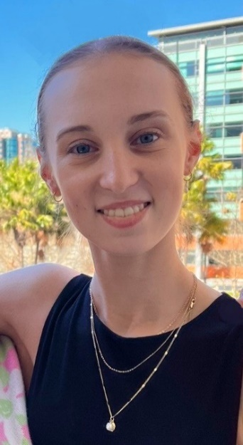

Live their best lives: creative piece
My name is Matt Bond. I am a proud Queer, Munanjahli, Bidjara person and 18 years old. I’ve been raised by a family of seven with three cats that I care for at home. I’m known for my shared experiences that I express through various writings to my communities, putting a spotlight on my personal journeys to communicate. I love attending performances, spoken word and several meetups that centre around the experience of being a Blak Queer. It helped shape me and push me to pursue future careers in which I can guide youths like me to navigate our world.
I wanted to link ‘living their best life’ to the transitioning of gender, specifically my transition. How such small things overall helped me and bettered my life from the people around me.
I used to cry a lot in my room. I used to cry about the world around me, the never-ending fights, the nightmares, but most importantly, I cried about the words I could never use. I cried about the words that could never truly express how I felt or continued to feel, and no one could hear me but my walls.
I would spend countless nights crying to my toys that I could never ‘fit in’ like my brothers could, that I could never do the same things that they could but only because I didn’t look like them.
I remember being envious of my brothers’ bonds with each other, this ‘brotherhood’ that I could never be a part of because I could never be like them. I could never be like them, and I cried.
The word was being transgender, but at the time, the only word I could think of was being broken. I was broken for wishing these things and broken because I could never achieve what I wanted. I’ll never be an older brother, I’ll never be the person I want to be and for that, I am broken.
I am broken, I am hurt, and I am lost in a sea of words that don’t define my emotions.
And I would cry because it was yet another thing that was out of my reach. I would never get what I wanted.
It wasn’t until I got older that I discovered the words I needed to free myself. And once the words were found, they were all I could say.
“I want to use he/him.”
“I want my name to be Matt.”
“I want to be an older brother.”
I wanted and I craved the validation that my brothers sought after so easily; I wanted what they had. I wanted so badly to be them that I cried.
I cried because for once in my life, I was getting something that I had desperately wanted for my whole life. I was getting what I wanted, I was getting what I begged for, I was getting what I deserved.
And I cried.
I cried when my younger brothers used my pronouns, I cried when my mum said she had 5 sons, and I cried when my dad offered his name for me to take.
I cried because suddenly the world didn’t hurt as much anymore, and everything made sense.
I cried because I wasn’t broken, I just wanted to be a boy. It was such a simple statement and yet it took my whole childhood to figure it out. Because all I could ever do was cry.
When life is too hard you cry, and I cried a lot.
But now I can cry with the freedom and knowledge that I am who I am now. I cry with the support of my family behind me, and I cry with their love in my heart.
I cry with happiness.
I cry with freedom.
I cry with pride.

Thrive in our communities
Young people thrive in our communities knowing they are connected, celebrated and resilient.
We acknowledge Queensland’s Aboriginal and Torres Strait Islander peoples’ distinct cultures and knowledge and as the traditional custodians of our state. We honour their deep connection to the vibrant lands, sky, and waters where we live and grow.
This strategy provides opportunities to embrace strengths-based language and the stories and practices shared by First Nations young people. It aims to support them as they exercise their right to belong to community and to freely determine their own development, as they build generational skills on Country and drive change in their local communities. Being part of a community and having shared aspirations with the people around us can foster a sense of connection, togetherness, and belonging. Finding our place in the world provides meaning in our lives and allows us to be part of something bigger than ourselves.
Our First Nations young people have shared that the key to their wellbeing is feeling connected to community and culture. For many, this involves understanding their ‘mob’ (kinship network) and ancestral ties, strengthening their inherent bond with their Country, as well as forging strong community connections and relationships. This sense of community and cultural richness are fundamental to the health and wellbeing of young First Nations Queenslanders.
This strategy harnesses opportunities for young people to play their part in building climate-resilient, inclusive, and cohesive communities that are equipped to adapt to our ever-changing physical and digital worlds; a community where everyone works together towards a brighter future.
By bolstering our partnership opportunities and delivering programs and initiatives that promote leadership and improved social cohesion, while supporting young people to travel where they need go, we strengthen our communities as they continue to grow and prosper.
The Young Queenslanders Strategy aligns with the vision of Communities 2032 where Queensland’s diverse communities support and empower every person to connect, participate, contribute, and thrive.
Young people have identified key themes that will guide our actions under this pathway:
Science, climate change and world issues
Connection
Transport
Celebrating culture and diversity
“[Climate Change] is making me rethink if I want to have children as the issues I see now are just going to become worse. First Nations knowledge has successfully managed the Australian climate for thousands of years – we should be using this knowledge now.”

Thrive in our communities: Seleena Blackley
My name is Seleena, I am a proud 20-year-old Kalkutungu, Waanyi and Torres Strait Islander woman. Born and raised in Mount Isa, far North-West Queensland on the traditional lands of my Kalkutungu people. I am an emerging leader within my community as a Youth Specialist and Senior Cultural Facilitator of Kalkutungu language, dance and traditional practices.
I am an emerging leader within my community of Mount Isa and have demonstrated leadership qualities from a young age. Alongside working as a Youth Specialist, I also casually work as a Senior Cultural Facilitator for my family-owned business, Malkarri. As a Senior Cultural Facilitator, I facilitate Kalkutungu dance, language and cultural practice workshops throughout the year. While facilitating I work to create a culturally safe space for Indigenous and non-Indigenous peoples to learn about Kalkutungu culture.
Growing up in a rural and remote place like Mount Isa was amazing, being connected to my culture on the lands of my Kalkutungu people it made for a wholesome upbringing. But with the Isa being so isolated, at times it was hard to dream bigger than the four corners of my little city.
In 2022, two years after graduating high school I was feeling just that…isolated, finding it hard to dream, that is until I found out about the Queensland Indigenous Youth Leadership Program (QIYLP) and thought why not? I applied and was successful, alongside a handful of other amazing young people from Mount Isa and it changed my life.
Not only did I grow personally and professionally during the program, but it also allowed for me to connect with other young people who were like-minded; passionate about improving the lives of First Nations peoples, seeing the importance and strength in being connected to culture and realising the value in what I bring to the table as a young person. Suddenly, that feeling of isolation turned into a sense of empowerment and I was ready to take on any opportunity presented to me.
My journey after QIYLP allowed me to apply for their funding specific to QIYLP alumni, in which I was able to bring a community project of mine to life; creating identity healing books for young people at risk of disengaging within the Mount Isa community. This was a big moment for me, securing my first grant and to have a team of people at the Office for Youth that believed in my vision.
QIYLP also opened the door for me to join the Interim Truth and Treaty Body (ITTB), a board committed to continuing Queensland’s treaty journey, focused on laying a firm foundation whilst a proposed First Nations Treaty Institute and Truth Telling and Healing Inquiry are being established through legislation. If you had told me before applying for QIYLP that I would be presented with an opportunity that would allow for me to be a voice for young people on a state level, to rub shoulders with childhood role models of mine – I wouldn’t have believed you.
In 2023 I was fortunate enough to go back to QIYLP as a guest speaker to share my experiences from my year at QIYLP and the amazing opportunities that can arise from it; truly a full circle moment. They say, ‘the world is your oyster’, and now I truly know that that is true. No matter where you grow up, anything is possible, you just must be willing to take that first step.
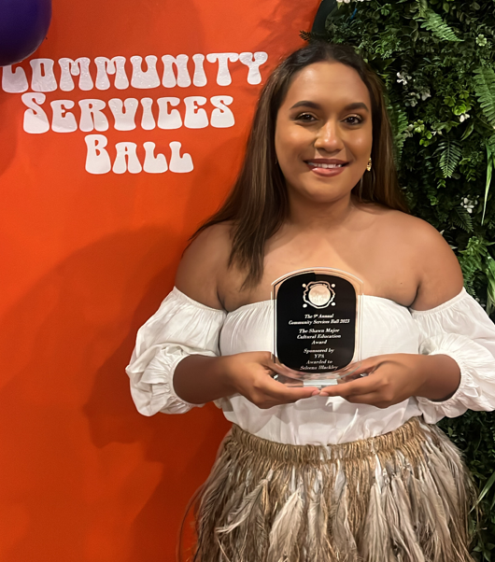

Thrive in our communities: creative piece
Amber Zhao is a 13-year-old writer and Year 8 student living in Brisbane. At the age of 6, inspired, she put pen to paper and never looked back. She was shortlisted for the KSP Young Writers Prize and the Hachette Australia Prize for Young Writers 2022 and received the top Year 3 NAPLAN writing results in Queensland in 2018. In her spare time, Amber enjoys reading, netball, and spending time with her cat.
Rice
It was strange, living under four walls. Marly’s family used to reside on the top floor of their rambling apartment. To extend space, the landowners had installed a loft. It was her room, and it jutted from the low roof. It was a fishbowl in which she began every day with the sound of soft traditional music and ended it with traffic noise through the electric circuit of the city.
Somehow, this place – and what she was about to do - was more frightening than that vertiginous space, leaving her off-balance in ways that went beyond physical.
Brisbane. It was the place that her family had decided to uproot their lives for. Marly stared out; eucalyptus trees in the backyard of their new, four-walled home trembled in the humid wind, raining leaves onto the freshly mowed grass. Everyone said it was relaxed, she thought. So why does it feel like I can’t settle myself?
Simple answer. She had been put on the spot by Mrs Cummings, who asked her to bring something that reminded Marly of Yangzhou, as part of a migrant program. An introduction to the class she’d been closed from on her first day. And she wasn’t ready.
The gates of the state school loomed. She arrived at her classroom and walked inside. A table was at the front of the classroom. She bowed her head while she set up, and once she was done, she had to begin.
“I’m Marly. I came from China a month ago, and I’m happy to be here.” She cringed at her stilted English. “I prepared some fried rice because I used to make it for my family. Hope you enjoy.”
Did she seem too foreign?
Was fried rice too stereotypical?
How badly would she stick out?
Before she could answer herself, the students spilled over to try. Mrs Cummings inquired, “Why did you choose to share food with us, Marly?”
Honestly? “I miss home,” she said. “The ability to make and taste it takes me back to our old kitchen. I need that sometimes.” She said this shakingly, hoping her classmates wouldn’t laugh. But there was nothing but low chatter and the clink of spoons. Soon, approval began to chorus around her table.
Mrs Cummings’s eyes glimmered. “Thank you for sharing. I hope you feel welcomed! Class, why don’t you get to know her better?”
“Do you have your phone? I’ll add you,” piped up a voice. Add me, too! Me! Soon Marly was swarmed by genuine interest and kind words. Included. Something that had felt hollow in her chest glowed a little.
She didn’t have her phone; she had almost nothing. None of her old toys and books, treasures that grounded her in home. She still felt impermanent here. But cautiously hopeful. These potential connections, that surge of resilience she’d felt…one day, she could – would – do more here than try to survive.
Yes, all she had was a pallet of rice.
But for now, it seemed like enough.

Our shared journey forward
The Young Queenslanders Strategy is a living framework which leads the Queensland Government’s forward plan to drive meaningful change for young people.
Guided by our foundational principles, our vision to empower young Queenslanders will be delivered through action plans that will evolve over time to respond to their emerging needs, with the first action plan to initiate the changes from 2024 to 2026.
As we move towards the future, we want to do so together – embracing the diversity, creativity, and abilities of all young Queenslanders. Our shared journey includes a commitment to truth-telling and healing. It is important that the pain of the past, as well as its continued impact on First Nations communities in the present, is recognised.
Acknowledging the inherent beauty of our cultures will be instrumental in building and fostering mutual respect between non-Indigenous and First Nations Queenslanders. This mutual respect must extend to the recognition and respect of ‘Closed Practices’ and will be paramount in continuing a positive relationship. Cultural respect is not a closed practice, and it must be universally applied as we journey towards a shared future of equality, honesty, healing, and respect.
The successful delivery of the Young Queenslanders Strategy and its action plans is a collective responsibility. We are committed to working collaboratively with our young people, across government, and with non-government partners and the sector as we navigate this journey to ensure that young people are at the centre of design every step of the way.
Each action plan will comprise tangible solutions to support our young people in the areas they tell us are the most important to them, both now and in the future, empowering them to actively participate, cultivate their futures, live their best lives, and thrive in our communities.
We are committed to continuous monitoring and reporting on the progress of actions to ensure we remain on track to deliver better outcomes for young Queenslanders and will deliver summary reports outlined in each respective action plan.
We acknowledge that as society transforms, so do the pressing challenges and needs of our young people. While we cannot predict what the world will look like in the future, we are committed to involving young people throughout the life of the Young Queenslanders Strategy to ensure the actions we create together are effective, relevant, and continue to respond to their current and emerging needs.

Language statement
Accessibility
Accessibility means making things easy for everyone to use, especially for people with different abilities or needs. It involves designing and organising things so that everyone, regardless of any challenges they might have, can access and use them comfortably. The goal is to create environments, products, or services that are inclusive and welcoming to everyone.
Acknowledgement of Country
An Acknowledgement of Country is a way of showing respect for, awareness of and acknowledging the traditional custodians of the land on which a meeting or event occurs. It has always been in place in Aboriginal and Torres Strait Islander cultures. Anyone can acknowledge Country and pay respect to the First Nations people of the Country on which the event or meeting is taking place. It is different than a Welcome to Country.
Co-Design
Co-design is when a group of people works together to make or enhance something. They share ideas, listen to each other, and make changes based on everyone's input. This process involves multiple rounds of collaboration, with feedback gathered and used to improve the project. It's like a team effort where everyone's thoughts matter, ensuring that the outcome is good for everyone. This continuous process allows for adjustments based on what works best for everyone involved.
Closed Practice
A closed cultural practice is like a special tradition or activity that is limited to people within a specific cultural group. It's something that is kept within the community, and people from outside that group cannot take part in it unless they are invited. Having closed practices can help a cultural group retain a strong cultural identity and preserve its unique customs, rituals, or knowledge. If practices are used by others without meaning or context, they can devalue and disrespect the proper cultural meanings. A closed practice is different from an open practice.
Cultivate
To ‘cultivate’ means to nurture, grow, or develop something, such as skills, relationships, or qualities. It involves fostering and tending to the growth or improvement of a particular aspect, like how one would care for and encourage the growth of a plant.
Cultural Protocol
Cultural protocols refer to a set of customary and respectful behaviours, actions, or ceremonies that guide interactions, events, and relationships within the community. These protocols are rooted in the cultural traditions, values, and practices of the specific Aboriginal and/or Torres Strait Islander peoples, cultural groups, and communities.

Cultural Safety
Cultural safety is about creating an environment where everyone feels respected and free from discrimination, regardless of their cultural background. It involves recognising and valuing diversity, promoting understanding, and ensuring that all people can express their cultural identity without fear of judgement or bias.
Domestic and Family Violence
Domestic and family violence encompasses various forms of abusive behaviour perpetrated within intimate or familial relationships, aiming to establish control and power over the victim. Domestic violence specifically refers to violent acts occurring between current or former intimate partners, characterised by one partner's attempts to dominate the other, often instilling fear. This form of violence can manifest in physical, sexual, emotional, social, verbal, spiritual, and economic abuse.
On the other hand, family violence is a broader term encapsulating violence among family members, which includes intimate partners, parent-child relationships, sibling dynamics, and more. It serves as the preferred terminology in contexts involving Aboriginal and/or Torres Strait Islander communities due to its acknowledgement of the extended family and kinship networks where violence may occur.
Behaviours associated with domestic and family violence can range from financial control and isolation tactics to psychological manipulation, threats of harm, and physical assault. While it's important to note that both men and women can experience violence, gendered patterns exist in both perpetration and victimisation. Women are disproportionately more likely to endure intimate partner violence, often with severe consequences such as hospitalisation or even fatality. Recognising these gendered dynamics is vital for comprehending the complexities of domestic and family violence and formulating effective intervention strategies, including preventative measures.
Early Intervention
Early intervention means taking action as soon as possible to address and help with a situation before it becomes more serious. It involves identifying and providing support or assistance at the early signs of a problem, aiming to prevent it from getting worse. The idea is to step in early to make a positive impact and support individuals before difficulties escalate.
Equity
Equity means fairness and justice. It ensures that everyone has a chance to succeed and receive what they need, considering their unique circumstances and challenges. It's about treating people fairly, addressing differences, and providing opportunities to bridge gaps so that everyone can reach their full potential.
Human Rights
A human right is a fundamental entitlement that every person has by virtue of being human. These rights are universal, which means they apply to everyone, and they cannot be taken away. They are interconnected, meaning they are all equally important.
In Queensland, the Human Rights Act 2019 (the Act) safeguards 23 human rights. The Act explicitly safeguards the cultural rights of Aboriginal and/or Torres Strait Islander peoples. The Act mandates that all branches of the government and businesses with public roles must align with these human rights.
Identity Capital
Identity capital refers to the collection of personal assets and resources that people accumulate as they navigate life and develop their identity. These assets can include education, skills, experiences, achievements, and social connections. Accumulating identity capital can enhance confidence, resilience, and ability to pursue personal and professional goals.
Intersectionality
Intersectionality is the acknowledgement that different aspects of a person’s identity such as race, gender and background can influence their experiences. Some people may face unique challenges or advantages based on the combination of factors. Intersectionality looks at how various aspects of identity intersect and interact, shaping a person's perspectives and experiences.
LGBTQIA+
The acronym LGBTQIA+ stands as a powerful symbol of diversity, encapsulating Lesbian, Gay, Bisexual, Transgender, Queer, Intersex, and Asexual/Aromantic identities. These are all terms that people may use to describe their experiences with gender, physiological sex characteristics, and sexuality. The plus or '+' sign serves as an open invitation, meant to encompass other diverse sexual identities including those which may not yet fit within established categories.
As society progresses towards greater inclusivity, this acronym has evolved – acknowledging and embracing a spectrum of preferences and identities. We acknowledge that there is inconsistency across Queensland with its use, including that the ‘A’ (Asexual/Aromantic) is often not included.
Prior to embarking on public consultation, we proactively sought the input of young people from the LGBTQIA+ community regarding the acronym and their preference. The resounding response was a clear endorsement to include the 'A’, aligning with best practice international standards. Removing it, they argued, would not only invalidate a substantial community but could also feel like a distressing erasure of identity for some individuals. This preference was implemented during public consultations when young people were asked to self-identify.
While retaining the ‘A’ may be inconsistent with other Queensland agency definitions, as this strategy specifically targets young Queenslanders and aims to foster inclusivity across the entire community, we have opted to preserve the complete acronym throughout the document. In doing so, we send a clear message of validation, respect, and recognition to all members of the community, ensuring that no identity is overlooked or erased.

Lived Experience
Lived experience refers to the personal knowledge and understanding gained through direct involvement or encounters in real-life situations. It's what someone learns and knows from going through certain events or circumstances firsthand. When government talks about ‘lived experience’ we are often talking about specific experiences which may make a person react with their environment differently and may mean the government needs to provide additional support – for example a person who may have lived experience of homelessness or out-of-home care.
Open Practice
An open cultural practice is like a tradition or activity that welcomes everyone – even people from outside the specific cultural group to participate, learn, and share in the cultural experience. Open practices are like cultural doors that are open to a broader community, encouraging understanding and collaboration between people from different backgrounds. An example of an open practice is an Acknowledgement of Country.
Prevention
Prevention is taking actions to stop something from happening before it occurs. It involves measures and strategies to avoid or reduce the likelihood of a problem, illness, or undesirable situation. The goal of prevention is to keep things from happening in the first place by addressing potential risks or issues.
Self-Determination
Self-determination means having the power and freedom to make your own choices and decisions. It's about being in control of your own life, setting goals, and taking actions based on your preferences and values. Self-determination empowers people to shape their own path and have a say in the direction of their lives.
Welcome to Country
A Welcome to Country is an important ceremony that can only be delivered by Traditional Owners, Elders, or a local First Nations person of significance with permission of a Traditional Owner or Elder who has cultural authority for the Country on which the ceremony is taking place. It is used by groups to welcome visitors to their Country. A Welcome to Country is different from an Acknowledgement of Country.
Young Person
In Queensland, a young person means someone aged between 12-25, inclusive. In this strategy, when we reference young person, it encompasses all young people within this age range, irrespective of their specific age, abilities, lived experiences, culture, or circumstances.
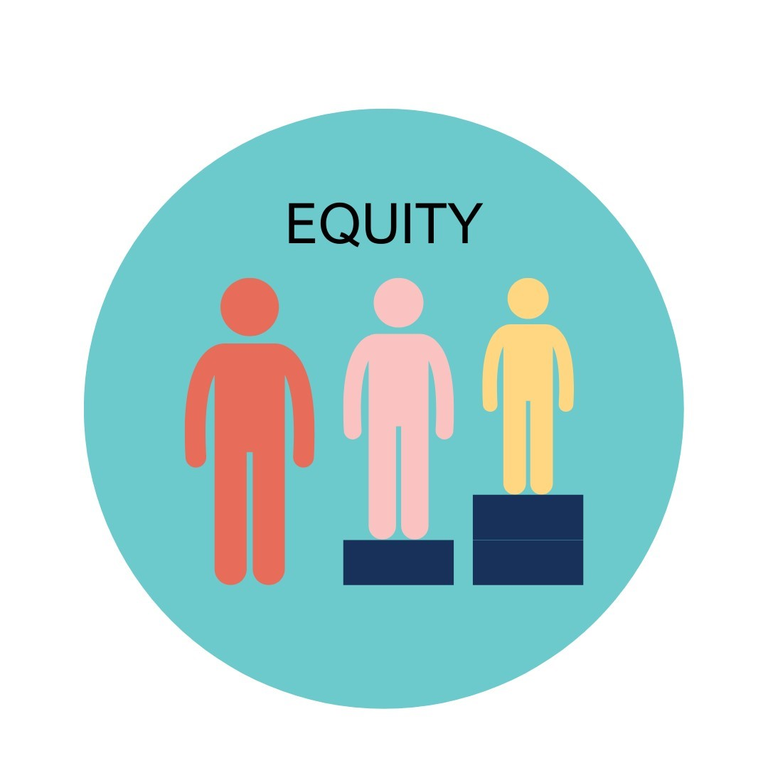



James E. Côté (2002). The Role of Identity Capital in the Transition to Adulthood: The Individualization Thesis Examined, Journal of Youth Studies, 5(2), 117-134, DOI: 10.1080/13676260220134403

