Kidney Transplant Seminar
  - Princess Alexandra Hospital invites patients with kidney disease, their families and friends to a:

Venue Russell Strong Auditorium

Lower Ground Level, Building 1
If you have already attended a Seminar attendance is not required

Date Friday 17 March 2023
Friday 7 July 2023
Friday 3 November 2023

Time 8.45 am – 11.30 am (Registration at 8.30 am)

RSVP by Friday the week before the scheduled seminar
Phone: 07 3176 6963

The Kidney Transplant seminar will be video-conferenced to requesting Hospitals for all Seminars. If you are unable to attend in person and would like to have a telehealth linkup, speak to the Nurse Practice Coordinator of your Dialysis Unit as soon as possible or call the Qld Kidney Transplant Coordinators on 3176 7397 or 3176 7769.

Topics

Being fit for a Kidney Transplant - work-up requirements

Surgical aspects of Kidney Transplantation
- Questions and Answers session – Pharmacist, Social Worker, Dietician, Transplant Coordinator and Transplant Outpatient Staff

Parking For more information on Metro Parking costs, TRANSLink and Princess Alexandra Hospital map, please turn over

Venue Directions - Russell Strong Auditorium
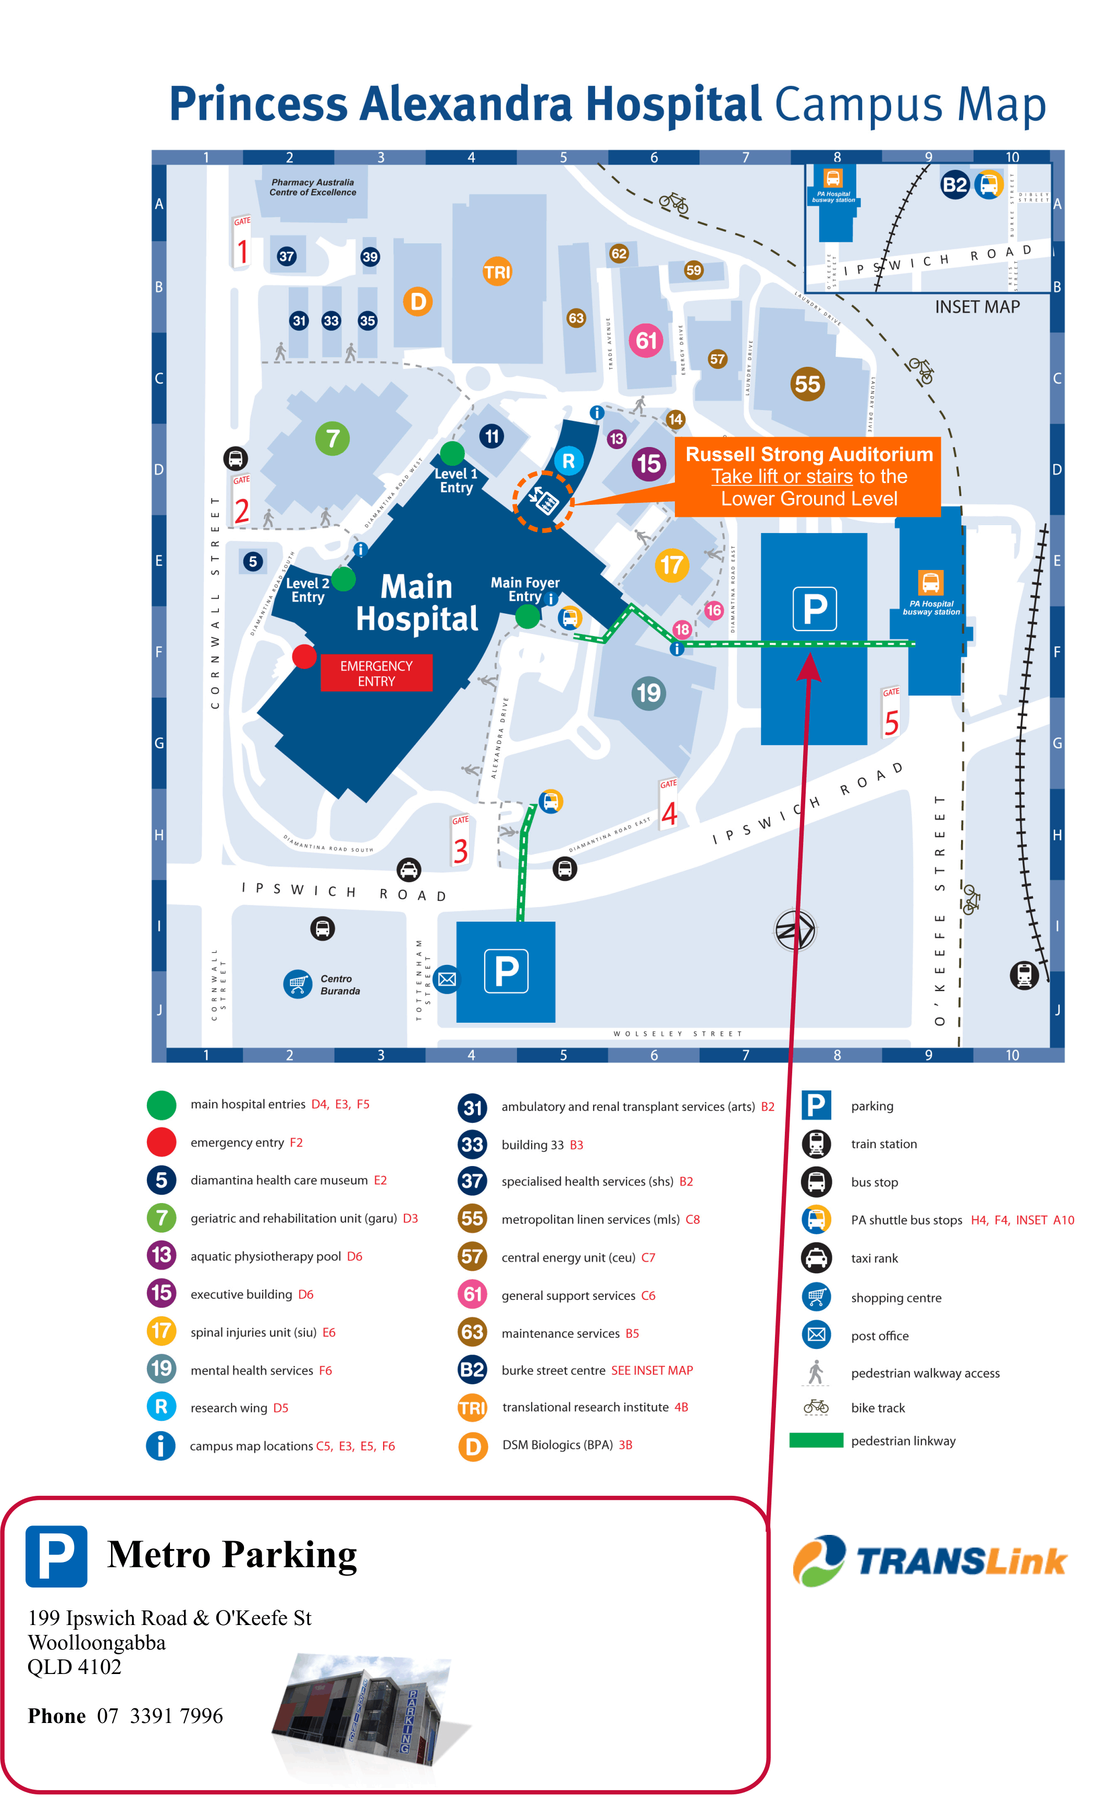

Approx Parking cost in hours:
0.5 hrs $5.00
0.5hrs-1 hr $10.00
1 hr – 1.5 hrs $15.00
1.5 hrs- 2 hrs $20.00
2 hrs – 7 hrs $25.00
7 hrs + $29.00

Bus & Train information
Call 13 12 30
www.translink.com.au

