Princess Alexandra Hospital invites potential living donors and their friends and family, to the:

Living Kidney Donation Seminar

Venue Bryan Emmerson Seminar Room 4L.3A Training Room
Building 1, 4th Floor, behind blue lifts

Date Friday 24 February 2023
Friday 23 June 2023
Friday 13 October 2023

Time 8.30 am – dial in for external centres
8:45am – registration for attendees
9:00am - 11:30 - Seminar

RSVP by Friday the week before the scheduled seminar
Phone: 07 3176 6963 or Email: PAHQKTSadmin@health.qld.gov.au

The Living Kidney donation seminar will be video-conferenced to requesting hospitals for all seminars listed above. If you are unable to attend in person and would like to have a telehealth link-up, please call the Qld Kidney Transplant Coordinators on 3176 7397 or 3176 7769 a week prior to the seminar date.

Topics
1. Living Kidney Donation – what you need to know
2. Social aspects of Living Kidney donation
3. The requirements for living kidney donation
4. Questions and Answers
(please have your questions ready or emailed to us prior to the day if possible)

Parking For more information on Metro Parking costs, TRANSLink and Princess Alexandra Hospital map, please turn over

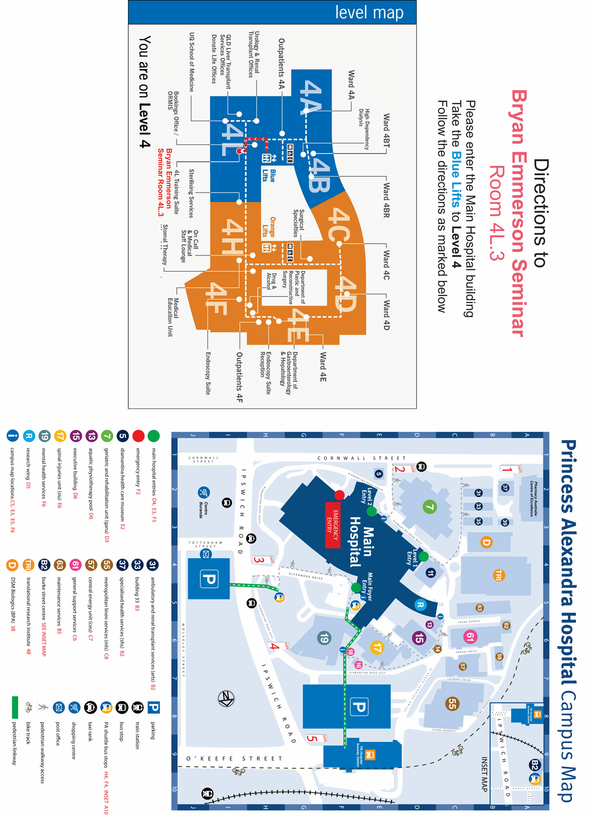

Approx Parking cost in hours:
0.5 hrs $5.00
1 hr $10.00
1 hr – 1.5 hrs $15.00
1.5 hrs- 2 hrs $20.00
2 hrs – 7 hrs $25.00
7 hrs + $29.00
Metro Parking
199 Ipswich Road & O’Keefe St, Woolloongabba Qld 4102
Phone: (07) 3391 7996

TRANSLINK
Bus & Train information
Phone: 13 12 30
www.translink.com.au

Approx Parking cost in hours:
0.5 hrs $4.80
1 hr $9.60
1 hr – 1.5 hrs $14.40
1.5 hrs- 2 hrs $19.20
2 hrs – 7 hrs $24
7 hrs + $28

Bus & Train information
Call 13 12 30
www.translink.com.au

